|  |  |
| --- | --- |
| |  | | --- | | **MINISTRY OF EDUCATION AND TRAINING** | |
| Capstone Project Document |
| Bus User Support System |
|  |
|  |
| |  |  |  |  | | --- | --- | --- | --- | | バス利用者支援システム・チーム | | | | | **Group Members** | Nguyễn Thành Nam | SE02942 | Namntse02942 | |  | Trịnh Thị Tuyết Mai | SE02630 | Maitttse02630 | |  | Bùi Bích Phương | SE02704 | Phuongbbse02704 | |  | Trần Tú Anh | SE02596 | Anhttse02596 | | **Supervisor** | Mr. Nguyễn Văn Sang | Lecture at FPT University | | | **Capstone Project code** | **BUSS** | | |     **Hanoi, 26th August, 2014** |

# Table of contents

Table of contents 2

Definition and Acronyms 6

1 Introduction 8

1.1 Project information 8

1.2 Project members 8

1.2.1 Supervisors 8

1.2.2 Team members 8

1.3 Purposes 8

1.4 Abstract 9

1.5 The existing system 9

1.5.1 Hanoi Bus 10

1.5.2 Bus Map 10

1.5.3 Bản đồ xe buýt 11

1.6 Proposal 11

1.6.1 The idea 11

1.6.2 Objectives 11

1.6.3 Brief description about system 12

1.6.4 System features 12

1.7 Benefit From Project 13

1.7.1 For our group 13

1.7.2 For Community 13

1.8 Critical Assumption and Constraints 13

1.9 Potential Risk 14

2 Software Project Management 15

2.1 Project Overview 15

2.1.1 Project Description 15

2.1.2 Purposes of Project 15

2.1.3 Scope Statement 15

2.2 Project Organization 19

2.2.1 Organizational Structure 19

2.2.2 Project Process 20

2.3 Project Schedule 22

2.3.1 Milestone and Deliverables 22

2.3.2 Gantt chart 25

2.4 Risk Management 26

2.5 Communication Management 29

2.6 Tools and Infrastructure 31

2.7 Configuration Management Plan 32

3 Software Requirement Specification 33

3.1 Overview 33

3.1.1 Purpose 33

3.1.2 Scope 33

3.2 User Requirements Specification 33

3.2.1 Business Process Overview 33

3.2.2 Product Features 35

3.3 Sofware Requirements Specification 36

3.3.1 Overall Description 36

3.3.2 Entity Relation Model 39

3.3.3 Functional Specification 43

3.3.4 Non-Functional Specification Requirements 77

4 Software Design Description 79

4.1 SDD Overview 79

4.2 Architecture Design 79

4.2.1 Layer architecture 79

4.2.2 Architectural Representation 82

4.2.3 Architecture Goals and Constraints 83

4.2.4 Use-Case View 83

4.2.5 Logical View 83

4.2.6 Process View 88

4.2.7 Deployment view 118

4.3 Class Design 119

4.3.1 Packages 119

4.3.2 Detailed Functional Design 120

4.4 Screen Design 124

4.4.1 Screen Flow 124

4.4.2 Screen description 126

4.5 Database design 176

4.5.1 Table diagram 176

4.5.2 User table 177

4.5.3 Place table 177

4.5.4 Favoriteplace table 178

4.5.5 Busroute table 178

4.5.6 Busstop table 179

4.5.7 Bus table 179

4.5.8 Favoritebus table 179

4.5.9 Track table 180

4.5.10 Reminder table 180

5 Software Source Code 181

6 Software Test Documentation 183

6.1 INTRODUCTION 183

6.1.1 Purposes 183

6.2 TEST PLAN 183

6.2.1 Scope of Testing 183

6.2.2 Test Strategies 186

6.2.3 Resources 190

6.2.4 Test Milestones 191

6.3 TEST CASES 192

6.3.1 Unit Test 192

6.3.2 Component Test Case 192

6.3.3 Integration Test Case 194

6.3.4 System Test Case 195

6.4 CHECKLISTS 196

6.4.1 Test Checklist 196

6.4.2 GUI checklist 198

6.5 TEST LOGS 198

6.5.1 Defect Logs 198

6.5.2 Test Reports 200

6.5.3 Quality Report 201

7 Software User Manual 202

7.1 Installation guide 202

7.1.1 Introduction 202

7.1.2 Environment 202

7.1.3 Application Installation 202

7.2 User Guide 202

7.2.1 Overview 202

7.2.2 Details guidelines 203

7.3 PROJECT RESULT REPORT 215

7.3.1 Product Judging 215

7.3.2 Product Summary 215

7.3.3 Lessons Learnt 216

7.4 Reference 217

# Definition and Acronyms

|  |  |  |
| --- | --- | --- |
| **Acronym** | **Definition** | **Note** |
| BUSS | Bus User Support System |  |
| JP | Japanese |  |
| EN | English |  |
| VI | Vietnamese |  |
| PM | Project Manager |  |
| PTL | Project Technical Leader |  |
| QA | Quality Assurance |  |
| RUP | Rational Unified Process |  |
| PMP | Project Management Plan |  |
| SRS | Software Requirement Specification |  |
| SAD | Software Architecture Design |  |
| SDD | Software Detail Design |  |
| STD | Software Test Documentation |  |
| UT | Unit Test |  |
| CT | Component Test |  |
| IT | Integration Test |  |
| ST | System Test |  |
| AT | Acceptance Test |  |
| UC | Use-case |  |
| TC | Test case |  |
| SC | Screen |  |
| UI | User Interface |  |
| GUI | Graphical User Interface |  |
| ERD | Entity-Relationship diagram |  |
| MVC | Model-View-Controller |  |
| DB | Database |  |

**Acknowledgements**

D

uring the implementation of this project, we have received overwhelming support from a number of people, to whom we would like to express our great appreciation. Without them, this project would have been done with much more obstacles than it was.

First and foremost, we would like to show our thankfulness to Lecturer Nguyễn Văn Sang, our supervisor of this project during four months and and teacher Nguyen Cuong, specialized consultants, who taught us Japanese. They have given us not only many valuable advices but also enthusiastic inspirations that helped raising our team members’ spirit to give us the possibility to complete this Capstone Project.

Last but not least, we are thankful to our families, our teachers and our friends in FPT University for their constant encouragement and support throughout this project.

# Introduction

## Project information

* **Project Name:** Bus User Support System
* **Project Code:** BUSS
* **Project Type:** Mobile application
* **Duration:** From 11th May 2015 to 28th August 2015

## Project members

### Supervisors

|  |  |  |  |
| --- | --- | --- | --- |
| **Full name** | **Phone** | **E-Mail** | **Position** |
| Nguyễn Văn Sang | 0912210727 | sangnv@fpt.edu.vn | Supervisor |

### Team members

|  |  |  |  |  |
| --- | --- | --- | --- | --- |
| **Full name** | **Roll No.** | **Phone** | **E-mail** | **Position** |
| Nguyễn Thành Nam | SE02942 | 01676491075 | [Namntse02942@fpt.edu.vn](mailto:Namntse02942@fpt.edu.vn) | Leader |
| Trịnh Thị Tuyết Mai | SE02630 | 01685991200 | [Maitttse02630@fpt.edu.vn](mailto:Maitttse02630@fpt.edu.vn) | Member |
| Bùi Bích Phương | SE02704 | 01664260019 | [Phuongbbse02704@fpt.edu.vn](mailto:Phuongbbse02704@fpt.edu.vn) | Member |
| Trần Tú Anh | SE02596 | 01666116617 | [Anhttse02596@fpt.edu.vn](mailto:Anhttse02596@fpt.edu.vn) | Member |

Table 1‑1: バス利用者支援システム・team members

## Purposes

This document is created as the introduction for project Bus User Support Sytem – our Capstone Project at FPT University. In this document, we will describe the overview of some existing systems, the initial idea for our project, a brief description about our expected system and some potential risks, critical assumptions, constrains. Moreover, this document also shows opportunities what it offers for users.

## Abstract

In Vietnam, road traffic is the most common and crowded form of transportation. Thus, this is also the worst kind. People used to drive their own personal vehicle everywhere such as cars, bike and especially all kinds of motorbike. The mass use of personal transportation vehicle dramatically decrease the effectiveness of traffic facilities and makes the air pollution situation worse than ever – which directly affects people' lives. This problem is a very familiar in other developing countries as well. Public transportation is the only key to solve this problem. Unfortunately, this kind of transportation is not getting enough attention from both citizens and government in Vietnam. And for the record, buses are the most common used public transportation in our country.

As formally students, we love buses. Bus is a cheap and effective way to get to almost everywhere in the city without too much concern for traffic jams or noise or exhaust gas. Using bus is a great way to contribute to decreasing the level of air pollution in the city and getting rid of the traffic jam status in big cities. To support and encourage the using of bus, BUSS is created base on a single idea of making bus traveling easy and fun for everyone, especially children, students and young people.

## The existing system

Bus is becoming more and more popular in daily transportation in big cities in Vietnam. However, the engineering limitation of low level public transportation development in our country due to the ignorance of the government does not allow the influence of new and advanced technology to make using bus more convenient. There are quite a few of bus user supporting application published, and most of them are not satisfied users.

### Hanoi Bus

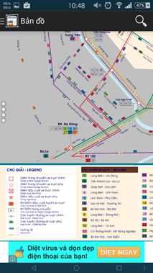The app at allow users to view bus map, locate current gps, look up bus list, find path and… call for a taxi?!?

*Advantages:*

* Support almost needed features

*Disadvantages:*

* Poorly designed, the bus map is nothing more than a high resolution picture of a real map.
* Including ads
* Out of date and has not been update for quite long

Reference: <https://play.google.com/store/apps/details?id=com.apkvn.hanoitravel>

Figure 1-1: Hanoi Bus interface

### Bus Map

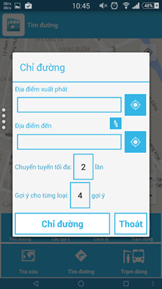The app allow users to view bus map, search for bus, look for bus-stop, find path, see bus list.

Advantages:

- Support almost needed features

- No ads included

Disadvantages:

- Complicate and confusing UI

- Pretty hard to navigate among functions

- Sometimes not function correctly

Reference: <https://play.google.com/store/apps/details?id=com.t7.busmap>

Figure 1-2: Bus Map interface

### Bản đồ xe buýt

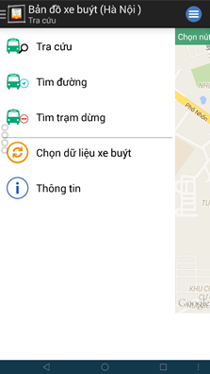The app allow users to view bus list, bus detail, find path and find bus stop.

*Advantages:*

* Support bus data from both Hanoi and Ho Chi Minh city
* Better and simple design

*Disadvantages:*

Lack of many needed functions

Reference: <https://play.google.com/store/apps/details?id=com.haui.busmaphaui.activity>

Figure 1-3: Bản đồ xe buýt interface

## Proposal

### The idea

Nowadays, there are quite many apps and websites which support finding and making use of buses. All of them have been created for the purpose of making users easier to catch a bus or to travel from places to places using buses. However, we found disadvantages while trying each of them. Some have confusing UI, some are better yet only not functionally focused on bus services and have not much to offer to users. Therefore, our project BUSS offers almost everything a bus user in Vietnam, especially “everyday-bus-users” would need. Not only support users finding buses, setting routes, notifying upcoming trips… All of this would be done through a smartphone application which connected to the web service. Completely free of charge.

### Objectives

BUSS is our Capstone Project in FPT University study program. Making this project meet all requirements from FU and the guidance teacher is the first objective of all team members. During the project, we should learn how to effectively communicate among members, working in groups, manage personal time, control project progress and develop personal techniques. Approaching to this project, we will have to learn how to develop an Android application which is connected to a .PHP web service and MySQL database. The project development process itself must be controlled through a very tight managing model. Therefore, this is a very good chance for us to practice everything we have learned in FU.

Not only means a lot to us, BUSS has its own social goal. By combining a simple and clean user interface with fully loaded user-concentrating functions and a new solution approach, BUSS is hoped to increase the use of buses in the city and further development of public transportations in general. The goal is pretty vague but the chances are good to try.

### Brief description about system

BUSS includes a web service and a smartphone application. The application which runs on Android is well-designed, registration-free and fun to use. It provides bus user support functions such as path finding, bus searching, route navigating, smart stop tracking, etc.

BUSS uses familiar technologies such as: Java, Android SDK, Google APIs, PHP webservice, codeIgnitor framework, MySQL Server, etc

### System features

BUSS features core functions of path finding, bus searching, route navigating, smart stop tracking and bus reminder. In here, we focus on features which can help users can understand the best way what user want to have with features of BUSS.

There are some detailed features of BUSS:

* **Path finding**: Users input the departure and destination location to find paths available for them to travel by bus. The results will automatically be sorted based on collected personal usage data and can be rearrange or filtered to match users' preferences.
* **Bus searching**: Users can search for specific bus through one of these scenario:
  + Look up from the bus list: Display a full list of all the buses available in the current city. Users can filter this list by number or names of the streets they pass.
  + Look for buses that pass or are near the current locations of users.
  + Look for buses that travel from the current location to a predefined destination.
* **Route navigating**: Step-by-step giving users detailed directions on how to get to the predefined destination mostly by bus. Maps and information will be refresh each time a step completed, continuously guide users until they reach their destination.
* **Smart stop tracking**: Once users get on a bus, they can setup an tracker which will keep an eye on the bus all the time. The user only have to choose a stop they want to get off, and leave the rest to the tracker. Whenever the bus comes near that predefined stop, it will notify them to prepare the leave.
* **Bus reminder**: the app functions similarly to an alarm yet with greater effort by integrating map information and bus information into users' schedule. To use this feature, the user first sets up a time frame at about which they need to hit the road. User then chooses a departure location and a bus that they should get on. About time, the app will notify user if there are buses of the preferred kind which about to get to the nearest bus-stop of the departure location. This feature function well in combination with Path finding and smart stop tracking features.

## Benefit From Project

### For our group

After developing and implementing this project, our group will achieve some benefits:

* Gain more experiences of managing a software project: how to manage plan, time, member and risk.
* Acquire more knowledge and skill about Android programming, database organization and web service behavior.
* Understand how to effectively communicate with team members and how to gather team effort with ease.
* If BUSS is well developed and delivered, the Capstone Project will be successfully completed, which is a good start for our future careers.

### For Community

Require only an android smartphone, which has become popular now, bus user can:

* Easily search for bus, bus information, route or path everywhere.
* Integrate the use of bus to daily schedule to optimize productivity and save time.
* Catch a bus with ease, ride buses without much worrying about where to get off.
* Be part of the changes: save the environment, encourage desirable attention on public transportation, eliminate the mass use of motorbike.

## Critical Assumption and Constraints

By analyzing requirements of this project and resources of our team, we have come to some assumptions and constraints as listed below:

Assumed that team’s main developer can learn and complete a short training on Android in at most 3 weeks.

Assumed that team’s secondary developer can study and design a 3 tier web service in at most 4 weeks.

By any means, the project must be delivered on time and all tasks must be completed at most 3 days before the final deadline

The system must be thoroughly tested in real conditions to assure an acceptable quality and reliable performance.

## Potential Risk

After studying the project, we found out some problem that we might encounter:

* It is the first time we participate in such a big project, we have not much experience in exchanging information, managing and controlling work so we might miss the deadline or under estimate scope, time.
* It is the first time our team work together so conflicts and disagreements are unavoidable.
* We do not have much knowledge and experience in developing Android application. Therefore, we almost start from zero. Our team might be faced with technical difficulties that might result in project delay.
* Project scope might be ill defined, too large or too vague that make it hard to implement the development process and to complete it in time.
* Team member might not be able to apply coding conventions, editing conventions and not properly back up data that result in hidden defects, losing data, etc
* The server might die due to the fact that the system including web services.

# Software Project Management

## Project Overview

### Project Description

|  |  |  |  |
| --- | --- | --- | --- |
| **Project name:** | **Bus User Support System** | | |
| **Project Code:** | **BUSS** | | |
| **Project manager:** | **Nguyễn Thành Nam** | | |
| **Project category:** | **🗹 New development** | **🞎 Maintenance** | **🞎 Other** |
| **Application Type:** | **Mobile Application** | | |
| **Business domain:** | **Education** | | |
| **Project start date:** | **11/05/2015** | | |
| **Expected end date:** | **28/08/2015** | | |
| **Planned duration:** | **75 days** | | |

**Table 2‑1:** Project description

### Purposes of Project

This project is a capstone project of our team at FPT University. The main purpose of the project is to complete our university study program and to get on with our future careers. Bus Support Interaction Network is the subject that we choose to prove our qualifications of all knowledge and experiences obtained in the study progress. However, we also want to create a truly creative and useful tool that actually helps and encourage people’ use and attention toward bus or public transportation in general. Not only by making it easier and more convenient but with a new and young approach, we also hope that this project may be a part of the change in Vietnamese’ traffic habits in the future. 4 months may not be a long time at all but with efforts and determined hearts, we are looking forward to achieving not only knowledge, experiences and skills but friendship and maturity.

### Scope Statement

The scope of this project contains: Requirement Analysis, Design, Coding and Testing (Unit Test, Integration Test, System Test and Acceptance Test).

|  |  |  |  |
| --- | --- | --- | --- |
| **Use Case No.** | **Group of functions** | **Functions** | **Glossary** |
|  | Account Management | Log in | Đăng nhập |
|  | Sign up | Đăng ký |
|  | Log out | Đăng xuất |
|  | Forgot Password | Quên mật khẩu |
|  | Change Password | Đổi mật khẩu |
|  | Common | Change app settings | Thay đổi cài đặt |
|  | Bus | View bus list | Xem danh sách buýt |
|  | Search bus in list | Tìm kiếm trong danh sách buýt |
|  | View bus info | Xem thông tin của xe buýt |
|  | View bus route | Xem lộ trình của xe buýt |
|  | View nearest bus | Xem xe buýt gần nhất thuộc tuyến đã chọn |
|  | View bus map | Xem đường đi của xe buýt trên bản đồ |
|  | View bus near me | Xem tất cả các xe buýt ở gần |
|  |  | Find path | Tìm đường |
|  | View paths found | Xem kết quả tìm được |
|  | View path detail | Xem chi tiết đường đi |
|  | View direction | Xem đường đi từng bước |
|  | Reminder | View bus reminder | Xem tất cả nhắc nhở |
|  | Add reminder | Thêm nhắc nhở |
|  | Edit reminder | Sửa nhắc nhở |
|  | Delete reminder | Xoá nhắc nhở |
|  | Suspend/Cancel suspend a chosen reminder | Hoãn/Ngừng hoãn một nhắc nhở đã chọn |
|  | Track | Set track | Theo dõi |
|  | Cancel track | Ngừng theo dõi |
|  | Favorite | View favorite places | Xem địa điểm yêu thích |
|  | Add favorite place | Thêm địa điểm yêu thích |
|  | Edit favorite place | Sửa địa điểm yêu thích |
|  | Delete favorite place | Xoá địa điểm yêu thích |
|  | Search favorite places | Tìm kiếm địa điểm yêu thích |
|  | View favorite buses | Xem xe buýt yêu thích |
|  | Add favorite bus | Thêm xe buýt yêu thích |
|  | Delete favorite bus | Xoá xe buýt yêu thích |
|  | Search favorite buses | Tìm kiếm xe buýt yêu thích |

Table 2-2: List function

## Project Organization

### Organizational Structure



Figure 2‑1 Project organizational structure

### Project Process

#### Fsoft Process Model



Figure 2‑2 Fsoft Process Model

The software lifecycle is broken into *cycles*, each cycle working on a new generation of the product. The Fsoft process divides one development cycle in six consecutive *phases*:

* Initiation phase
* Definition phase
* Solution phase
* Construction phase
* Transition
* Termination

#### Project Life Cycle

Basing on Fsoft process and real-world project, we decided to divide the project into four phases: Initiation, Solution, Construction and Termination:

**- Initiation Phase:** This is the explanatory phase of the project. Project objective and description is described at this stage. The purpose of this phase is to collect and understand business requirements, detail the project plan and agree upon a high level statement of work. Our primary objectives are complete project identification and project plan. After these are completed, the project is checked against the following criteria:

* + Identify business functions of the system
  + Determining the scope, conditions and limitations of the project
  + List the main functions of the system
  + List one or more suitable architecture for the system
  + Identify project risks
  + Complete Report 1, and Report 2

**- Solution Phase:**

* + In this phase, the architecture of the system is designed. The goal is to translate requirements and specification into a technical solution to produce Technical Design. Our primary objectives are complete requirement specification, architecture design and database design.
  + Finally, the plan must provide (including estimates of cost and time) for the construction phase. The plan must ensure proper and accurate based on experience.
  + Complete Report 3 and Report 4

**- Construction Phase:**

* + This is the longest phase of a project life cycle.
  + In this phase, all functions of the system will be installed. The installation will be divided into small stages, each stage of the installation a few functions. The results of each phase will be the release of the module function can be executed.
  + Construction and improvement of products until the final product is ready to deliver to the user. During this phase, all the components and other features of the application is developed and integrated into the product.
  + This phase emphasizes the resource management and control operations to optimize cost, time and quality.
  + Complete software packages and Report 5, Report 6

**- Termination Phase:**

* + This is the final phase in the life cycle of a project.
  + Their products will be deployed to the client. The feedback received during the transfer process will be recorded and put on the new functional requirements or functionality enhancements in the next version of the product.
  + Phase transfer switch also includes the training system and the new system for the user.

## Project Schedule

The Effort estimation is documented in the table below.

|  |  |  |  |  |  |
| --- | --- | --- | --- | --- | --- |
|  | **Initiation** | **Solution** | **Construction** | **Termination** | **Total** |
| Effort(person/day) | 37.2 | 74.8 | 130.8 | 37.2 | 280 |
| Total % budgeted Effort Usage (%) | 13 | 27 | 47 | 13 | 100 |

Table 2-3: Effort Estimate

### Milestone and Deliverables

| No | Stage | Committed Delivery date | Actual Delivery Date | Description of Deliverable | Delivery media |
| --- | --- | --- | --- | --- | --- |
| Initiation | |  |  | Requirements agreed, Report 1 reviewed | |
| 1 | Develop project idea | 12-05-2015 | 12-05-2015 | Project goals and scope defined, milestone description defined, resource committed | Commit to GitHub |
| 2 | Q&A Management Sheet | 14-05-2015 | 14-05-2015 | Criteria: Documentation reviewed | Commit to GitHub |
| 3 | Submit report no.1 final | 25-5-2015 | 25-05-2015 | Completed report no.1 | Commit to GitHub |
| 4 | Project Plan | 25-05-2015 | 25-05-2015 | Criteria: Documentation reviewed | Commit to GitHub |
| 5 | SRS | 25-05-2015 | 25-05-2015 | Completed report no.2 | Commit to GitHub |
| Solution | |  |  |  | |
| 1 | Screen Prototype | 29-05-2015 | 29-05-2015 | Criteria: Documentation reviewed | Commit to GitHub |
| 2 | Architecture Design | 05-6-2015 | 05-6-2015 | Criteria: Documentation reviewed | Commit to GitHub |
| 3 | Screen Design | 10-06-2015 | 10-06-2015 | Criteria: Documentation reviewed | Commit to GitHub |
| 4 | Class Design | 11-06-2015 | 11-06-2015 | Criteria: Documentation reviewed | Commit to GitHub |
| 5 | Detail Data Design | 28-06-2015 | 28-06-2015 | Criteria: Documentation reviewed | Commit to GitHub |
| 6 | Submit Report no. 2 Final | 31-06-2015 | 31-06-2015 | Completed report no.2 | Commit to GitHub |
| 7 | Submit Report no.3 Final | 09-07-2015 | 09-07-2015 | Completed report no.3 | Commit to GitHub |
| 8 | Submit Test Plan Final | 23-06-2015 | 23-06-2015 | Criteria: Documentation reviewed | Commit to GitHub |
| 9 | Create Unit Test Case | 02-07-2015 | 02-07-2015 | Criteria: Documentation reviewed | Commit to GitHub |
| 10 | Submit Report no.4 Final | 31-07-2015 | 31-07-2015 | Completed report no.4 | Commit to GitHub |
| Construction | |  |  | Product developed & tested and released to supervisor, documentation reviewed. | |
| 1 | Review Test Document | 09-07-2015 | 09-07-2015 | Criteria: Documentation reviewed | Commit to GitHub |
| 2 | Submit report no.5 Final | 16-07-2015 | 16-07-2015 | Completed report no.5 | Commit to GitHub |
| 3 | Complete Coding and Unit Test | 24-07-2015 | 24-07-2015 | Source code  Acceptance criteria: Product unit tested | Commit to GitHub |
| 4 | Complete Testing | 12-08-2015 | 12-08-2015 | Completed Test | Commit to GitHub |
| 5 | Submit report no.5 Final | 13-08-2015 | 13-08-2015 | Completed report no.5 | Commit to GitHub |
| Termination | |  |  | Project post-mortem is conducted, Project assets archived and released to supervisor | |
| 1 | Submit report no.6 Final | 26-08-2015 | 26-08-2015 | Completed report no.6 | Commit to GitHub |
| 2 | Submit the last document and CD source code | 26-08-2015 | 26-08-2015 | Final Documents and Source Code | Print document and copy to CD |
| 3 | Lesson learned | 24-8-2015 | 24-8-2015 | Criteria: Completed | Group Meeting |
| 4 | Complete Presentation Slide | 26-8-2015 | 26-8-2015 | Criteria: Completed | Commit to GitHub |
| 5 | Represent capstone project | 28-08-2015 | 28-08-2015 | Criteria: Completed | Present |
| 6 | Project Complete | 28-08-2015 | 28-08-2015 | Criteria: Completed |  |

**Table 2‑4:** Milestone and Deliverables

### Gantt chart

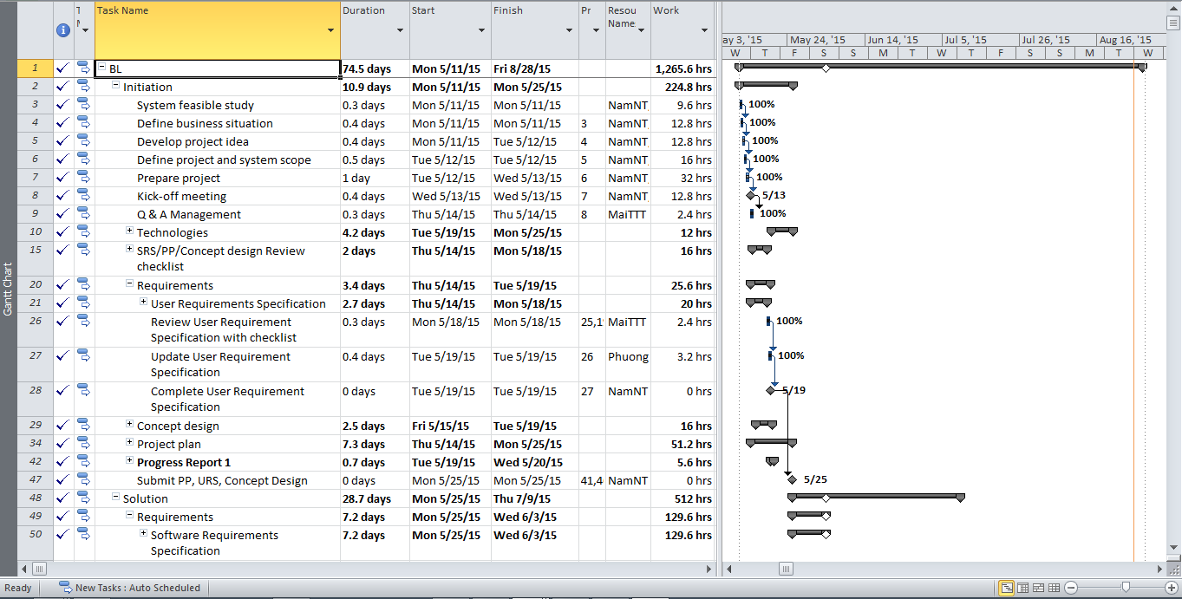

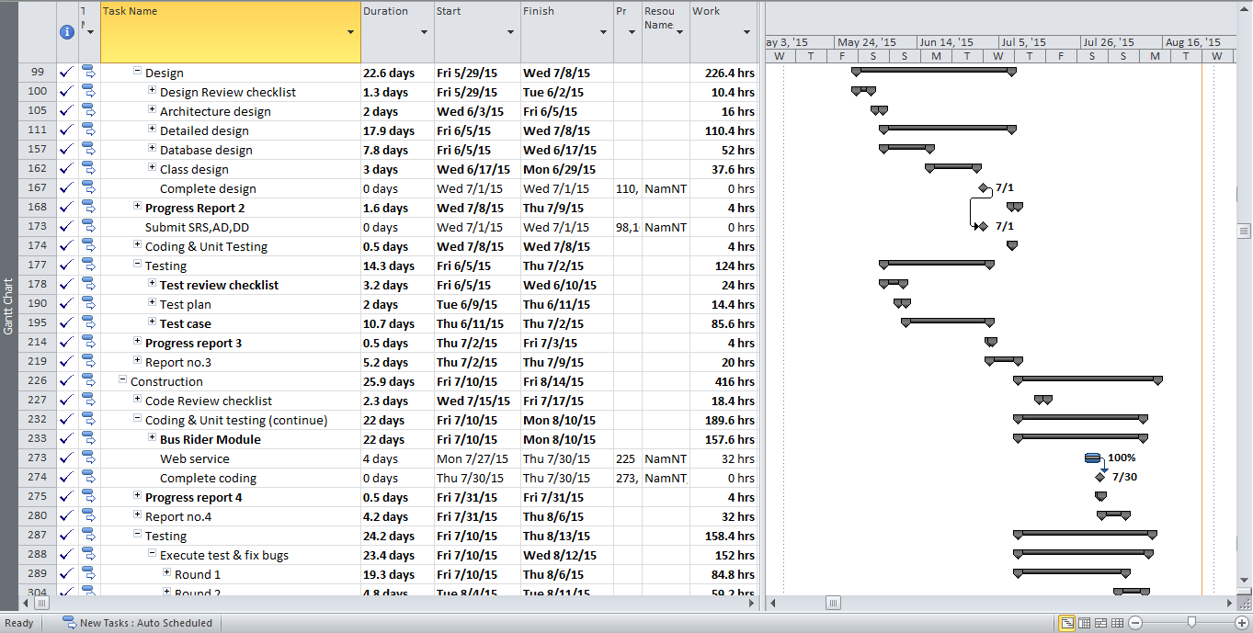

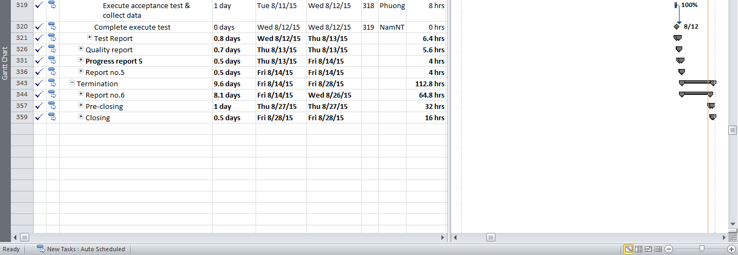

Figure 2-3: BUSS Gantt chart

## Risk Management

|  |  |  |  |  |  |  |  |  |  |  |  |  |
| --- | --- | --- | --- | --- | --- | --- | --- | --- | --- | --- | --- | --- |
| **Risk ID** | **Risk Source** | **Risk Category** | **Risk Description** | **Probability** | **Impact** | **Exposure** | **Priority** | **Trigger** | **Risk Status** | **Mitigation** | **Contigency** | **Person in charge** |
| R01 | Project Requirement | Not meeting performance requirements | Quality of document which is wrote by Japanese maybe not good | 0.3 | 2 | 0.6 | 4 | Member don’t know much about Japanese. | Open | 1. Create plan to training Japanese for member from beginning of project. |  | Team member |
| 2. Using English instead of Japanese (if can). |  | Team member |
| 3. When deliver documents to customer can write by two languages: English and Japanese. |  | Team member |
| R02 | Human resource | Shortage of Human resource | Member leave team while running project. | 0.2 | 8 | 1.6 | 3 | Member being absent at the meeting minues and cannot contact | Open |  | If risk occurs, PM assigns work to other member. | Team member |
|  |
| R03 | Project Management | Insufficient PM Experience | PM may not follow the process because lacks of project management skill. | 0.5 | 5 | 2.5 | 1 | Project is not follow the process | Open | 1. PM ask for helping from Supervisor when need. |  | NamNT |
| 2.PM self-study about Project Management Skill |  | NamNT |
|  |
| R04 | Technical | Process risk | Delivery report day is delay. | 0.6 | 4 | 2.4 | 2 | Schedule is unclearly and member don't know about delevery report day | Open | PM must make schedule clearly and take care specially to delivery day. |  | Team member |
| R05 | Project Requirement | Not meeting performance requirements | Change requirement | 0.4 | 6 | 2.4 | 2 | Requirement is changed when designing/ coding or testing | Open | Change design, code, test case |  | Team member |
| R06 | Project Management | Structure risk | Not suitable schedule | 0.5 | 6 | 3 | 3 | Schedule is not suitable, duration is too long or too short | Open | Change schedule |  | Team member |
| R07 | Project Requirement | Not meeting performance requirements | Miss requirement | 0.4 | 7 | 2.8 | 2 | The product of project cannot meet fully requirements | Open | PM must make schedule clearly and take care specially to delivery day. |  | Team member |
| R08 | Human resource | Shortage of Human resource | Developer of project doesn't have any experience about PHP language. | 0.3 | 6 | 1.8 | 4 | Developer has not worked or studied with PHP language before. | Open | - Have plan for developer to study and code demo by PHP language before the project start.  - Refer unit test of Fsoft's project. |  | Team member |
| R09 | Human resource | Shortage of Human resource | Tester of project may can't join with project full time. | 0.6 | 6 | 3.6 | 3 | - Website may not be tested clearly and fully | Open | Other member will join full time in project when it is necessary. |  | Team member |
| R10 | Human resource | Shortage of Human resource | During the time doing project, member of project may have problem and can't do their job fully. | 0.6 | 9 | 5.4 | 5 | - Their job may be late and affect project schedule. | Open | - Always have the people to support for another when it is necessary |  | Team member |

Table 2-5: Risk Management

## 

## Communication Management

| Communication Type | Method / Tool | When | Information | Participants / Responsible | |
| --- | --- | --- | --- | --- | --- |
| Project Task Tracking | | | | | |
| Task scheduling | MS Project Professional 2010 | At the beginning of every stage, and weekly  Refinement and rescheduling as necessary |  | PM | |
| Task assignment | MS Project Professional 2010 | Weekly |  | PTL | |
| Task status reporting | Daily Report | Daily |  | Project Team Members | |
| Project Meeting | | | | | |
| Kick-off Meeting | Face to face | Initiation stage | Project introduction; Project plan review; Risk identification; stakeholders identify. | PM, Project Team Members | |
| Project Progress Review Meetings | Face to face | Weekly and on event | Communicate project status  Communicate and resolve any open issue, risks, and changes  Discuss any suggested improvement | PM, Project Team Members | |
| Milestone Meetings | Face to face | 5 days after the completion of stages: Definition, Solution & Construction | Project objective review, evaluate project performance (quality, schedule, effort), Causal analysis, update project plan for next stage | PM, Project Team Members, QA, Supervisor | |
| Transfer/Sharing of project documentation/information | GitHub | When available | All project documentation and information | PM, Project Team Members, QA | |
| Supervisor Communication and Reporting: | | | | | |
| Project Report | Agreed Fsoft and FU standard format | 5pm Monday, Weekly | Project status report, Issue requiring clarifications, escalation, if any | | PM |
| Project Meetings with supervisor | Face to face | 12h45 Friday, Weekly | As above | | PM |
| Requirement gathering/clarification | Face to face meeting | During requirement analysis phase | As in Q&A list | | PM |
| Communication with Supervisor | | | | | |
| Review Project Plan & Project schedule | By attend project meeting | Significant changes to WO, PP and Project schedule (scope, objectives Organization, HR, major milestone, deliverables ) |  | | PM |
| Project Progress Review | By email and/or via Operation meeting at Group/Division level | Weekly | Project status report, Issue requiring clarifications, escalation, if any | | PM |
| Project Milestone Review | By email and via project milestone review meeting | End of every stage | Project objective review, evaluate project performance (quality, schedule, effort), Causal analysis, update project plan for next stage | | PM |

Table 2-6: Communication Management

## Tools and Infrastructure

Below is the list of tools and infrastructure requirements needed for development environment.

| Item | Description | Expected Availability by | Note |
| --- | --- | --- | --- |
| Development Environment | | | |
| Operating System | Window 8.1 64 bit | 12-05-2015 |  |
| Smartphone | Any with Android 5.0+ | 12-05-2015 |  |
| Development language | Java, XML, PHP | 12-05-2015 | for Web interface |
| Technology | | | |
| Development language | Java, PHP | 12-05-2015 |  |
| Server | <http://buslover.herobo.com/> <http://buslover.byethost6.com/> | 12-05-2015 |  |
| Hardware Requirement | | | |
| Hardware Configuration | 2GB workspaces on server | 12-05-2015 |  |
| Equipment & Tools | | | |
| Source Version Control | GitHub | 12-05-2015 |  |
| Task Tracking | MS Project Professional 2010 | 12-05-2015 |  |
| SRS | Microsoft Office Word, Microsoft Office Excel, Microsoft Office Visio | 12-05-2015 |  |

Table 2-7: Tools and Infrastructure

## Configuration Management Plan

Reference to BUSS_CMPlan_v1.1_EN for more detail.

# Software Requirement Specification

## Overview

### Purpose

This document is created for better understanding about our Capstone project – Bus User Support System. In this document, we will provide an overview of all the functions and use cases of our system, and a brief description of our solution for designing the system. This document is based on thorough analysis of user requirements and other requirements.

### Scope

The scope of this project contains Requirement Analysis, Design, Coding and Testing (Unit Test, Integration Test, System Test and Acceptance Test).

## User Requirements Specification

### Business Process Overview

#### Find Path workflow



Figure 3-1: Find path workflow

**Brief description**: User can do that find path process. It is divided into these steps:

**Step 1**: User input departure and destination on edit text.

**Step 2**: After user click on search button, system will return path results.

**Step 3**: User can click on a path result to view detail information.

**Step 4**: System return path detail.

#### Track Workflow



Figure 3-2: Track workflow

**Brief description**: Once users get on a bus, they can setup track that will keep an eye on the bus all the time. The user only have to choose a stop they want to get off, and leave the rest to the tracker. Whenever the bus comes near that predefined stop, it will notify them to prepare the leave:   
**Step 1**: Start the tracker and choose a preferred stop on a bus’s route   
**Step 2**: System will mark the location of the chosen stop on the map and continuously contact the app to request for its current location **Step 3**: The app will return its current location to server each time it been asked  
**Step 4**: BUSS system will continuously compare user’s location with the marked location on the map. If the distance is less than 200m, it will notify user to get off the bus

#### Reminder workflow



Figure 3-3: Register workflow

**Brief description**: the app functions similarly to an alarm yet with greater effort by integrating map information and bus information into users' schedule. To use this feature, the user first sets up a timeframe at about which they need to hit the road. User then chooses a departure location and a bus that they should get on. About time, the app will notify user if there are buses of the preferred kind which about to get to the nearest bus stop of the departure location. This feature function well in combination with **Path finding** and **Bus tracking** features  
**Step 1**: the user sets up a timeframe at about which they need to hit the road, and then chooses a departure location and a bus that they should get on  
**Step 2**: About time, the system will contact buses to know if there is any bus of this kind is near the departure location.  
**Step 3**: If there is, the app will notify user, and keep repeat from step 1 until user manually dismiss the reminder.

### Product Features

Some main features are:

**Search bus**

Allows users to search for specific bus through several scenarios and receive detail information about specific buses.

**Find path**

Allows users to input the departure and destination location to find paths available for them to travel by bus

**Manage reminder**

Allow users to add, view, edit and delete bus reminder.

**Bus track**

Allows users set up tracker which will notify them when the bus is about to reach their preferred stop.

## Sofware Requirements Specification

### Overall Description

#### System overview

Nowadays, there are quite many apps and websites which support finding and making use of buses. All of them have been created for the purpose of making users easier to catch a bus or to travel from places to places using buses. However, we found disadvantages while trying each of them. Some have confusing UI, some are better yet only not functionally focused on bus services and have not much to offer to users. Therefore, our project BUSS offers almost everything a bus user in Vietnam, especially “everyday-bus-users” would need. Not only support users finding buses, setting routes, notifying upcoming trips… All of this would be done through a smartphone application which connected to the web service. Completely free of charge.

#### Product Features

|  |  |  |  |
| --- | --- | --- | --- |
| **Use Case No.** | **Group of functions** | **Functions** | **Glossary** |
|  | Account Management | Log in | Đăng nhập |
|  | Sign up | Đăng ký |
|  | Log out | Đăng xuất |
|  | Forgot Password | Quên mật khẩu |
|  | Change Password | Đổi mật khẩu |
|  | Common | Change app settings | Thay đổi cài đặt |
|  | Bus | View bus list | Xem danh sách buýt |
|  | Search bus in list | Tìm kiếm trong danh sách buýt |
|  | View bus info | Xem thông tin của xe buýt |
|  | View bus route | Xem lộ trình của xe buýt |
|  | View nearest bus | Xem xe buýt gần nhất thuộc tuyến đã chọn |
|  | View bus map | Xem đường đi của xe buýt trên bản đồ |
|  | View bus near me | Xem tất cả các xe buýt ở gần |
|  |  | Find path | Tìm đường |
|  | View paths found | Xem kết quả tìm được |
|  | View path detail | Xem chi tiết đường đi |
|  | View direction | Xem đường đi từng bước |
|  | Reminder | View bus reminder | Xem tất cả nhắc nhở |
|  | Add reminder | Thêm nhắc nhở |
|  | Edit reminder | Sửa nhắc nhở |
|  | Delete reminder | Xoá nhắc nhở |
|  | Suspend/Cancel suspend a chosen reminder | Hoãn/Ngừng hoãn một nhắc nhở đã chọn |
|  | Track | Set track | Theo dõi |
|  | Cancel track | Ngừng theo dõi |
|  | Favorite | View favorite places | Xem địa điểm yêu thích |
|  | Add favorite place | Thêm địa điểm yêu thích |
|  | Edit favorite place | Sửa địa điểm yêu thích |
|  | Delete favorite place | Xoá địa điểm yêu thích |
|  | Search favorite places | Tìm kiếm địa điểm yêu thích |
|  | View favorite buses | Xem xe buýt yêu thích |
|  | Add favorite bus | Thêm xe buýt yêu thích |
|  | Delete favorite bus | Xoá xe buýt yêu thích |
|  | Search favorite buses | Tìm kiếm xe buýt yêu thích |

Table 3-1: Product features

#### User Characteristics

This application is developed towards young people who are using bus every day or have the need to use bus as their main transportation vehicle. The system requires users to have an Android smartphone with an active internet connection and GPS enabled. Users can freely use all functions without any limitation but to save their usage data, they must log in – which requires only a minimum number of information and steps.

#### User Documentation

List of document when delivering this application is in the table below:

|  |  |
| --- | --- |
| **Name** | **Description** |
| User Manual | Provide detailed explanation about the system, screens and guide users how to use all features of BUSS system. |

Table 3-2: User documentation

#### Assumption

* Receive the guidance and good support of teacher.
* No one of member got sick in the software development process.
* In the development process, no device got fail.
* Every report meets the deadline.
* Team member do not conflict in the work process.
* On each bus, there is a device which is able to submit GPS over 3G network.
* Reviewers will have seven days to approve a milestone document. If no comments were received within this time period, the documents would be considered approved

### Entity Relation Model

#### Entity-Relationship Diagram

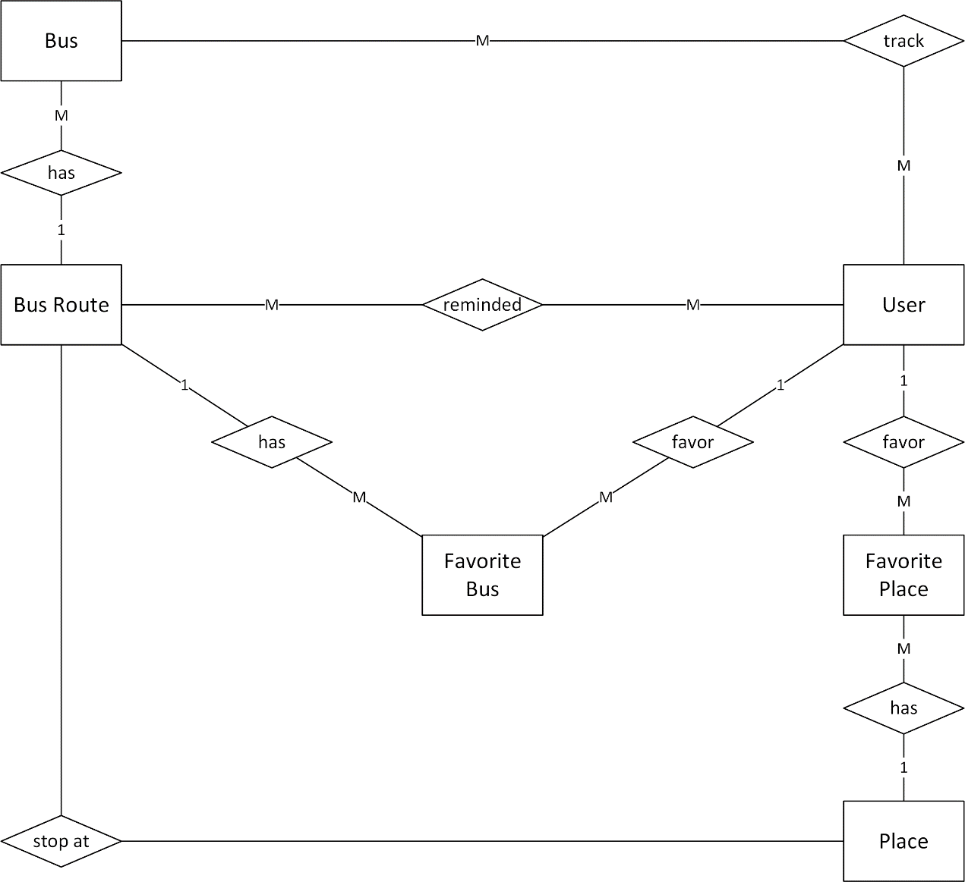

Figure 3-5: Entity Relationship Diagram

#### Entity Detail

##### Bus

|  |  |  |  |  |
| --- | --- | --- | --- | --- |
| **No** | **Field Name** | **Type** | **Mandatory** | **Description** |
| 1 | busID | Text | Y | Bus’s id |
| 2 | busrouteID | Integer | Y | Bus route’s number |
| 3 | busLocationX | Real | Y | Bus’s latitude |
| 4 | busLocationY | Real | Y | Bus’s longitude |
| 5 | busDirection | Text | Y | Bus’s direction |
| 6 | busLicensePlate | Text | Y | Bus license plate |

##### Bus route

|  |  |  |  |  |
| --- | --- | --- | --- | --- |
| **No** | **Field Name** | **Type** | **Mandatory** | **Description** |
|  | busrouteID | Integer | Y | Bus route’s id |
|  | busrouteName | Text | Y | Bus route’s name |
|  | busrouteAway | Text | Y | Bus away route |
|  | busrouteBack | Text | Y | Bus back route |
|  | busrouteStartTime | Text | Y | Bus route start time |
|  | busrouteEndTime | Text | Y | Bus route end time |
|  | busrouteTimeEach | Text | Y | Bus route time between two bus |
|  | busrouteTicketPrice | Integer | Y | Bus route ticket price |
|  | busrouteCompanyInfo | Text | Y | Bus route company info |

##### Bus stop

|  |  |  |  |  |
| --- | --- | --- | --- | --- |
| **No** | **Field Name** | **Type** | **Mandatory** | **Description** |
|  | placeID | Integer | Y | Place id |
|  | busrouteID | Integer | Y | Bus route id |
|  | busstopOrder | Integer | Y | Bus stop order |
|  | busrouteDirection | Text | Y | Bus route direction |

##### Favorite bus

|  |  |  |  |  |
| --- | --- | --- | --- | --- |
| **No** | **Field Name** | **Type** | **Mandatory** | **Description** |
|  | userID | Integer | Y | User’s id |
|  | busrouteID | Integer | Y | Bus route’s id |

##### User

|  |  |  |  |  |
| --- | --- | --- | --- | --- |
| **No** | **Field Name** | **Type** | **Mandatory** | **Description** |
|  | userID | Integer | Y | User’s id |
|  | userEmail | Text | Y | User email |
|  | userPassword | Text | Y | User password |

##### Place

|  |  |  |  |  |
| --- | --- | --- | --- | --- |
| **No** | **Field Name** | **Type** | **Mandatory** | **Description** |
|  | placeID | Integer | Y | Place id |
|  | placeName | Text | Y | Place name |
|  | placeLocationX | Text | Y | Place location X |
|  | placeLocationY | Text | Y | Place location Y |

##### Favorite place

|  |  |  |  |  |
| --- | --- | --- | --- | --- |
| **No** | **Field Name** | **Type** | **Mandatory** | **Description** |
|  | userID | Integer | Y | User id |
|  | placeID | Integer | Y | Place id |
|  | favoritePlaceName | Text | Y | Favorite place name |
|  | favoritePlaceImageID | Integer | Y | Favorite place image id |

##### History

|  |  |  |  |  |
| --- | --- | --- | --- | --- |
| **No** | **Field Name** | **Type** | **Mandatory** | **Description** |
|  | userID | Integer | Y | User id |
|  | historyName | Text | Y | History name |
|  | historyLat | Text | Y | History latitude |
|  | historyLng | Text | Y | History longitude |

##### Track

|  |  |  |  |  |
| --- | --- | --- | --- | --- |
| **No** | **Field Name** | **Type** | **Mandatory** | **Description** |
|  | userID | Integer | Y | User id |
|  | busrouteID | Integer | Y | Bus route ID |
|  | busstopID | Integer | Y | Bus stop ID |

##### Reminder

|  |  |  |  |  |
| --- | --- | --- | --- | --- |
| **No** | **Field Name** | **Type** | **Mandatory** | **Description** |
|  | userID | Integer | Y | User id |
|  | busrouteID | Integer | Y | Bus route ID |
|  | placeID | Integer | Y | Place ID |
|  | reminderTime | Text | Y | Reminder time |
|  | reminderDuration | Text | Y | Reminder duration |
|  | busrouteDirection | Text | Y | Bus route direction |
|  | reminderRecurrence | Text | Y | reminderRecurrence |
|  | reminderRadius | Integer | Y | reminderRadius |
|  | reminderStatus | Text | Y | reminderStatus |

### Functional Specification

#### Account Management Function group

##### Use Case Diagram

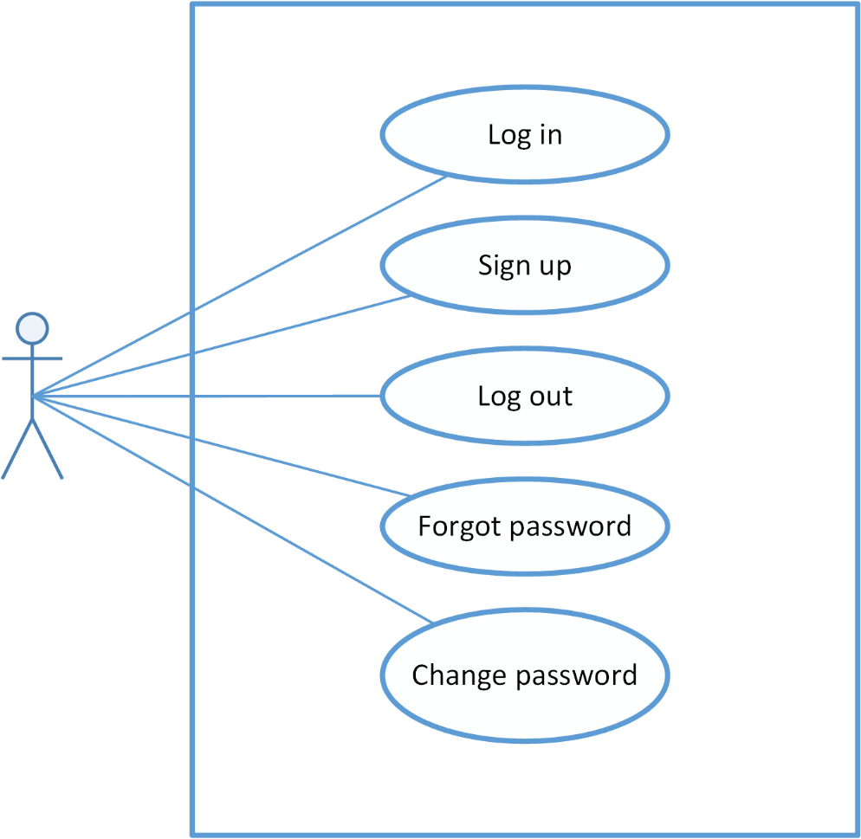

Figure 3-6: Account Management Use Case Diagram

##### Use Case Specification

###### UC001: Login

|  |  |  |  |  |
| --- | --- | --- | --- | --- |
| Use Case ID | | UC001 | **Version** | 1.0 |
| Use Name | | Log in | | |
| Actor | | BUSS User | | |
| Description | | The function allows an user to log in. | | |
| Precondition | | User has registered account but not logged in yet | | |
| Trigger | | User taps “Log in” button | | |
| **Post-Condition** | | “Find Path” screen is shown | | |
| **Main flows** | | | | |
| **Step** | **Actor** | **Action** | | |
| 1 | BUSS User | Opens the Bus lover app | | |
| 2 | BUSS | Displays “Log in” screen | | |
| 3 | BUSS User | Inputs “email” and “password” field, then taps “Log in” button | | |
| 4 | BUSS | Validates information and logs user into app then moves to “Find Path” screen. | | |
|  | | | | |

**Exception**

|  |  |  |
| --- | --- | --- |
| **E1** | At step 3 in the main flows**,** if BUSS User leaves either “email” or “password” field blank then taps “Sign in” button | |
| **Step** | **Actor** | **Action** |
| 4.1 | BUSS | Returns Error message “Email/Password is required” |

|  |  |  |
| --- | --- | --- |
| **E2** | At step 4 in the main flows**,** if BUSS fails to validate email & password | |
| **Step** | **Actor** | **Action** |
| 4.2 | BUSS | Returns Error message “Please enter a correct combination of email and password” |

###### UC002: Sign up

|  |  |  |  |  |
| --- | --- | --- | --- | --- |
| Use Case ID | | UC002 | **Version** | 1.0 |
| Use Name | | Sign up | | |
| Actor | | BUSS User | | |
| Description | | The function allows an user to sign up an account in order to sign in. | | |
| Precondition | | User doesn’t have account | | |
| Trigger | | User taps “Sign up now” button | | |
| Post-Condition | | “Find Path” screen is shown | | |
| **Main flows** | | | | |
| **Step** | **Actor** | **Action** | | |
| 1 | BUSS User | Opens the Bus lover app and tap “Sign up now” button | | |
| 2 | BUSS | Displays “Sign up” screen | | |
| 3 | BUSS User | Inputs “email”, “password” and “confirm password” field, then taps “Accept” button | | |
| 4 | BUSS | Validates information and logs user into app then moves to “Find Path” screen and notify user that “Sign up was completed”. | | |
|  | | | | |

**Exception**

|  |  |  |
| --- | --- | --- |
| **E1** | At step 3 in the main flows**,** if BUSS User leaves either “email” or “password” or “confirm password” blank then taps “Sign in” button | |
| **Step** | **Actor** | **Action** |
| 4.1 | BUSS | Returns Error message “Email/ Password/ Confirm password is required” |

|  |  |  |
| --- | --- | --- |
| **E2** | At step 4 in the main flows**,** if BUSS fails to validate email & password | |
| **Step** | **Actor** | **Action** |
| 4.2 | BUSS | Returns Error message “Please enter a correct combination of email and password” |

|  |  |  |
| --- | --- | --- |
| **E3** | At step 3 in the main flows**,** if BUSS User inputs “password” and “confirm password” field that are not matched, then taps “Sign in” button. | |
| **Step** | **Actor** | **Action** |
| 4.2 | BUSS | Returns Error message “Confirm password is not matched with new password” |

###### UC003: Sign out

|  |  |  |  |  |
| --- | --- | --- | --- | --- |
| **Use Case ID** | | UC003 | **Version** | 1.0 |
| **Use Name** | | Sign out | | |
| **Actor** | | BUSS User | | |
| **Description** | | The function allows user to sign out. | | |
| **Precondition** | | User has signed in. | | |
| **Trigger** | | User taps “Sign out” button | | |
| **Post-Condition** | | “Login” screen is shown | | |
| **Main flows** | | | | |
| **Step** | **Actor** | **Action** | | |
| 1 | BUSS User | Opens Menu and tap Sign out | | |
| 2 | BUSS | Log user out and displays “Log in” screen | | |
|  |  |  | | |
|  |  |  | | |
|  | | | | |

###### UC004: Forgot password

|  |  |  |  |  |
| --- | --- | --- | --- | --- |
| **Use Case ID** | | UC004 | **Version** | 1.0 |
| **Use Name** | | Forgot password | | |
| **Actor** | | BUSS User | | |
| **Description** | | The function allows user to receive their password if they forgot. | | |
| **Precondition** | | User hasn’t logged in | | |
| **Trigger** | | User taps “forgot password” button | | |
| **Post-Condition** | | Displays “Sign in” screen and password is sent to email | | |
| **Main flows** | | | | |
| **Step** | **Actor** | **Action** | | |
| 1 | BUSS User | Enters Bus lover app | | |
| 2 | BUSS | Displays “Sign in” screen | | |
| 3 | BUSS User | Taps “forgot password” button | | |
| 4 | BUSS | Displays “Forgot password” dialog | | |
| 5 | BUSS | Inputs “Email” text field then taps “Send” button | | |
| 6 | BUSS | Validates email and sends password to the inputted email | | |
|  | | | | |

**Alternative scenario**

|  |  |  |
| --- | --- | --- |
| **AT1** | At step 5 in the main flows**,** if BUSS User taps Cancel button | |
| **Step** | **Actor** | **Action** |
| 6.1 | BUSS | Returns Log In screen |

**Exception**

|  |  |  |
| --- | --- | --- |
| **E1** | At step 5 in the main flows**,** if BUSS User leaves email blank | |
| **Step** | **Actor** | **Action** |
| 6.1 | BUSS | Returns Error message “Email is required” |

|  |  |  |
| --- | --- | --- |
| **E2** | At step 6 in the main flows**,** if BUSS failed to validate email | |
| **Step** | **Actor** | **Action** |
| 6.2 | BUSS | Returns popup with Error message “Please enter a correct email” |

###### UC005: Search specialized Japanese

|  |  |  |  |  |
| --- | --- | --- | --- | --- |
| **Use Case ID** | | UC005 | **Version** | 1.0 |
| **Use Name** | | Change password | | |
| **Actor** | | BUSS User | | |
| **Description** | | The function allows user to change his/her account profile info | | |
| **Precondition** | | User has logged in | | |
| **Trigger** | | User taps Change password item | | |
| **Post-Condition** | | Changes account info popup is shown | | |
| **Main flows** | | | | |
| **Step** | **Actor** | **Action** | | |
| 1 | BUSS User | Taps menu button | | |
| 2 | BUSS | Displays Menu | | |
| 3 | BUSS User | Taps Change password item | | |
| 4 | BUSS | Displays Change account info popup | | |
| 5 | BUSS User | Edits “Old Password”, “New Password” and “Confirm password” field then taps Save button | | |
| 6 | BUSS | System will validate and save the changes | | |
|  | | | | |

**Exception**

|  |  |  |
| --- | --- | --- |
| **E1** | At step 5 in the main flows**,** if BUSS User leaves “old password”, “new password” and “confirm password” field blank, then taps “Save” button | |
| **Step** | **Actor** | **Action** |
| 6.1 | BUSS | Returns Error message “Old Password/ New Password/ Confirm password is required” |

|  |  |  |
| --- | --- | --- |
| **E2** | At step 6 in the main flows, if BUSS fails to validate password, then taps “Save” button | |
| **Step** | **Actor** | Action |
| 6.2 | BUSS | Returns Error message “Old password is incorrect” |

|  |  |  |
| --- | --- | --- |
| **E3** | At step 5 in the main flows**,** if BUSS User inputs “new password” and “confirm password” field that are not matched, then taps “Save” button. | |
| **Step** | **Actor** | **Action** |
| 6.3 | BUSS | Returns Error message “Confirm password is not matched with new password” |

#### Common function group

##### Use Case Diagram

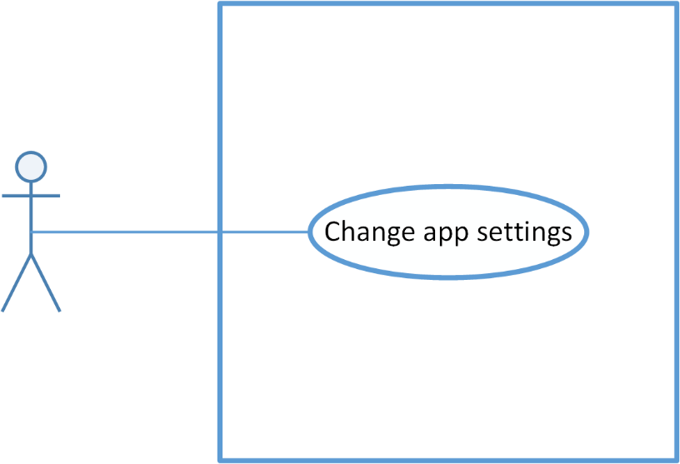

Figure 3-11: Common Use Case Diagram

##### Use Case Specification

###### UC006: Setting

|  |  |  |  |  |
| --- | --- | --- | --- | --- |
| **Use Case ID** | | UC006 | **Version** | 1.0 |
| **Use Name** | | Change app setting | | |
| **Actor** | | BUSS User | | |
| **Description** | | The function allows user to change app setting | | |
| **Precondition** | | User has logged in | | |
| **Trigger** | | User taps Menu then taps Setting item | | |
| **Post-Condition** | | Setting screen is shown | | |
| **Main flows** | | | | |
| **Step** | **Actor** | **Action** | | |
| 1 | BUSS User | Taps “Menu” button then tap “Settings” button | | |
| 2 | BUSS | Displays Settings screen | | |
| 3 | BUSS User | Taps “Language” and “Search nearby range” dropdown to choose an item | | |
| 4 | BUSS | The information of “Language” and “Search nearby range” field are changed | | |
| 5 | BUSS User | Taps Done button | | |
| 6 | BUSS | Saves all edited information | | |
|  | | | | |

**Alternative scenario**

|  |  |  |
| --- | --- | --- |
| **AT1** | At step 3 in the main flows**,** if BUSS User doesn’t change anything and taps Done button | |
| **Step** | **Actor** | **Action** |
| 4.1 | BUSS | Nothing is changed |

#### Bus function group

##### Use case diagram

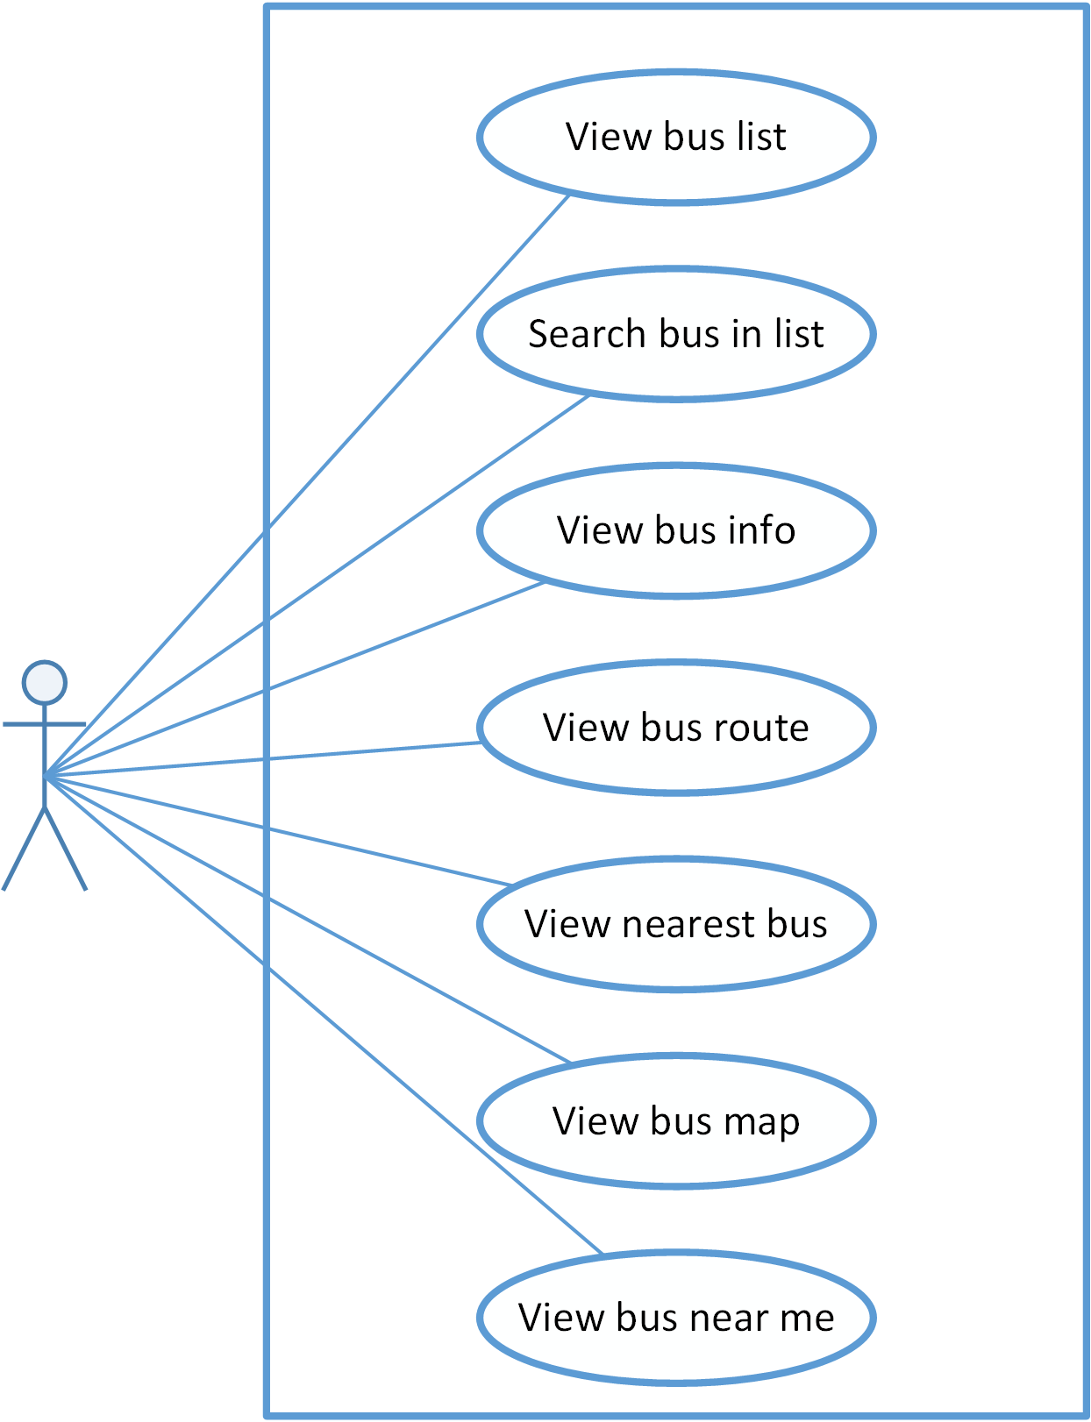

Figure 3-14: Bus function group Use Case Diagram

##### Use Case Specification

###### UC007: View Bus List

|  |  |  |  |  |
| --- | --- | --- | --- | --- |
| **Use Case ID** | | UC007 | **Version** | 1.0 |
| **Use Name** | | View bus list | | |
| **Actor** | | BUSS User | | |
| **Description** | | The function allows user to view bus list. | | |
| **Precondition** | | User has logged in | | |
| **Trigger** | | User taps Menu then taps Bus List item | | |
| **Post-Condition** | | Bus List screen is displayed | | |
| **Main flows** | | | | |
| **Step** | **Actor** | **Action** | | |
| 1 | BUSS User | Taps on Menu then taps on “Bus list” item | | |
| 2 | BUSS | Displays “Bus list” screen | | |
|  | | | | |

###### UC008: Search bus in list

|  |  |  |  |  |
| --- | --- | --- | --- | --- |
| **Use Case ID** | | UC008 | **Version** | 1.0 |
| **Use Name** | | Search bus in list | | |
| **Actor** | | BUSS User | | |
| **Description** | | The function allows a user to search bus in the bus list. | | |
| **Precondition** | | Bus List screen displayed | | |
| **Trigger** | | User taps Search button | | |
| **Post-Condition** | | Displays the bus results | | |
| **Main flows** | | | | |
| **Step** | **Actor** | **Action** | | |
| 1 | BUSS User | Taps on Search button on the top of screen | | |
| 2 | BUSS | Displays Search form on Search bar | | |
| 3 | BUSS User | Inputs search keyword | | |
| 4 | BUSS | Searches and displays results | | |
|  | | | | |

**Exception**

|  |  |  |
| --- | --- | --- |
| **E1** | At step 4 in the main flows**,** if BUSS doesn’t find any item that is matched with search keyword | |
| **Step** | **Actor** | **Action** |
| 4.1 | BUSS | Displays blank sreen |

###### UC009: View Bus Info

|  |  |  |  |  |
| --- | --- | --- | --- | --- |
| **Use Case ID** | | UC009 | **Version** | 1.0 |
| **Use Name** | | View bus info | | |
| **Actor** | | BUSS User | | |
| **Description** | | The function allows a user to view all information of a bus. | | |
| **Precondition** | | Bus List screen displayed | | |
| **Trigger** | | User taps on one bus | | |
| **Post-Condition** | | Bus Detail screen displayed | | |
| **Main flows** | | | | |
| **Step** | **Actor** | **Action** | | |
| 1 | BUSS User | Taps on a bus item. | | |
| 2 | BUSS | Displays Bus Detail screen – Info tab. | | |
|  | | | | |

###### UC010: View Bus Route

|  |  |  |  |  |
| --- | --- | --- | --- | --- |
| **Use Case ID** | | UC010 | **Version** | 1.0 |
| **Use Name** | | View bus route | | |
| **Actor** | | BUSS User | | |
| **Description** | | The function allows a user to view route of a chosen bus. | | |
| **Precondition** | | Bus Detail screen displayed | | |
| **Trigger** | | User taps on Route tab | | |
| **Post-Condition** | | Route tab of Bus Detail displayed | | |
| **Main flows** | | | | |
| **Step** | **Actor** | **Action** | | |
| 1 | BUSS User | Taps on Route tab on the Bus Detail screen. | | |
| 2 | BUSS | Displays Bus Detail screen with the Route tab. | | |
|  | | | | |

###### UC011: View nearest Bus

|  |  |  |  |  |
| --- | --- | --- | --- | --- |
| **Use Case ID** | | UC011 | **Version** | 1.0 |
| **Use Name** | | View nearest bus | | |
| **Actor** | | BUSS User | | |
| **Description** | | The function allows a user to view all nearest bus of the chosen bus route. | | |
| **Precondition** | | Bus Detail screen displayed | | |
| **Trigger** | | User taps on Nearest tab | | |
| **Post-Condition** | | Bus Detail tab Nearest displayed | | |
| **Main flows** | | | | |
| **Step** | **Actor** | **Action** | | |
| 1 | BUSS User | Taps on Nearest tab on the Bus Detail screen. | | |
| 2 | BUSS | Displays Bus Detail screen with the Nearest tab. | | |
|  | | | | |

###### UC012: View Bus Map

|  |  |  |  |  |
| --- | --- | --- | --- | --- |
| **Use Case ID** | | UC012 | **Version** | 1.0 |
| **Use Name** | | View bus map | | |
| **Actor** | | BUSS User | | |
| **Description** | | The function allows a user to view route of a chosen bus on the map. | | |
| **Precondition** | | Bus Detail screen displayed | | |
| **Trigger** | | User taps on Map tab | | |
| **Post-Condition** | | Bus Detail tab Map displayed | | |
| **Main flows** | | | | |
| **Step** | **Actor** | **Action** | | |
| 1 | BUSS User | Taps on Map tab on the Bus Detail screen. | | |
| 2 | BUSS | Displays Bus Detail screen with the Map tab. | | |
|  | | | | |

###### UC013: View Bus near Me

|  |  |  |  |  |
| --- | --- | --- | --- | --- |
| **Use Case ID** | | UC013 | **Version** | 1.0 |
| **Use Name** | | View bus near me | | |
| **Actor** | | BUSS User | | |
| **Description** | | The function allows a user to view all buses near his/her current location. | | |
| **Precondition** | | User has logged in | | |
| **Trigger** | | User taps Bus near me button | | |
| **Post-Condition** | | Bus near me screen displayed | | |
| **Main flows** | | | | |
| **Step** | **Actor** | **Action** | | |
| 1 | BUSS User | Taps on Bus near me button. | | |
| 2 | BUSS | Displays Bus near me screen. | | |
| 3 | BUSS User | Taps on Bus route button | | |
| 4 | BUSS | Displays buses of the chosen bus route | | |
| 5 | BUSS User | Taps on Bus icon on map | | |
| 6 | BUSS | Displays info window with:   * the distance from bus to the nearest bus-stop * the “Detail” link | | |
| 7 | BUSS User | Taps “Detail” link | | |
| 8 | BUSS | Displays details of the chosen bus in Bus Detail screen | | |
|  | | | | |

#### Path function group

##### Use case diagram

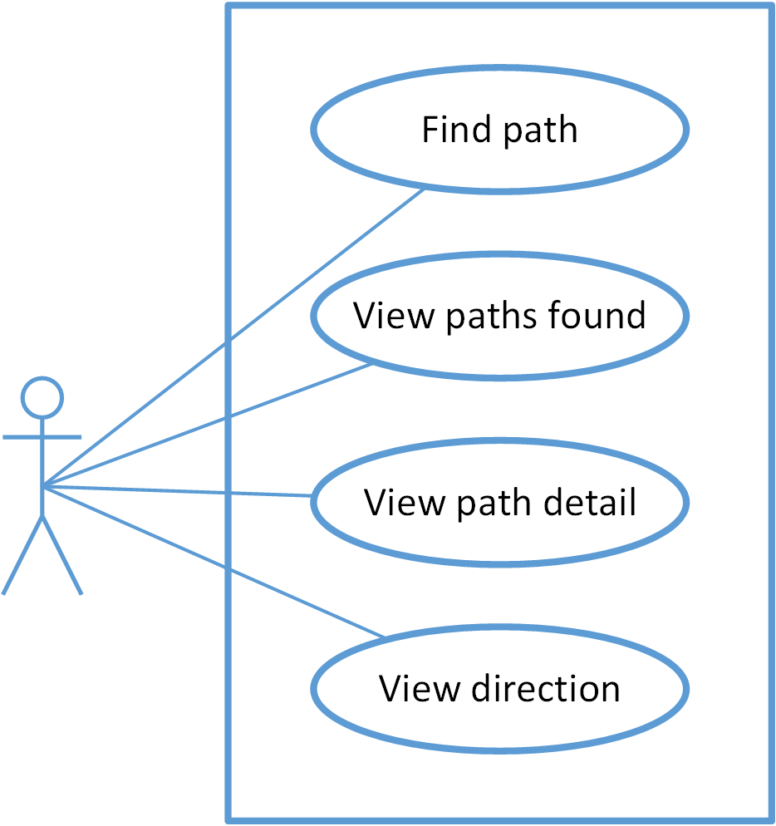

Figure 3-22: Path function group Use Case Diagram

##### Use case specification

###### UC014: Find Path

|  |  |  |  |  |
| --- | --- | --- | --- | --- |
| **Use Case ID** | | UC014 | **Version** | 1.0 |
| **Use Name** | | Find path | | |
| **Actor** | | BUSS User | | |
| **Description** | | The function allows an user to find path | | |
| **Precondition** | | User has logged in | | |
| **Trigger** | | User taps “Path finder” item on Menu | | |
| **Post-Condition** | | “Path finder” screen is shown | | |
| **Main flows** | | | | |
| **Step** | **Actor** | **Action** | | |
| 1 | BUSS User | Taps “Path finder” item on menu | | |
| 2 | BUSS | Display “Path finder” screen | | |
| 3 | BUSS User | In “Map” tab, inputs departure into “from” text field and destination into “to” text field then taps Search button | | |
| 4 | BUSS | Searches and displays found paths | | |
|  | | | | |

**Alternative scenario**

|  |  |  |
| --- | --- | --- |
| **AT1** | At step 3 in the main flows**,** if BUSS User inputs “from” and “to” text field then taps Revert direction button then taps Search button | |
| **Step** | **Actor** | **Action** |
| 4.1 | BUSS | Swaps 2 locations then searches and displays found paths |

|  |  |  |
| --- | --- | --- |
| **AT2** | At step 3 in the main flows**,** in “Map” tab, if BUSS User taps “Get current location” button in order to input “from” or “to” text field and inputs the other text field then taps Search button | |
| **Step** | **Actor** | **Action** |
| 4.2 | BUSS | Returns user’s current location into that text field then searches and displays found paths |

|  |  |  |
| --- | --- | --- |
| **AT3** | At step 3 in the main flows**,** in “Map” tab, if BUSS User chooses locations on map in order to input “from” and “to” text field then taps Search button | |
| **Step** | **Actor** | **Action** |
| 4.3 | BUSS | Returns locations into “from” and “to” text field then searches and displays found paths |

|  |  |  |
| --- | --- | --- |
| **AT4** | At step 3 in the main flows**,** if BUSS User taps “History” tab then chooses places for “from”/ “to” text field then taps Search button | |
| **Step** | **Actor** | **Action** |
| 4.4 | BUSS | Displays places which were found before then searches and displays found paths |

|  |  |  |
| --- | --- | --- |
| **AT5** | At step 3 in the main flows**,** if BUSS User taps “Favorite” tab then chooses places for “from”/ “to” text field then taps Search button | |
| **Step** | **Actor** | **Action** |
| 4.5 | BUSS | Displays favorite places which were set before then searches and displays found paths |

**Exception**

|  |  |  |
| --- | --- | --- |
| **E1** | At step 3 in the main flows**,** if BUSS User inputs a place, which doesn’t exist, into “from”/ “to” text field then taps Search button | |
| **Step** | **Actor** | **Action** |
| 4.1 | BUSS | Returns popup with Error message “from/ to is not exist” |

|  |  |  |
| --- | --- | --- |
| **E2** | At step 3 in the main flows**,** if BUSS User leaves “from”/ “to” text field blank then taps Search button | |
| **Step** | **Actor** | **Action** |
| 4.2 | BUSS | Returns popup with Error message “Please input both from and to field” |

|  |  |  |
| --- | --- | --- |
| **E3** | At step 3 in the main flows**,** if BUSS User inputs “from” and “to” text field then taps Search button without Internet | |
| **Step** | **Actor** | **Action** |
| 4.3 | BUSS | Returns popup with Error message “No connection” |

###### UC015: View path found

|  |  |  |  |  |
| --- | --- | --- | --- | --- |
| **Use Case ID** | | UC015 | **Version** | 1.0 |
| **Use Name** | | View path found | | |
| **Actor** | | BUSS User | | |
| **Description** | | The function allows an user to view path found | | |
| **Precondition** | | “Path Finder” screen displayed | | |
| **Trigger** | | User taps Search button | | |
| **Post-Condition** | | “Paths Found” screen is shown | | |
| **Main flows** | | | | |
| **Step** | **Actor** | **Action** | | |
| 1 | BUSS User | Enters “Path Finder” screen, inputs informations and taps Search button | | |
| 2 | BUSS | * Searches and displays list of found paths in “Paths found” screen. * “from”/ “to” text field and Revert direction button will be disable. * A path will show the following information: total distance , walking distance, the number of exchange | | |
| 3 | BUSS User | Taps “Shortest” tab | | |
| 4 | BUSS | Displays list paths found by filter: shortest | | |
|  | | | | |

**Alternative scenario**

|  |  |  |
| --- | --- | --- |
| **AT1** | At step 3 in the main flows**,** if BUSS User taps “Least Exc ” tab | |
| **Step** | **Actor** | **Action** |
| 4.1 | BUSS | Displays list paths found by filter: least exchange |

|  |  |  |
| --- | --- | --- |
| **AT2** | At step 3 in the main flows**,** in “Map” tab, if BUSS User taps “Least walk” tab | |
| **Step** | **Actor** | **Action** |
| 4.2 | BUSS | Displays list paths found by filter: least walk |

###### UC016: View Path Detail

|  |  |  |  |  |
| --- | --- | --- | --- | --- |
| **Use Case ID** | | UC016 | **Version** | 1.0 |
| **Use Name** | | View path details | | |
| **Actor** | | BUSS User | | |
| **Description** | | The function allows an user to view path detail | | |
| **Precondition** | | “Path Found” screen displayed | | |
| **Trigger** | | User taps one path | | |
| **Post-Condition** | | “Path Details” screen is shown | | |
| **Main flows** | | | | |
| **Step** | **Actor** | **Action** | | |
| 1 | BUSS User | In “Path Found” screen, chooses a path | | |
| 2 | BUSS | Displays “Path Details” screen and shows:   * The chosen path on the map * The bus which is nearest from the departure location will also be shown on the path draw.This bus will show how far from bus to nearest bus-stop that is from departure location. * The nearest bus-stop from departure and the nearest bus-stop from destination | | |
|  | | | | |

**Alternative scenario**

|  |  |  |
| --- | --- | --- |
| **AT1** | After step 2 in the main flows**,** if BUSS User taps “Arrow up” button | |
| **Step** | **Actor** | **Action** |
| 3.1 | BUSS | Displays Path Details 2 screen with the list: how far walk, which bus to get on... |

###### UC017: View Direction

|  |  |  |  |  |
| --- | --- | --- | --- | --- |
| **Use Case ID** | | UC017 | **Version** | 1.0 |
| **Use Name** | | View direction | | |
| **Actor** | | BUSS User | | |
| **Description** | | The function allows an user to view path direction | | |
| **Precondition** | | “Path Detail” screen displayed | | |
| **Trigger** | | User taps “Navigate” button | | |
| **Post-Condition** | | “Direction” screen is shown | | |
| **Main flows** | | | | |
| **Step** | **Actor** | **Action** | | |
| 1 | BUSS User | In “Path Detail” screen, taps “Arrow up” button | | |
| 2 | BUSS | Displays “Path Detail” screen | | |
| 3 | BUSS User | Taps “Navigate” button | | |
| 4 | BUSS | Shows step-by-step detailed direction according to the user’s current location. | | |
|  | | | | |

#### Reminder function group

##### Use case diagram

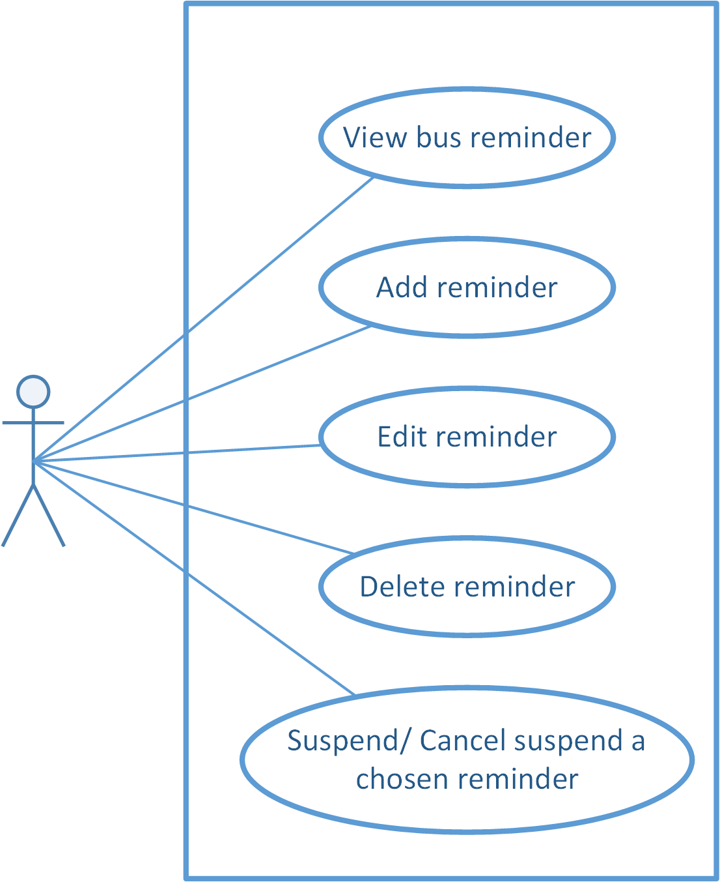

Figure 3-30: Reminder function group Use Case Diagram

##### Use case specifications

###### UC018: View Bus Reminder

|  |  |  |  |  |
| --- | --- | --- | --- | --- |
| **Use Case ID** | | UC018 | **Version** | 1.0 |
| **Use Name** | | View bus reminder | | |
| **Actor** | | BUSS User | | |
| **Description** | | The function allows an user to view bus reminders | | |
| **Precondition** | | User has logged in | | |
| **Trigger** | | User taps “Reminders” button | | |
| **Post-Condition** | | “Bus Reminder” screen is shown | | |
| **Main flows** | | | | |
| **Step** | **Actor** | **Action** | | |
| 1 | BUSS User | Taps “Reminders” button | | |
| 2 | BUSS | Displays “Bus Reminder” screen and shows list of reminders and the next reminder. If there isn’t any reminder, system will show message “There aren’t any reminders” | | |
|  | | | | |

**Alternative scenario**

|  |  |  |
| --- | --- | --- |
| **AT1** | At step 1 in the main flows**,** if BUSS User taps Menu and chooses “Bus reminder” item | |
| **Step** | **Actor** | **Action** |
| 2.1 | BUSS | Displays “Bus Reminder” screen and shows list of reminder and the next reminder. If there isn’t any reminder, system will show message “There aren’t any reminders” |

###### UC019: Add reminder

|  |  |  |  |  |
| --- | --- | --- | --- | --- |
| **Use Case ID** | | UC019 | **Version** | 1.0 |
| **Use Name** | | Add reminder | | |
| **Actor** | | BUSS User | | |
| **Description** | | The function allows an user to add reminder | | |
| **Precondition** | | User has logged in | | |
| **Trigger** | | User taps “Add” button | | |
| **Post-Condition** | | “Bus reminder” screen is shown | | |
| **Main flows** | | | | |
| **Step** | **Actor** | **Action** | | |
| 1 | BUSS User | Taps Menu and choose “Bus reminder” item then taps “Add” button. | | |
| 2 | BUSS | Displays “Add reminder” screen | | |
| 3 | BUSS User | Inputs “Time” field | | |
| 4 | BUSS | Shows inputted time in “Time” field | | |
| 5 | BUSS User | Taps “Bus route” button | | |
| 6 | BUSS | Displays Bus List | | |
| 7 | BUSS User | Chooses a bus item in Bus list | | |
| 8 | BUSS | Return Add Reminder screen and shows the chosen bus in “Bus route” button | | |
| 9 | BUSS User | Taps “Departure” field | | |
| 10 | BUSS | Shows Departure dropdown list with 2 options: Favorite Place and Other Place. | | |
| 11 | BUSS User | Chooses Favorite Place item in list | | |
| 12 | BUSS | Displays Favorite Place screen | | |
| 13 | BUSS User | Chooses a place | | |
| 14 | BUSS | Return Add Reminder screen and shows the chosen place in “Departure” field. | | |
| 15 | BUSS User | Taps “Direction” field then chooses an item in Direction dropdown list | | |
| 16 | BUSS | Shows the chosen item in “Direction” field. | | |
| 17 | BUSS User | Taps “Recurrence” field, chooses days in Recurrence check box list | | |
| 18 | BUSS | Shows the chosen days in “Recurrence” field | | |
| 19 | BUSS User | Taps “Time Interval” field, chooses an item in Time Interval dropdown list | | |
| 20 | BUSS | Shows the chosen item in “Time Interval” field | | |
| 21 | BUSS User | Taps “Reminder distance” field then chooses an item in Reminder distance dropdown list | | |
| 22 | BUSS | Shows the chosen item in “Reminder distance” field. | | |
| 23 | BUSS User | Taps “Add Reminder” button | | |
| 24 | BUSS | Saves reminder and displays “Reminder set done” screen | | |
| 25 | BUSS User | Taps “Done” button | | |
| 26 | BUSS | Returns “Bus reminder” screen. This reminder will be shown in Bus Reminders list and its Suspend switch will turn into ON status | | |
|  | | | | |

**Alternative scenario**

|  |  |  |
| --- | --- | --- |
| **AT1** | At step 1 in the main flows**,** if BUSS User enters “Bus List” screen and chooses a bus from list, then taps “Add Reminder” button | |
| **Step** | **Actor** | **Action** |
| 2.1 | BUSS | Displays Add Reminders screen. |

|  |  |  |
| --- | --- | --- |
| **AT2** | At step 11 in the main flows**,** if BUSS User chooses Other Place item in list | |
| **Step** | **Actor** | **Action** |
| 12.2 | BUSS | Displays “Search Place” screen |

|  |  |  |
| --- | --- | --- |
| **AT3** | At step 25 in the main flows**,** if BUSS User taps “Add other reminder” button | |
| **Step** | **Actor** | **Action** |
| 26.3 | BUSS | Displays “Add Reminder” screen |

|  |  |  |
| --- | --- | --- |
| **AT4** | At step 19, if BUSS taps on Help button in “Time Interval” field | |
| **Step** | **Actor** | **Action** |
| 20.4 | BUSS | Displays Tooltip :”Time interval to be notified in ...” |

|  |  |  |
| --- | --- | --- |
| **AT5** | At step 21, if BUSS taps on Help button in “Reminder distance” field | |
| **Step** | **Actor** | **Action** |
| 22.5 | BUSS | Displays Tooltip :”Reminder will notify you when the chosen bus is about to your nearest bus-stop” |

|  |  |  |
| --- | --- | --- |
| **AT6** | From step 3 to step 23, if BUSS User inputs only “Departure” field then taps “Add Reminder” button | |
| **Step** | **Actor** | **Action** |
| 24.6 | BUSS | Saves reminder with inputted “Departure” field and others default info |

**Exception**

|  |  |  |
| --- | --- | --- |
| **E1** | At step 9 in the main flows**,** if BUSS User leaves “departure” text field blank, then taps Add button | |
| **Step** | **Actor** | **Action** |
| 14.1 | BUSS | Skips from step 10 to step 13 and returns Error message “Departure is required” |

###### UC020: Edit reminder

|  |  |  |  |  |
| --- | --- | --- | --- | --- |
| **Use Case ID** | | UC020 | **Version** | 1.0 |
| **Use Name** | | Edit reminder | | |
| **Actor** | | BUSS User | | |
| **Description** | | The function allows an user to edit reminder | | |
| **Precondition** | | “Bus Reminder” screen displayed | | |
| **Trigger** | | User taps on one Reminder | | |
| **Post-Condition** | | “Edit Reminder” screen is shown | | |
| **Main flows** | | | | |
| **Step** | **Actor** | **Action** | | |
| 1 | BUSS User | Taps on one Reminder | | |
| 2 | BUSS | Displays “Edit Reminder” screen | | |
| 3 | BUSS User | Edits “Time”, “Destination” , “Direction”, “Recurrence”, “Time Interval” and “Reminder distance” field then taps “Save” button | | |
| 4 | BUSS | Saves reminder and displays “Reminder set done” screen | | |
| 5 | BUSS User | Taps “Done” button | | |
| 6 | BUSS | Returns “Bus reminder” screen. This reminder will be shown in Bus Reminders list and its Suspend switch will turn into ON status | | |
|  | | | | |

**Alternative scenario**

|  |  |  |
| --- | --- | --- |
| **AT1** | At step 3 in the main flows**,** if BUSS User taps “Save” button without editing any fields | |
| **Step** | **Actor** | **Action** |
| 4.1 | BUSS | Saves reminder and displays “Reminder set done” screen |

**Exception**

|  |  |  |
| --- | --- | --- |
| **E1** | At step 3 in the main flows**,** if BUSS User leaves “Destination” text field blank, then taps “Save” button | |
| **Step** | **Actor** | **Action** |
| 4.1 | BUSS | Returns Error message “Destination is required” |

###### UC021: Delete reminder

|  |  |  |  |  |
| --- | --- | --- | --- | --- |
| **Use Case ID** | | UC0023 | **Version** | 1.0 |
| **Use Name** | | Delete reminder | | |
| **Actor** | | BUSS User | | |
| **Description** | | The function allows an user to delete reminder | | |
| **Precondition** | | “Bus Reminder” screen displayed | | |
| **Trigger** | | User taps on one Reminder then taps “Delete” button | | |
| **Post-Condition** | | “Bus Reminder” screen is shown without deleted Reminder | | |
| **Main flows** | | | | |
| **Step** | **Actor** | **Action** | | |
| 1 | BUSS User | Taps on one Reminder | | |
| 2 | BUSS | Displays “Edit Reminder” screen | | |
| 3 | BUSS User | Taps “Delete” button | | |
| 4 | BUSS | Displays “Confirm delete” dialog. | | |
| 5 | BUSS User | Taps “OK” button | | |
| 6 | BUSS | Deletes this reminder and comes back to Bus Reminder screen. | | |
|  | | | | |

**Alternative scenario**

|  |  |  |
| --- | --- | --- |
| **AT1** | At step 5 in the main flows**,** if BUSS User taps “Cancel” button. | |
| **Step** | **Actor** | **Action** |
| 6.1 | BUSS | Do not delete anything and returns to Reminder Detail screen |

###### UC022: Suspend/ Cancel suspend a chosen reminder

|  |  |  |  |  |
| --- | --- | --- | --- | --- |
| **Use Case ID** | | UC0025 | **Version** | 1.0 |
| **Use Name** | | Suspend/Cancel suspend a chosen reminder | | |
| **Actor** | | BUSS User | | |
| **Description** | | The function allows an user to suspend/Cancel suspend a chosen reminder | | |
| **Precondition** | | “Bus Reminder” screen displayed, “Suspend” switch button is OFF | | |
| **Trigger** | | User taps “Suspend” button | | |
| **Post-Condition** | | “Suspend” switch button turn from OFF to ON/ON to OFF | | |
| **Main flows** | | | | |
| **Step** | **Actor** | **Action** | | |
| 1 | BUSS User | Taps “Suspend” switch button | | |
| 2 | BUSS | Suspends that reminder | | |
| 3 | BUSS User | Taps “Suspend” switch button again | | |
| 4 | BUSS | Cancel suspends that reminder | | |
|  | | | | |

#### Track

##### Use case diagram

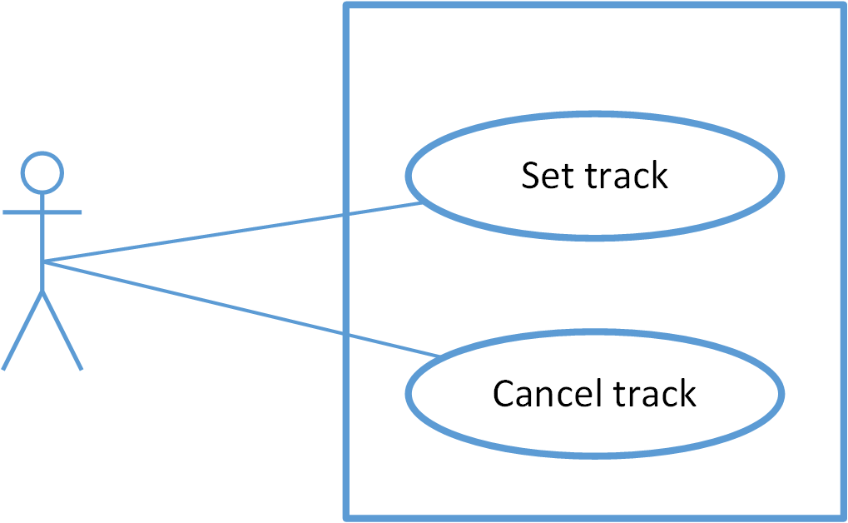

Figure 3-35: Track

##### Screen description

##### Use case specifications

###### UC023: Track

|  |  |  |  |  |
| --- | --- | --- | --- | --- |
| **Use Case ID** | | UC023 | **Version** | 1.0 |
| **Use Name** | | Set track | | |
| **Actor** | | BUSS User | | |
| **Description** | | The function allows an user to set track | | |
| **Precondition** | | User has logged in | | |
| **Trigger** | | User taps on “Set tracker” button | | |
| **Post-Condition** | | “Track” switch button turn from OFF to ON | | |
| **Main flows** | | | | |
| **Step** | **Actor** | **Action** | | |
| 1 | BUSS User | In Bus Detail screen, taps “Set tracker” button | | |
| 2 | BUSS | Displays “Set Tracker” screen | | |
| 3 | BUSS User | Taps on one bus stop | | |
| 4 | BUSS | “Track” button changes into “Cancel Track” button (See in Figure 3-36). When the bus comes near the predefined stop, system will notify the user to leave | | |
|  | | | | |

**Alternative scenario**

|  |  |  |
| --- | --- | --- |
| **AT1** | At step 1 in the main flows**,** if BUSS User taps “Set tracker” button in Path Detail screen | |
| **Step** | **Actor** | **Action** |
| 2.1 | BUSS | Displays “Set Tracker” screen |

**Exception**

|  |  |  |
| --- | --- | --- |
| **E1** | At step 3 in the main flows**,** if BUSS User doesn’t choose any bus stop then taps “Track” switch | |
| **Step** | **Actor** | **Action** |
| 4.1 | BUSS | Returns Error message “Choose a bus stop to get off” |

|  |  |  |  |  |  |  |  |
| --- | --- | --- | --- | --- | --- | --- | --- |
| **No** | **Field name** | **Field name in Vietnamese** | **Type** | **Require** | **Mandatory** | **Length** | **Description** |
| 1 | Cancel track | Hủy theo dõi | Button | Click | Y |  | User taps on Cancel track button |
| 2 | Reverse | Đảo chiều | Button | Click | Y |  | User taps on Revert button to reverse direction |
| 3 | Bus stop | Trạm dừng | List item | Click | Y |  | User taps on Bus stop item to choose where to stop. |
| 2 | Back | Quay lại | Button | Click | Y |  | User taps on Back button to go back |

###### UC024: Cancel track

|  |  |  |  |  |
| --- | --- | --- | --- | --- |
| **Use Case ID** | | UC024 | **Version** | 1.0 |
| **Use Name** | | Cancel track | | |
| **Actor** | | BUSS User | | |
| **Description** | | The function allows an user to cancel track | | |
| **Precondition** | | “Set Tracker” screen displayed and “Track” switch is ON | | |
| **Trigger** | | User taps on “Track” switch | | |
| **Post-Condition** | | “Track” switch turn from ON to OFF | | |
| **Main flows** | | | | |
| **Step** | **Actor** | **Action** | | |
| 1 | BUSS User | Taps “Track” switch | | |
| 2 | BUSS | Cancels tracker and “Track” switch turn from ON to OFF | | |
|  | | | | |

#### Favorites function group

##### Use case diagram

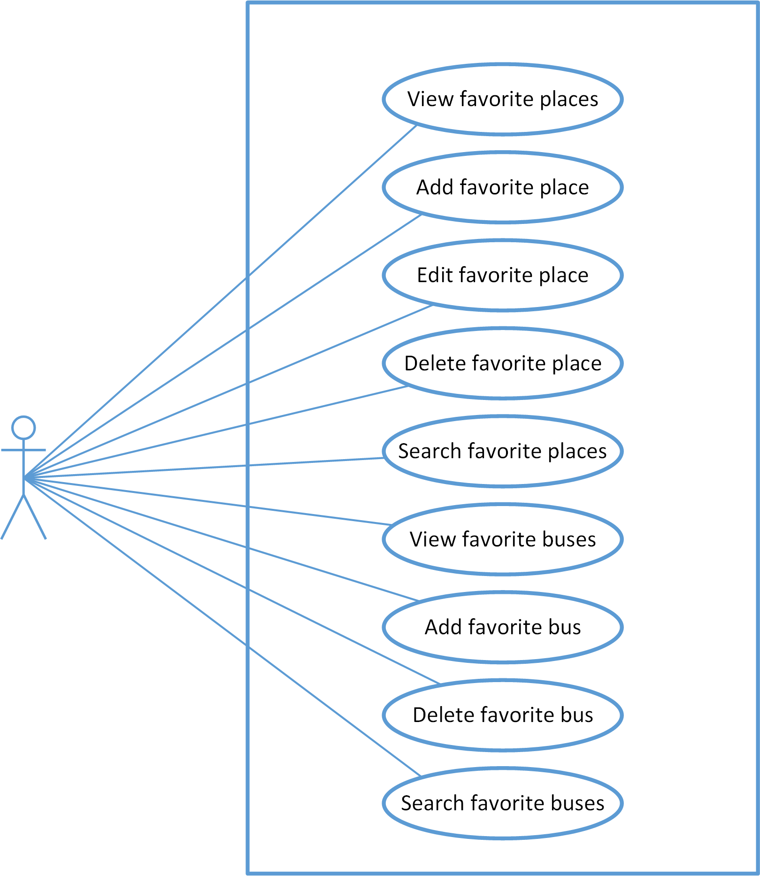

Figure 3-37: Favorite function group Use Case Diagram

##### Use case specifications

###### UC025: View favorite place

|  |  |  |  |  |
| --- | --- | --- | --- | --- |
| **Use Case ID** | | UC025 | **Version** | 1.0 |
| **Use Name** | | View favorite place | | |
| **Actor** | | BUSS User | | |
| **Description** | | The function allows a user to view the favorite place list he/she added before. | | |
| **Precondition** | | User has logged in | | |
| **Trigger** | | User taps Favorite item on Menu | | |
| **Post-Condition** | | “Favorite Places” screen displayed | | |
| **Main flows** | | | | |
| **Step** | **Actor** | **Action** | | |
| 1 | BUSS User | Taps Menu then taps Favorite item | | |
|  | | | | |

###### UC026: Add favorite place

|  |  |  |  |  |
| --- | --- | --- | --- | --- |
| **Use Case ID** | | UC026 | **Version** | 1.0 |
| **Use Name** | | Add favorite place | | |
| **Actor** | | BUSS User | | |
| **Description** | | The function allows a user to add the favorite place he/she cares. | | |
| **Precondition** | | Favorite Place screen displayed | | |
| **Trigger** | | User taps on Add button | | |
| **Post-Condition** | | Favorite Place screen displayed (new place added) | | |
| **Main flows** | | | | |
| **Step** | **Actor** | **Action** | | |
| 1 | BUSS User | Taps on Add button. | | |
| 2 | BUSS | Displays “Place Search” screen with blank info | | |
| 3 | BUSS User | Enters the place User want to search into the input form. | | |
| 4 | BUSS | Searches and display a list of place which has name like the key word. | | |
| 5 | BUSS User | Taps on Place item on search result | | |
| 6 | BUSS | Displays “Add Favorite Place” screen, and shows the chosen place | | |
| 7 | BUSS User | Enters “Name alias” text field and chooses icon then taps “Done” | | |
| 8 | BUSS | Returns “Favorite Place” screen. The chosen place will be added in the favorite place list. | | |
|  | | | | |

**Alternative scenario**

|  |  |  |
| --- | --- | --- |
| **AT1** | At step 3 in the main flows**,** if BUSS User chooses a place on map | |
| **Step** | **Actor** | **Action** |
| 4.1 | BUSS | Shows this place on Input place text field |
| 5.1 | BUSS User | Taps on Confirm button |

|  |  |  |
| --- | --- | --- |
| **AT2** | At step 3 in the main flows**,** if User taps Current location button | |
| **Step** | **Actor** | **Action** |
| 4.2 | BUSS | Gets current location and displays its coordinates |
| 5.2 | BUSS User | Taps on Confirm button |

**Exception**

|  |  |  |
| --- | --- | --- |
| **E1** | At step 4 in the main flows**,** if BUSS enters the place which doesn’t exit | |
| **Step** | **Actor** | **Action** |
| 4.1 | BUSS | Returns message “No search result for”...” ” |

###### UC027: Edit favorite place

|  |  |  |  |  |
| --- | --- | --- | --- | --- |
| **Use Case ID** | | UC027 | **Version** | 1.0 |
| **Use Name** | | Edit favorite place | | |
| **Actor** | | BUSS User | | |
| **Description** | | The function allows a user to edit the favorite place in the list. | | |
| **Precondition** | | Favorite Place screen displayed | | |
| **Trigger** | | User taps on one place | | |
| **Post-Condition** | | Favorite Place screen displayed (place edited) | | |
| **Main flows** | | | | |
| **Step** | **Actor** | **Action** | | |
| 1 | BUSS User | Taps on a favorite place. | | |
| 2 | BUSS | Displays Edit Favorite Place screen with information about it. | | |
| 3 | BUSS User | Edit favorite place’s name | | |
| 4 | BUSS | Displays edited name | | |
| 5 | BUSS User | Taps on favorite place’s location | | |
| 6 | BUSS | Displays Search Place screen | | |
| 7 | BUSS User | Edits location | | |
| 8 | BUSS | Gets that location and displays its coordinates | | |
| 9 | BUSS User | Taps Done button | | |
| 10 | BUSS | Displays Favorite Place screen with edited info | | |
|  | | | | |

**Alternative flows**

|  |  |  |
| --- | --- | --- |
| **AT1** | At step 7 on main scenario, if User taps Current location button | |
| **Step** | **Actor** | **Action** |
| 8.2 | BUSS | Gets current location and displays its coordinates |

|  |  |  |
| --- | --- | --- |
| **AT2** | At step 3 in the main flows**,** if BUSS User chooses a place on map | |
| **Step** | **Actor** | **Action** |
| 4.2 | BUSS | Shows this place on Input place text field |
| 5.2 | BUSS User | Taps on Confirm button |

**Exception**

|  |  |  |
| --- | --- | --- |
| **E1** | At step 4 in the main flows**,** if BUSS enters the place which doesn’t exit | |
| **Step** | **Actor** | **Action** |
| 4.1 | BUSS | Returns message “No search result for”...” ” |

###### UC028: Delete favorite place

|  |  |  |  |  |
| --- | --- | --- | --- | --- |
| **Use Case ID** | | UC028 | **Version** | 1.0 |
| **Use Name** | | Delete favorite place | | |
| **Actor** | | BUSS User | | |
| **Description** | | The function allows a user to delete the favorite place if he/she does not need anymore. | | |
| **Precondition** | | Favorite Place screen displayed | | |
| **Trigger** | | User taps on Delete button then taps Yes button | | |
| **Post-Condition** | | Displays Favorite Place screen (chosen place deleted) | | |
| **Main flows** | | | | |
| **Step** | **Actor** | **Action** | | |
| 1 | BUSS User | Taps on Delete button | | |
| 2 | BUSS | Displays Delete confirm notice | | |
| 3 | BUSS User | Taps on “OK” button | | |
| 4 | BUSS | Deletes this place from database and displays Favorite Place screen | | |
|  | | | | |

**Alternative scenario**

|  |  |  |
| --- | --- | --- |
| **AT1** | At step 3 in the main flows**,** if BUSS User taps “Cancel” button. | |
| **Step** | **Actor** | **Action** |
| 4.1 | BUSS | Do not delete anything and returns to Favorite Place screen |

###### UC029: Search favorite place

|  |  |  |  |  |
| --- | --- | --- | --- | --- |
| **Use Case ID** | | UC029 | **Version** | 1.0 |
| **Use Name** | | Search favorite place | | |
| **Actor** | | BUSS User | | |
| **Description** | | The function allows a user to search in the favorite place list. | | |
| **Precondition** | | Favorite Place displayed | | |
| **Trigger** | | User taps on Search item then input keyword | | |
| **Post-Condition** | | Favorite Place displayed (place searched) | | |
| **Main flows** | | | | |
| **Step** | **Actor** | **Action** | | |
| 1 | BUSS User | Taps on Search item. | | |
| 2 | BUSS | Displays Search form. | | |
| 3 | BUSS User | Inputs the place where user wants to search into the Search form. | | |
| 4 | BUSS | Displays a list of place which has name like the keyword. | | |
|  | | | | |

**Exception**

|  |  |  |
| --- | --- | --- |
| **E1** | At step 4 in the main flows**,** if BUSS doesn’t find any item that is matched with search keyword | |
| **Step** | **Actor** | **Action** |
| 4.1 | BUSS | Displays blank sreen |

###### UC030: View favorite bus

|  |  |  |  |  |
| --- | --- | --- | --- | --- |
| **Use Case ID** | | UC030 | **Version** | 1.0 |
| **Use Name** | | View favorite bus | | |
| **Actor** | | BUSS User | | |
| **Description** | | The function allows a user to view the favorite bus list he/she added before. | | |
| **Precondition** | | Favorite Place screen displayed | | |
| **Trigger** | | User taps on Buses tab | | |
| **Post-Condition** | | Favorite Bus screen displayed | | |
| **Main flows** | | | | |
| **Step** | **Actor** | **Action** | | |
| 1 | BUSS User | Taps on Buses tab on the Favorite screen. | | |
| 2 | BUSS | Displays Favorite screen with Buses tab. | | |
|  | | | | |

###### UC031: Add favorite bus

|  |  |  |  |  |
| --- | --- | --- | --- | --- |
| **Use Case ID** | | UC031 | **Version** | 1.0 |
| **Use Name** | | Add favorite bus | | |
| **Actor** | | BUSS User | | |
| **Description** | | The function allows a user to add the favorite bus he/she cares. | | |
| **Precondition** | | Favorite Bus screen displayed | | |
| **Trigger** | | User taps Add button then chooses a bus and taps Heart item | | |
| **Post-Condition** | | Favorite Bus screen displayed (new bus added) | | |
| **Main flows** | | | | |
| **Step** | **Actor** | **Action** | | |
| 1 | BUSS User | Taps on Add button | | |
| 2 | BUSS | Displays Bus List screen | | |
| 3 | BUSS User | Chooses a bus he/she want to add | | |
| 4 | BUSS | Displays Favorite Bus screen with new bus added | | |
|  | | | | |

###### UC032: Delete favorite bus

|  |  |  |  |  |
| --- | --- | --- | --- | --- |
| **Use Case ID** | | UC032 | **Version** | 1.0 |
| **Use Name** | | Delete favorite bus | | |
| **Actor** | | BUSS User | | |
| **Description** | | The function allows a user to delete the favorite place if he/she does not need anymore. | | |
| **Precondition** | | Favorite Bus screen displayed | | |
| **Trigger** | | User taps on Delete button and taps on Yes button | | |
| **Post-Condition** | | Favorite Bus screen displayed (chosen bus deleted) | | |
| **Main flows** | | | | |
| **Step** | **Actor** | **Action** | | |
| 1 | BUSS User | Taps on Delete button. | | |
| 2 | BUSS | Displays Delete confirm notice. | | |
| 3 | BUSS User | Taps on Yes button. | | |
| 4 | BUSS | Deletes this place from database and displays Favorite screen with Buses tab | | |
|  | | | | |

**Alternative scenario**

|  |  |  |
| --- | --- | --- |
| **AT1** | At step 3 in the main flows**,** if BUSS User taps “Cancel” button. | |
| **Step** | **Actor** | **Action** |
| 4.1 | BUSS | Do not delete anything and returns to Favorite Buses screen |

###### UC033: Search favorite bus

|  |  |  |  |  |
| --- | --- | --- | --- | --- |
| **Use Case ID** | | UC033 | **Version** | 1.0 |
| **Use Name** | | Search favorite bus | | |
| **Actor** | | BUSS User | | |
| **Description** | | The function allows a user to search in the favorite bus list. | | |
| **Precondition** | | Favorite Bus displayed | | |
| **Trigger** | | User taps on Search item then input keyword | | |
| **Post-Condition** | | Favorite Bus displayed (bus searched) | | |
| **Main flows** | | | | |
| **Step** | **Actor** | **Action** | | |
| 1 | BUSS User | Taps on Search item. | | |
| 2 | BUSS | Displays Search form. | | |
| 3 | BUSS User | Inputs the place he/she want to search into the Search form. | | |
| 4 | BUSS | Displays a list of bus which has name like the keyword. | | |
|  | | | | |

**Exception**

|  |  |  |
| --- | --- | --- |
| **E1** | At step 4 in the main flows**,** if BUSS doesn’t find any item that is matched with search keyword | |
| **Step** | **Actor** | **Action** |
| 4.1 | BUSS | Displays blank sreen |

### Non-Functional Specification Requirements

#### Reliability

* Mean time between failures: The mean time between each failure is expected to be about 480 hours of using.
* The maximum bugs per function are 2 bugs/a function when user uses software within 2 months. The average number of bugs in the software during system testing is about to be around 10 bug/1KLOC.
* The database must be backed up daily and can be recovered if necessary

#### Performance Requirements

##### Availability

The application must be available 95% of time. Users can access to it everywhere from their

Android smartphones with an active internet connection and GPS enabled.

##### Response time

In term of response time, time for the app to fully load will not exceed 5 seconds. Accessing any function will not takes more than 2 second. Depending on the internet connections and GPS services, waiting time of requesting data will takes no more than 20 seconds in worst case.

#### User Interface

* **Color:** The background color will mostly be dark grey. The color of text will be white. Accent colors is pink/green/yellow.
* **Language:** Vietnamese by default. English option can be found in Settings menu.
* **Text:** All texts bases on the Android default font and title or label will use upper case in the first letter.
* **Graphics:** Big, bold, clear and colorful to attract user’s attention.

#### Maintainability

* **Coding standards and naming conventions**
  + Output of the project must include coding standards and naming conventions documentations. Implementation code must be easy to maintain.
  + All code must be clearly commented, including class, method documentations.
  + If some components are reused, the documentations of those components must also be included.
* **Design**
  + The design of the system must be loosely coupled that chances on some module will not affect others.
* **Mean time to repair:** Immediately when problem found. Average 1 day.

#### Usability

Usability Requirements support the following from the perspective of its primary users:

● **Efficiency of use:** user can complete each function in less than 10 actions

● **Intuitiveness:** all help/error messages are simple and easy to understand (80% of surveyor agreed); user can figure out exactly how to use each feature after using it once.

#### Security Requirements

In order to avoid unwanted access by strangers, the security implemented in various ways:

* **User layer**: User data will be stored at user’s devices and can be protected by basic security options provided by Android system itself. User data can be synchronized to server after user active this function with distinct email and password. There will also be an option to delete all user data on the current device – which will not affect synchronized data on server.
* **Manage Data Layer**: Only Administrator can modify database system. User can access data if he/she logged in.
* **Stored Data**: All synchronized user data will be saved in MySQL and optimized for daily backup.

#### Hardware/Software Requirements

● **Hardware requirement:** Android smartphones of all kinds (with active internet connection and GPS enabled)

● **Software requirements:** Android 5.0+

# Software Design Description

## SDD Overview

This document provides a comprehensive architectural overview of the BUSS, using a number of different architectural views to depict different aspects of the system. It is intended to capture and convey the significant architectural decisions that have been made on the system.

The system of BUSS is structured based on Android combined with layered architecture and existing server built with Codeigniter framework (to deploy web service).

Developers and testers will base on this design to develop source code and perform tests.

This section of document is the **software design description** of the project in order to develop the software, it includes four main parts: Architecture Design, Class Design, Detail Design, and Database design.

## Architecture Design

### Layer architecture

The purpose of BUSS is developing an Android application that supports users about buses. The system of BUSS is structured based on Android combined with layered architecture.

#### Layer architecture ****overview****

Layered architecture is a software architecture pattern that uses many layers for allocating the different responsibilities of a software product. It focuses on the grouping of related functionality within an application into distinct layers that are stacked vertically on top of each other. Functionality within each layer is related by a common role or responsibility. Communication between layers is explicit and loosely coupled. Layering your application appropriately helps to support a strong separation of concerns that, in turn, supports flexibility and maintainability.

The layers of an application may reside on the same physical computer (the same tier) or may be distributed over separate computers (n-tier), and the components in each layer communicate with components in other layers through well-defined interfaces. For example, a typical Web application design consists of a presentation layer (functionality related to the UI), a business layer (business rules processing), and a data layer (functionality related to data access, often almost entirely implemented using high-level data access frameworks).

However, the terms "tier" and "layer" are often used interchangeably. Most experts recognize a distinction between the two, where 'tier' is used when representing the physical layout of the various mechanisms in a system's infrastructure, while 'layer' is used when representing the orientation of the different physical *or conceptual* elements that make up an entire software solution. For example, a three-layer solution could easily be deployed on a single tier, such as a personal workstation. Easily, the term “tier” is for physical and the term “layer” is for logical.

Here we are going to consider about the layer architecture pattern

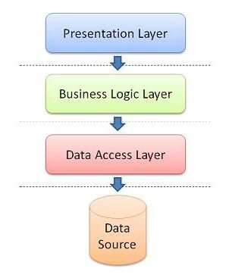

Figure 4-1: Layer architecture

These layer are:

* **Presentation layer**: provides the application's user interface (UI).
* **Business layer**: provide the business logic and object as well as services.
* **Data layer:** provides access to external systems such as databases…

Beside it, we have **Common** package, which have common class for the whole system.

#### ****Advantages and disadvantages of MVC model****

* Advantages:
  + Layered architecture increases flexibility, maintainability, and scalability.
  + Multiple applications can reuse the components.
  + Layered architecture enables develop loosely coupled systems.
  + Different components of the application can be independently deployed, maintained, and updated, on different time schedules.
  + Layered architecture also helps you to test the components independently of each other.
* Disadvantages:
  + There might be a negative impact on the performance as we have the extra overhead of passing through layers instead of calling a component directly.
  + Development of user-intensive applications can sometime take longer if the layering prevents the use of user interface components that directly interact with the database.
  + The use of layers helps to control and encapsulate the complexity of large applications, but adds complexity to simple applications.
  + Changes to lower level interfaces tend to percolate to higher levels, especially if the relaxed layered approach is used.

#### ****The reason of choosing Layer architecture****

* - Easily in develop and maintain system due to high flexibility, scalability and maintainability.
* Better support for test-driven development.
* It is good support for application built by project team has not too much developers thanks to the ease of reusability.
* BUSS system is not complete system, now. We built the system that towards extensibility and maintainability in the future.

### Architectural Representation

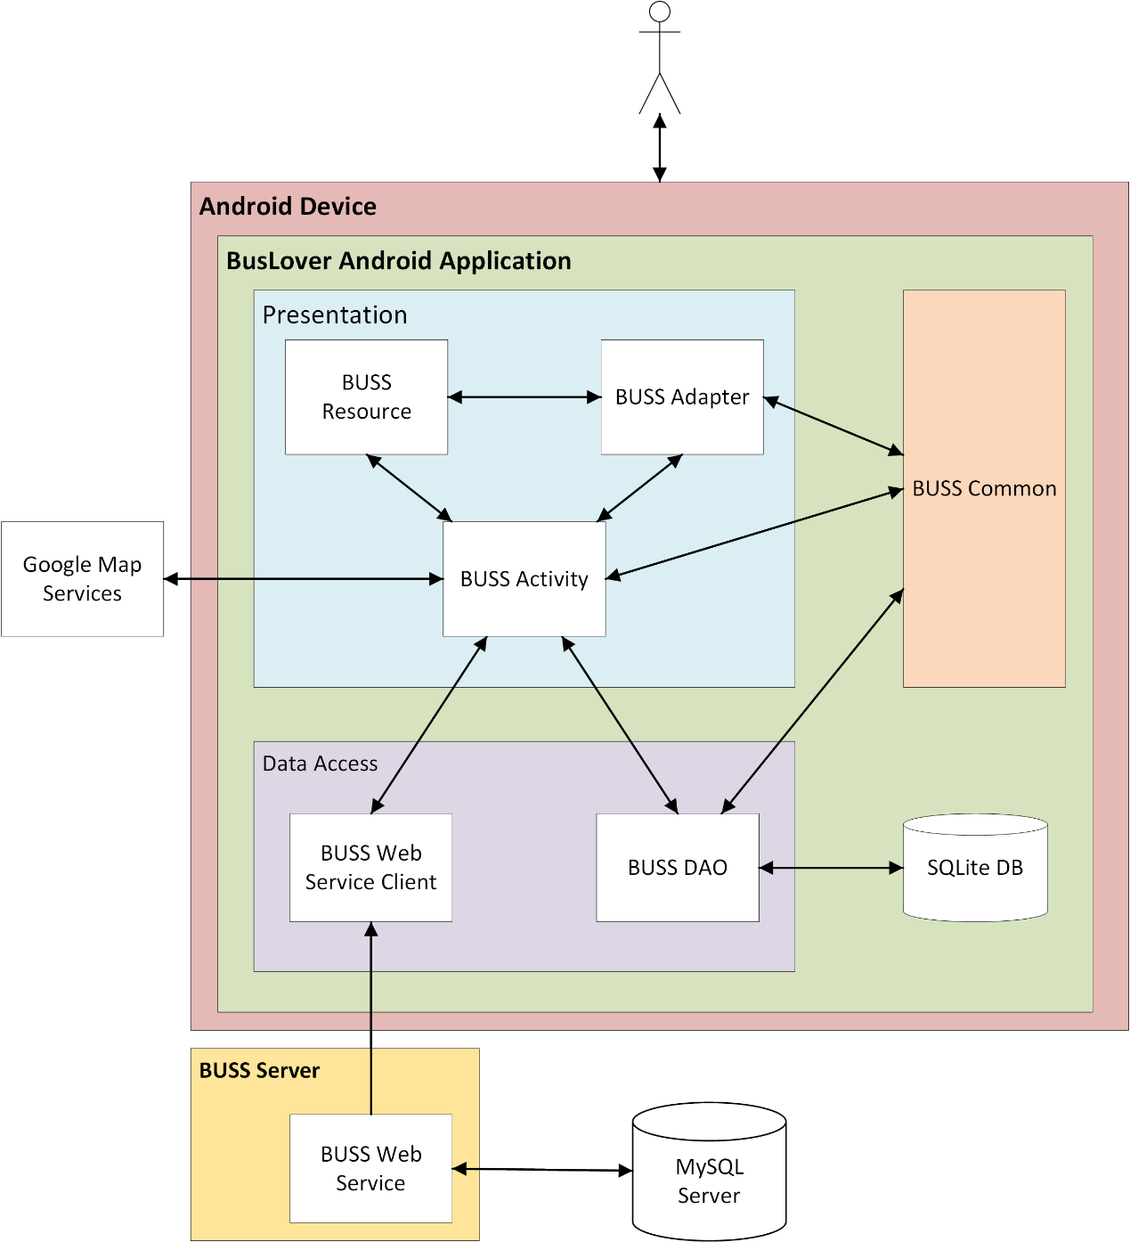

Figure 4-2: System overview

We follow layer architecture for Android to implement the BUSS Project. That pattern offers architectural benefits over standard - it helps us write better-organized and therefore more maintainable code.

**Presentation layer**

* Contains activity, adapter and resources packages.
* Responsible for creating and displaying the UI and handling user interactions.
* Data shown is fetched from the Domain Model (Common package).

**Data access layer**

* Consists of two package: WebserviceClient and DAO.
* Responsible for querying database, calling a web service or send email…

Common package: which have common class for the whole system.

Webserver: deploy webservice and have connection to MySQL Server DB.

SQLite DB: local DB on device

Google Map Services: services of Google which were called by implement APIs.

### Architecture Goals and Constraints

**Availability:** The application must be available 95% of time. Users can access to it everywhere having internet.

**Maintainability:**

* Coding standards and naming conventions
  + Output of the project must include coding standards and naming conventions documentations. Implementation code must be easy to maintain.
  + All code must be clearly commented, including class, method documentations.
  + If some components are reused, the documentations of those components must also be included.
* Design
  + The design of the system must be loosely coupled that chances on some module will not affect others.

**Usability:** Usability Requirements support the following from the perspective of its primary users:

* Efficiency of use**:** user can complete each function in less than 10 actions
* Intuitiveness**:** all help/error messages are simple and easy to understand (80% of surveyor agreed); user can figure out exactly how to use each feature after using it once.

**Capacity and scalability:** throughput, storage and growth requirements.

### Use-Case View

Refer section 3.3.3 Functional Specification.

### Logical View

#### Overview

Logical View includes Package diagram and Class diagram. Package diagram describes the organization of packages and elements. Class Diagram provides an overview of the target system by describing the objects and classes inside the system and the relationships between them. It provides a wide variety of usages; from modeling the domain-specific data structure to detailed design of the target system. In this section, package diagrams would be presented, and class diagrams would be presented in the Class Design section later.

#### Architecturally Significant Design Packages

##### Android

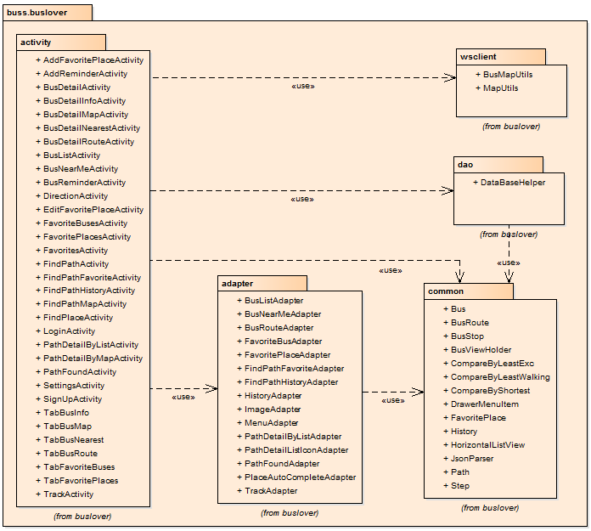

Figure 4-3: Android package diagram

###### Buss.buslover.activity

|  |  |  |
| --- | --- | --- |
| **No.** | **activity class** | **Role** |
| 1 | AddFavoritePlaceActivity | Provide activity add favorite place |
| 2 | AddReminderActivity | Provide activity add reminder |
| 3 | BusDetailActivity | Provide activity bus detail |
| 4 | BusDetailInfoActivity | Provide activity bus detail tab info |
| 5 | BusDetailMapActivity | Provide activity bus detail tab map |
| 6 | BusDetailNearestActivity | Provide activity bus detail tab nearest |
| 7 | BusDetailRouteActivity | Provide activity bus detail tab route |
| 8 | BusListActivity | Provide activity bus list |
| 9 | BusNearMeActivity | Provide activity bus near me |
| 10 | DirectionActivity | Provide activity direction – navigation |
| 11 | EditFavoritePlaceActivity | Provide activity edit favorite place |
| 12 | FavoritesActivity | Provide activity favorites |
| 13 | FavoriteBusesActivity | Provide activity favorite tab bus |
| 14 | FavoritePlacesActivity | Provide activity favorite tab place |
| 15 | FindPathActivity | Provide activity find path |
| 16 | FindPathFavoriteActivity | Provide activity find path tab favorite |
| 17 | FindPathHistoryActivity | Provide activity find path tab history |
| 18 | FindPathMapActivity | Provide activity find path tab map |
| 19 | FindPlaceActivity | Provide activity find place |
| 20 | LoginActivity | Provide activity login |
| 21 | PathDetailByListActivity | Provide activity path detail by list |
| 22 | PathDetailByMapActivity | Provide activity path detail by map |
| 23 | PathFoundActivity | Provide activity path found |
| 24 | SettingsActivity | Provide activity settings |
| 25 | SignUpActivity | Provide activity sign up |
| 26 | TrackActivity | Provide activity track |

Table 4-1: activity package diagram

###### Buss.buslover.adapter

|  |  |  |
| --- | --- | --- |
| **No.** | **adapter class** | **Role** |
| 1 | BusListAdapter | Adapter for BusListActivity |
| 2 | BusNearMeAdapter | Adapter for BusNearMeActivity |
| 3 | BusRouteAdapter | Adapter for BusRouteActivity |
| 4 | FavoriteBusAdapter | Adapter for FavoriteBusesActivity |
| 5 | FavoritePlaceAdapter | Adapter for FavoritePlacesActivity |
| 6 | FindPathFavoriteAdapter | Adapter for FindPathFavoriteActivity |
| 7 | FindPathHistoryAdapter | Adapter for FindPathHistoryActivity |
| 8 | ImageAdapter | Adapter for ImageChooserDialog |
| 9 | MenuAdapter | Adapter for Menu |
| 10 | PlaceDetailByListAdapter | Adapter for PlaceDetailByList |
| 11 | PathFoundAdapter | Adapter for PathFoundActivity |
| 12 | PlaceAutoCompleteAdapter | Adapter for PlaceAutoCompleteTextView |
| 13 | TrackAdapter | Adapter for TrackActivity |

Table 4-2: adapter pakgage digram

###### Buss.buslover.common

|  |  |  |
| --- | --- | --- |
| **No.** | **common class** | **Role** |
| 1 | Bus | Bus class |
| 2 | BusRoute | Bus route class |
| 3 | BusStop | Bus stop class |
| 4 | BusViewHolder | View holder class for bus |
| 5 | CompareByLeastExc | Compare by least execution class for path found |
| 6 | CompareByLeastWalking | Compare by least walking class for path found |
| 7 | CompareByShortest | Compare by shortest class for path found |
| 8 | DrawerMenuItem | Drawer class for menu item |
| 9 | FavoritePlace | Favorite place class |
| 10 | History | History class |
| 11 | HorizontalListView | Horizontal list view class |
| 12 | JsonParser | Json parser class |
| 13 | Path | Path class |
| 14 | Step | Step class |

Table 4-3: common pakage diagram

###### Buss.buslover.dao

|  |  |  |
| --- | --- | --- |
| **No.** | **common class** | **Role** |
| 1 | DataBaseHelper | Database helper class |

Table 4-4: dao pakage diagram

###### Buss.buslover.wsclient

|  |  |  |
| --- | --- | --- |
| **No.** | **common class** | **Role** |
| 1 | BusMapServiceClient | Bus map service class |
| 2 | FindPathServiceClient | Find path service client |

Table 4-5: wsclient package diagram

##### Webservice



Figure 4-4: Webservice package diagram

### Process View

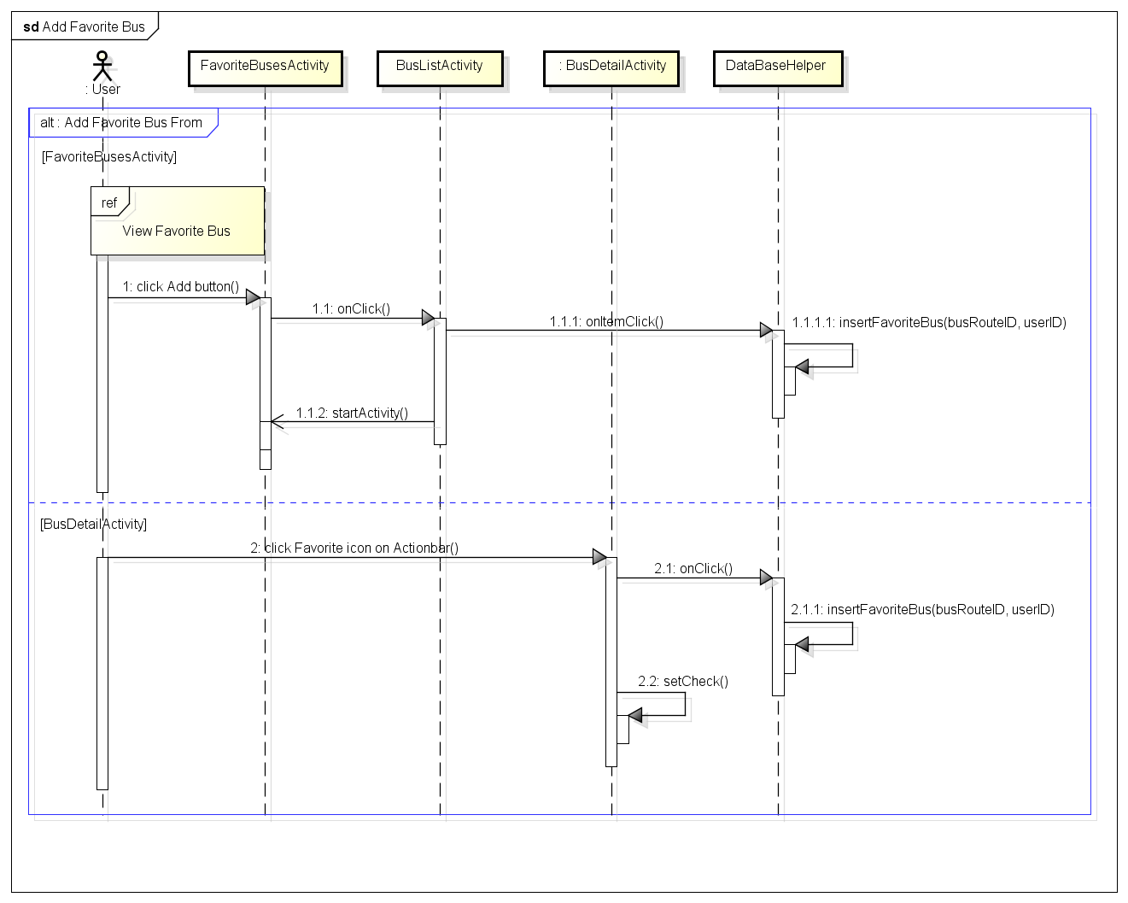

Figure 4-5: Add Favorite Bus sequence

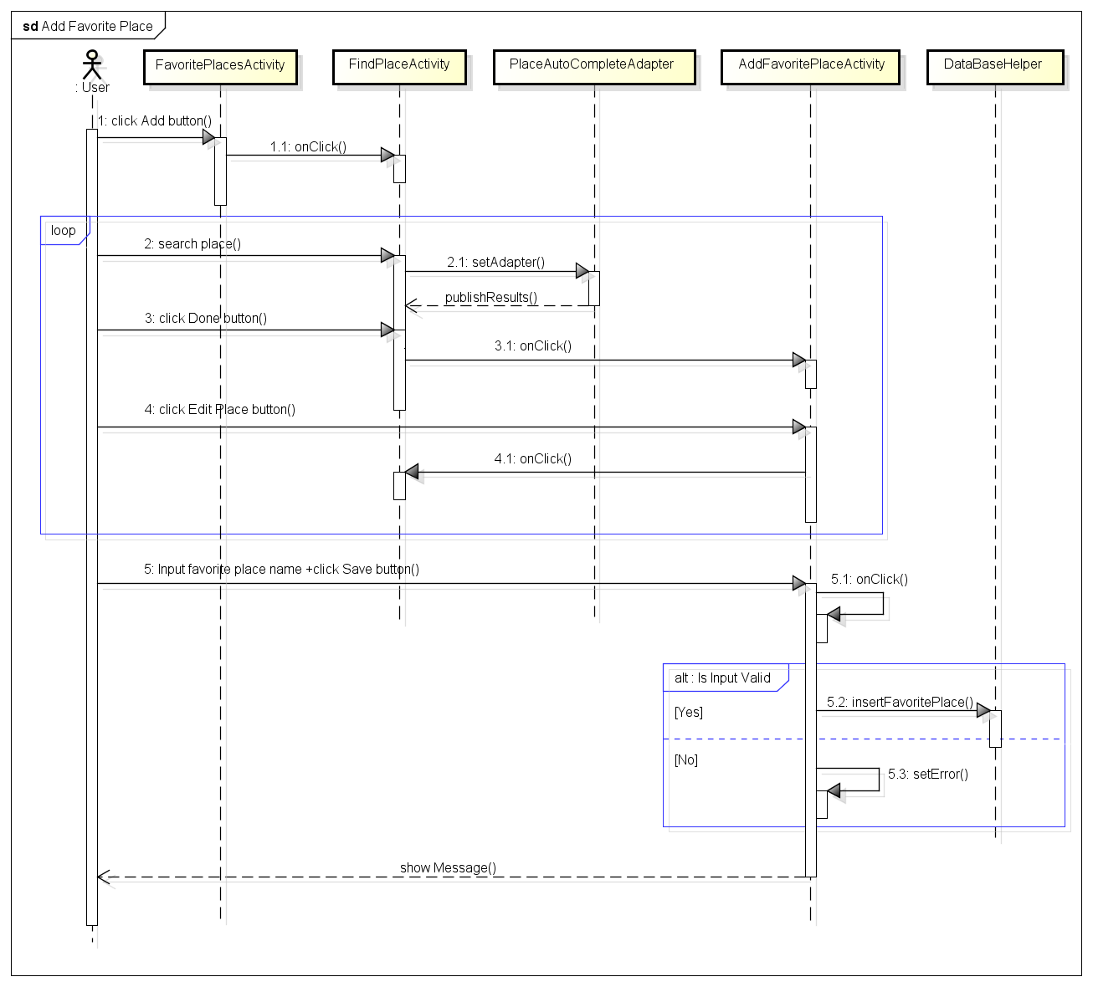 Figure 4-6: Add favorite place sequence

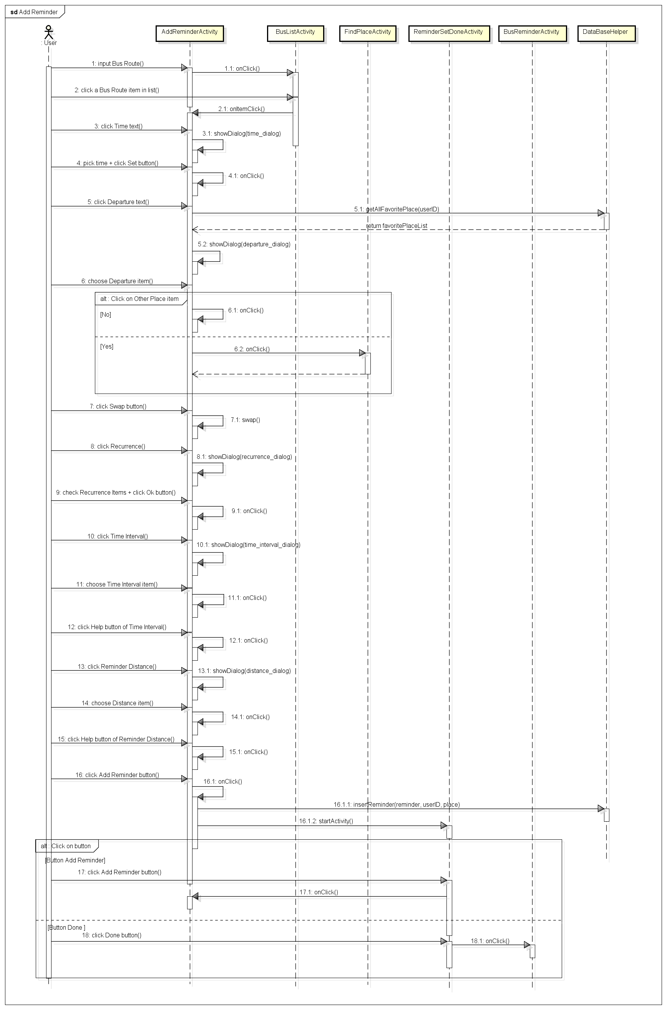

Figure 4-7: Add Reminder sequence

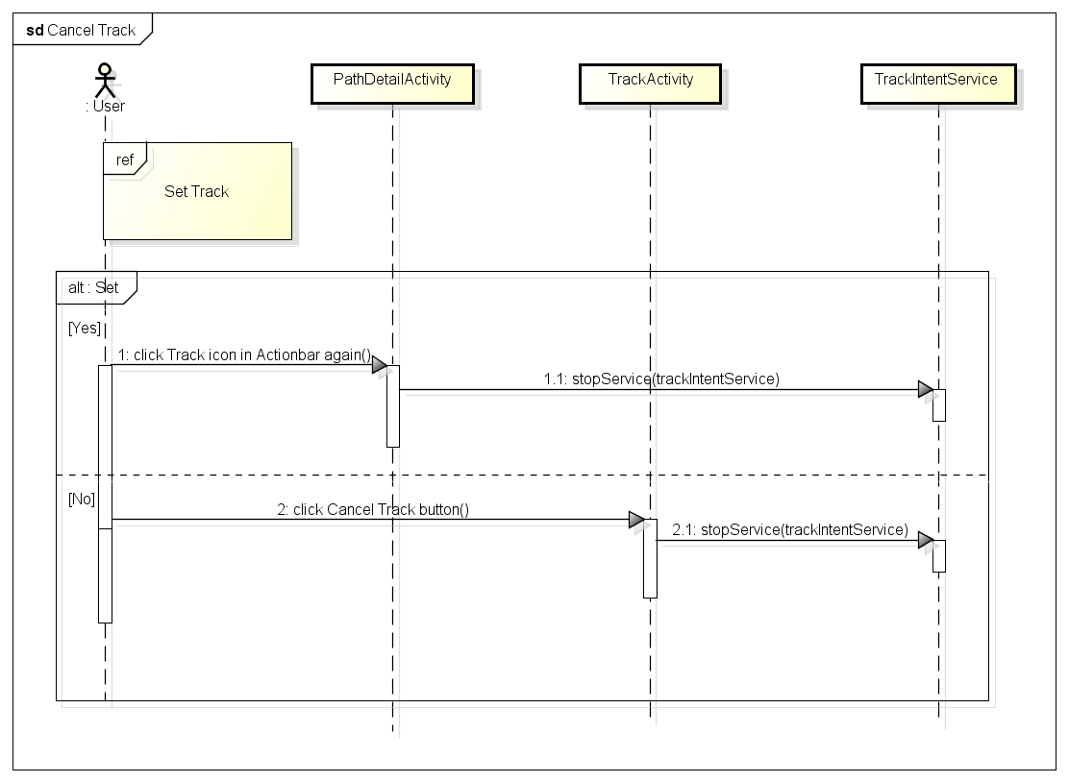

Figure 4-8: Cancel track sequence

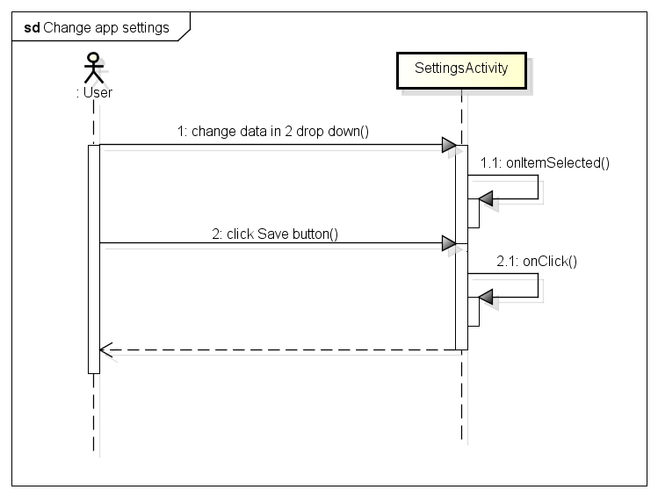 Figure 4-9: Change app Settings sequence

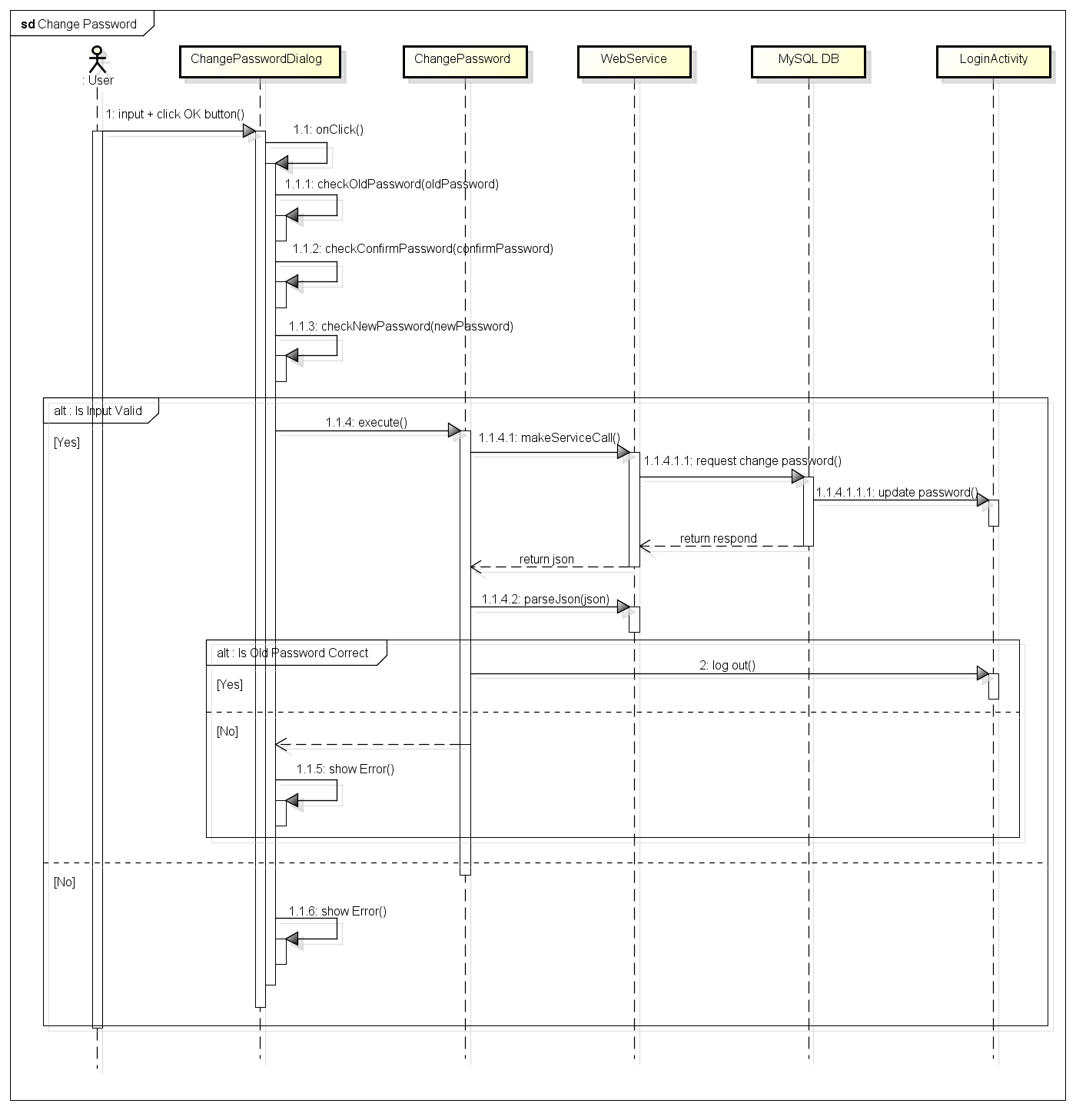 Figure 4-10: Change password sequence

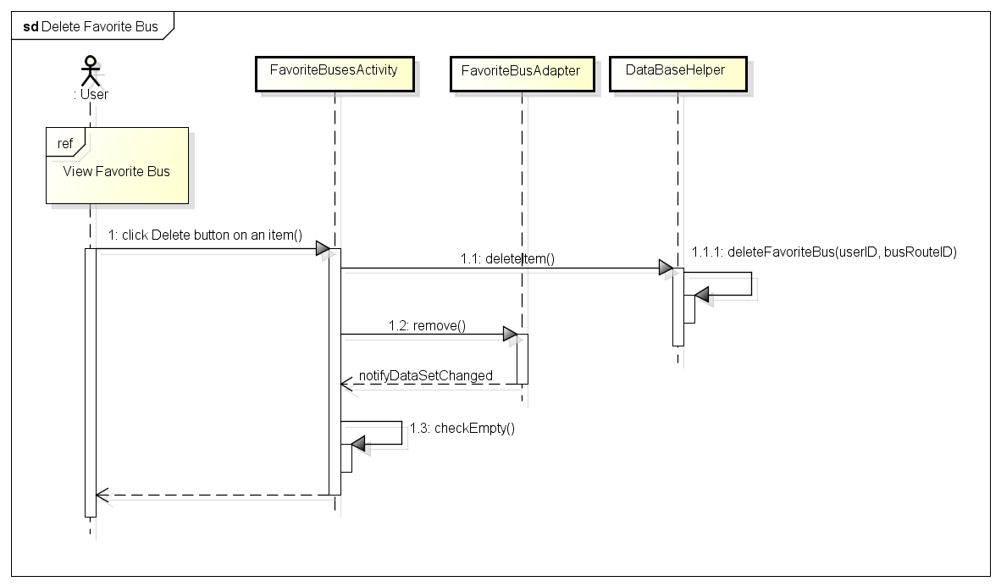 Figure 4-11: Delete favorite bus sequence

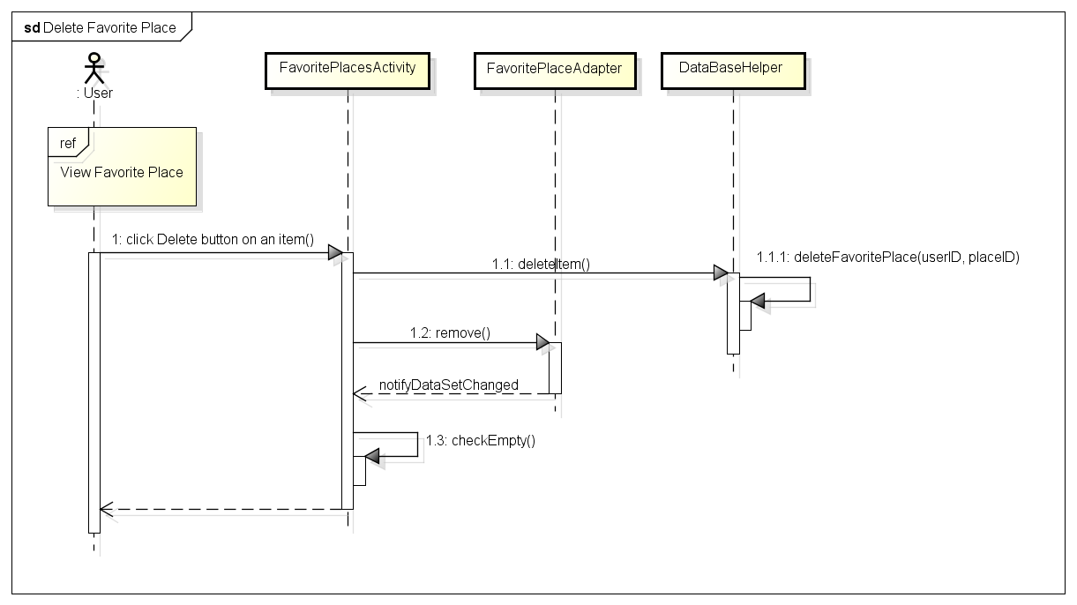 Figure 4-12: Delete favorite place sequence

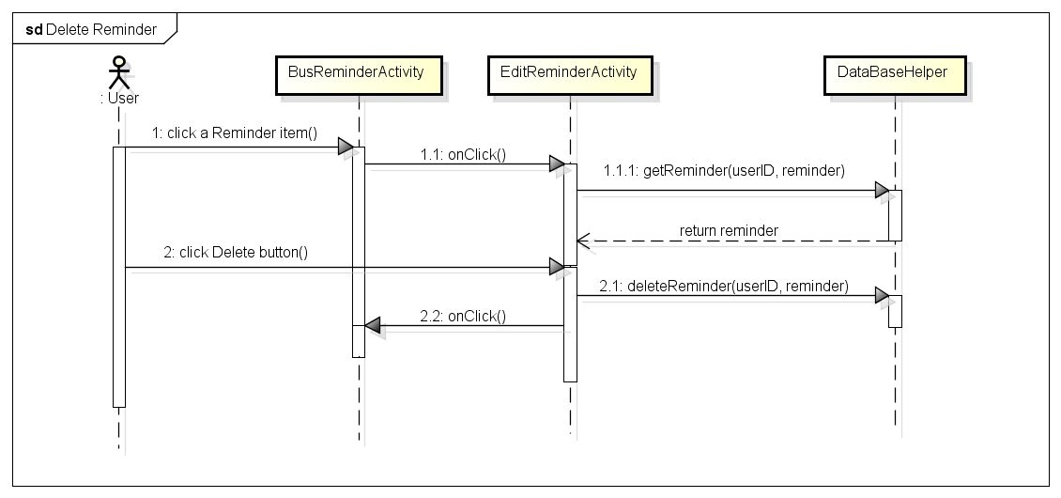 Figure 4-13: Delete reminder sequence

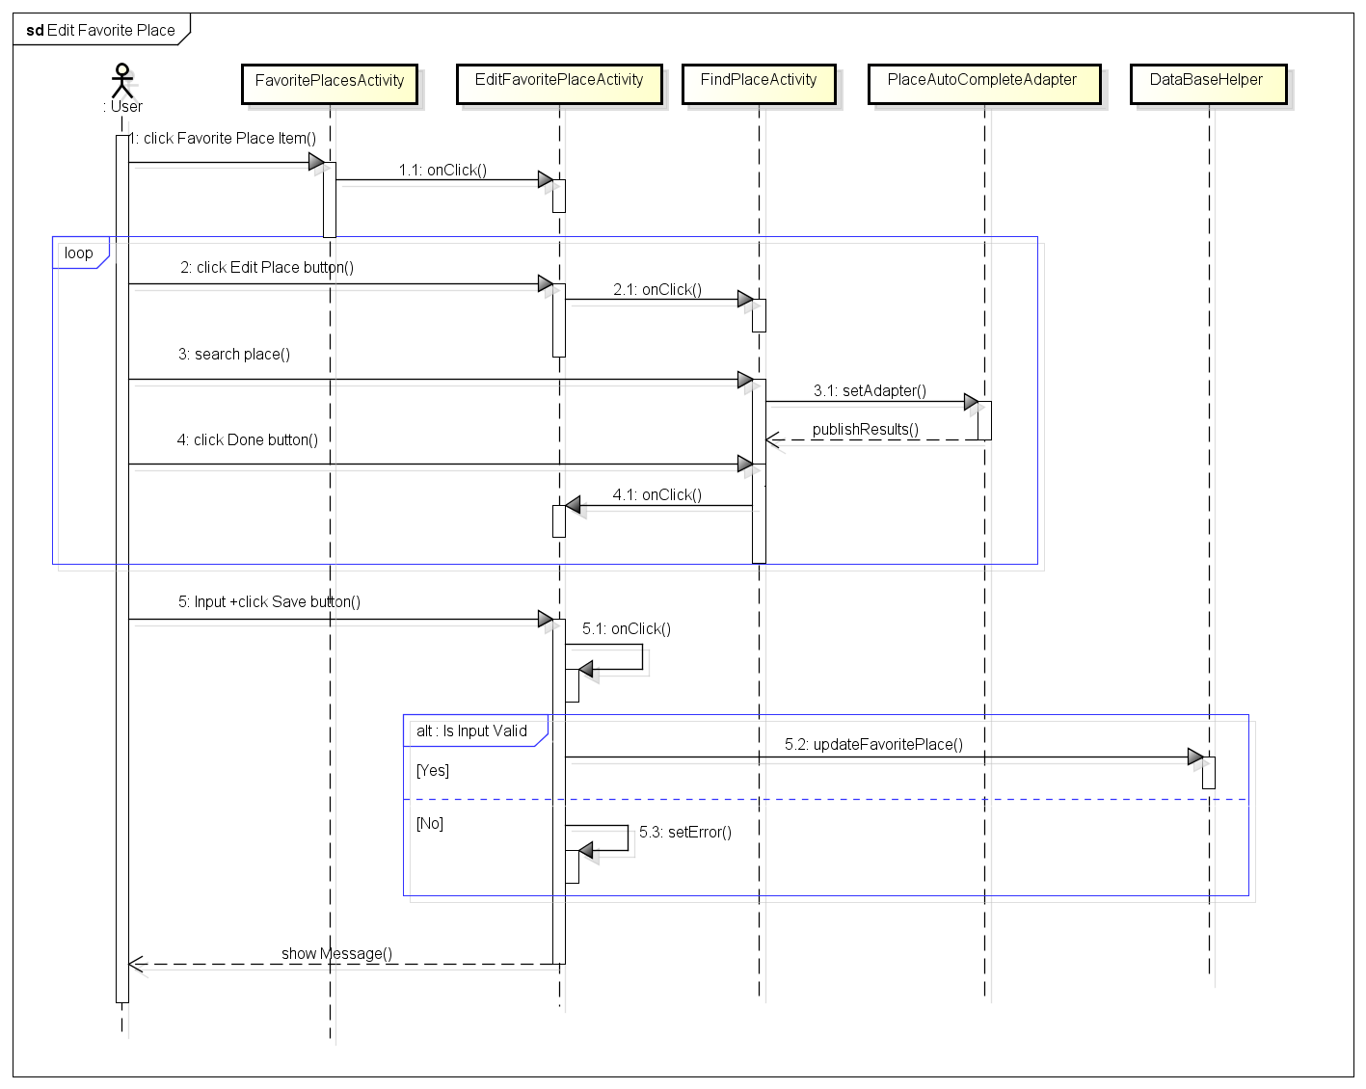 Figure 4-14: Edit favorite place sequence

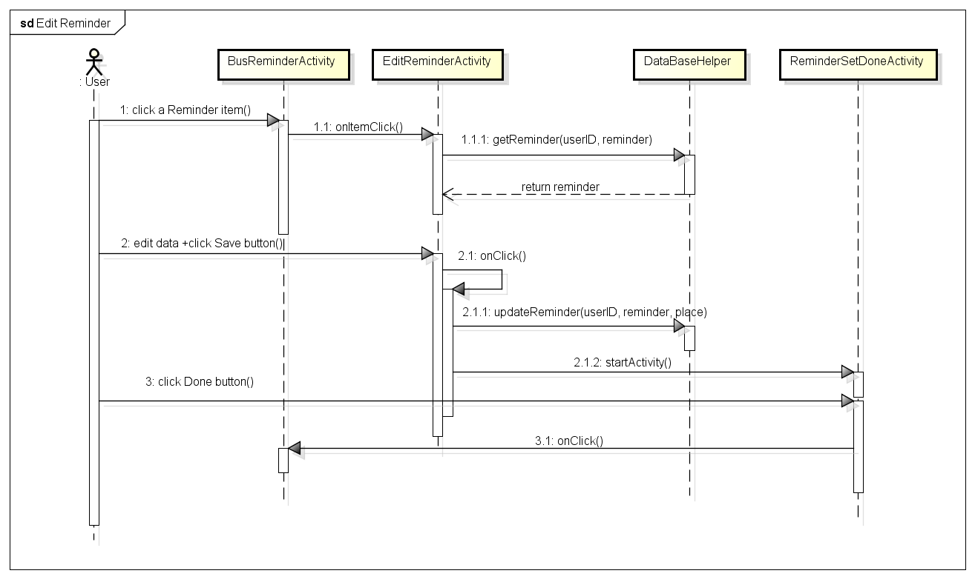Figure 4-15: Edit reminder sequence

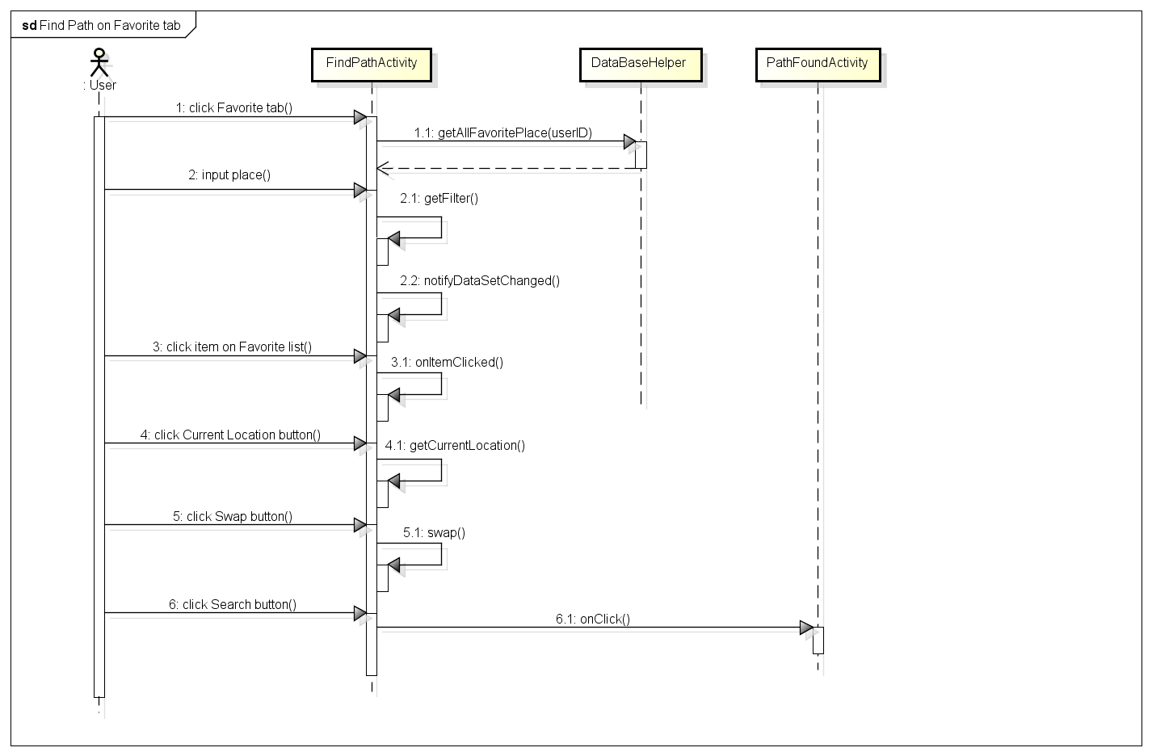Figure 4-16: Find path on Favorite tab sequence

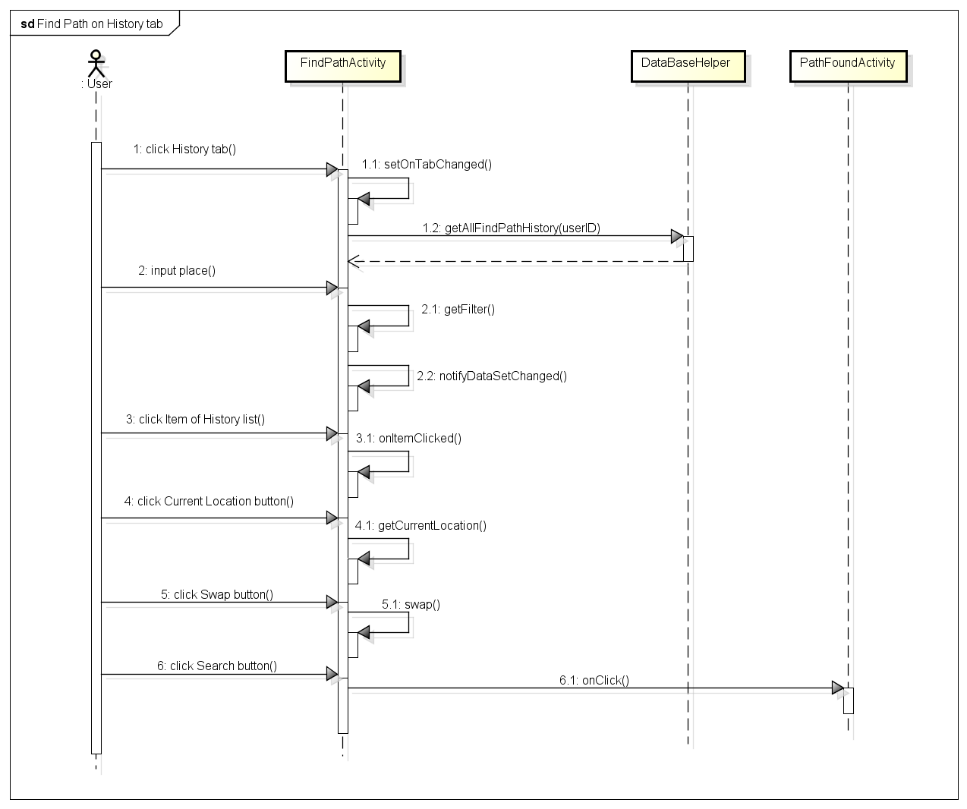 Figure 4-17: Find path on history tab sequence

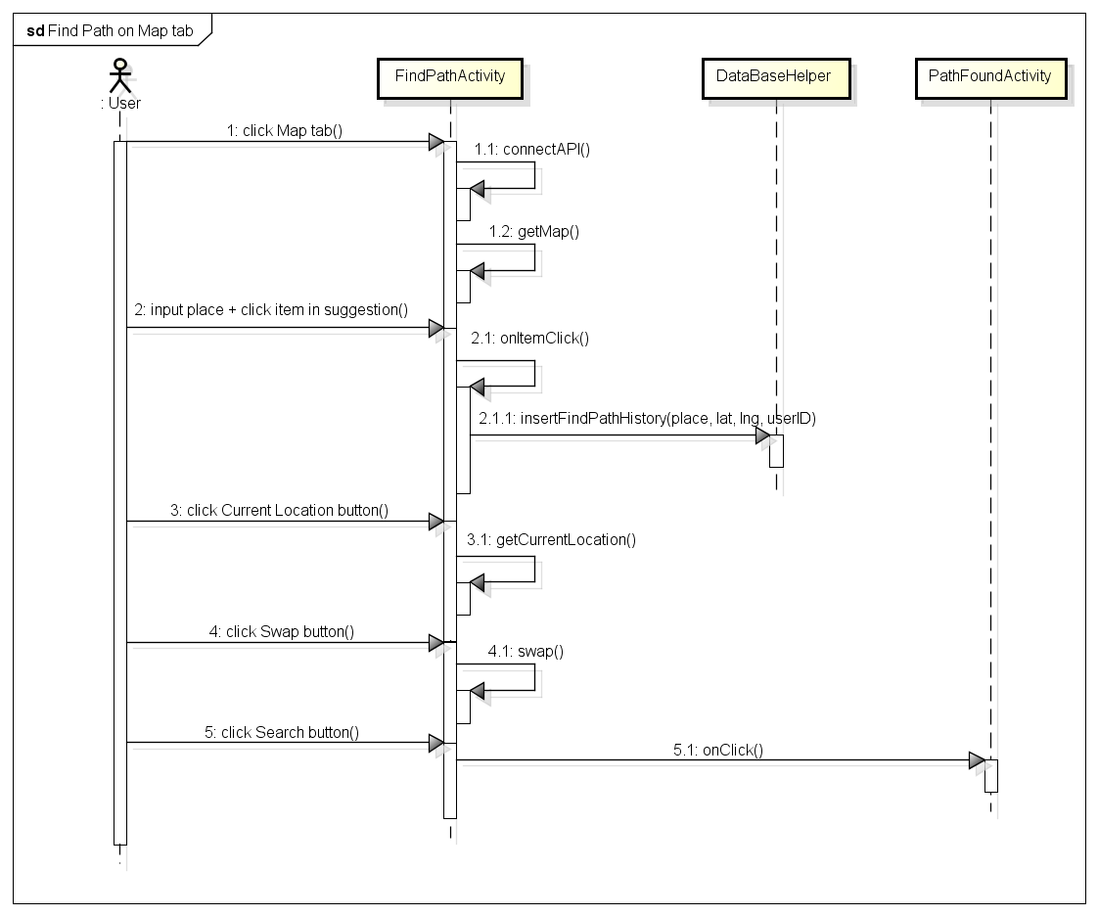Figure 4-18: Find path on map tab sequence 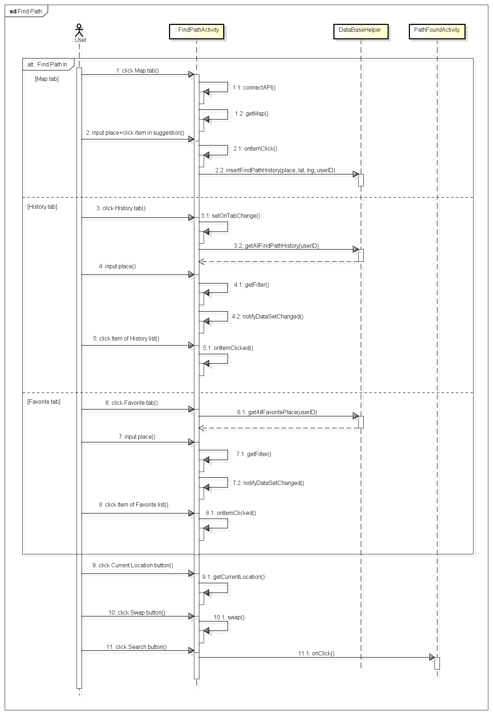 Figure 4-19: Find path sequence 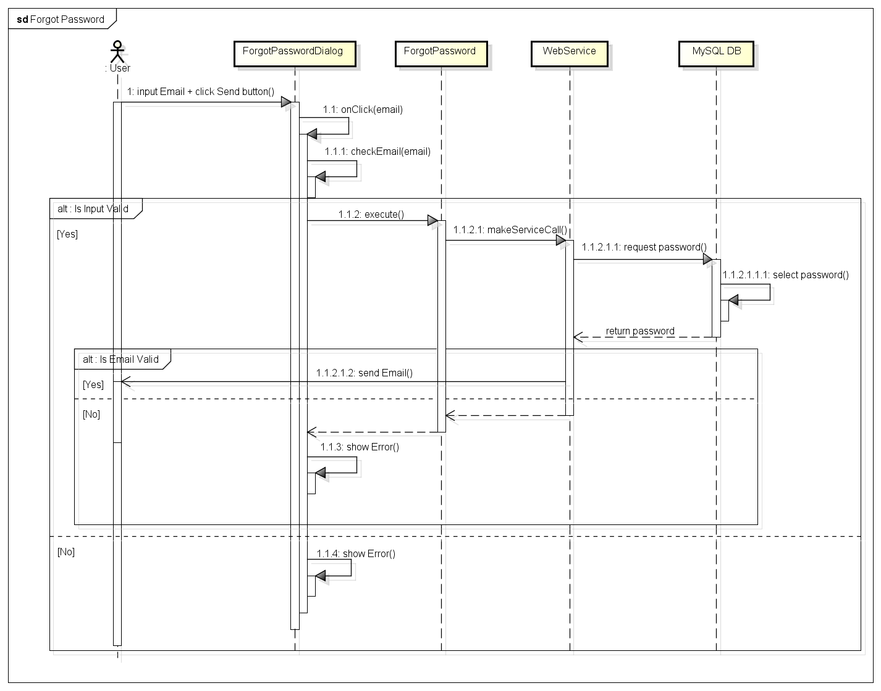 Figure 4-20: Forgot password sequence 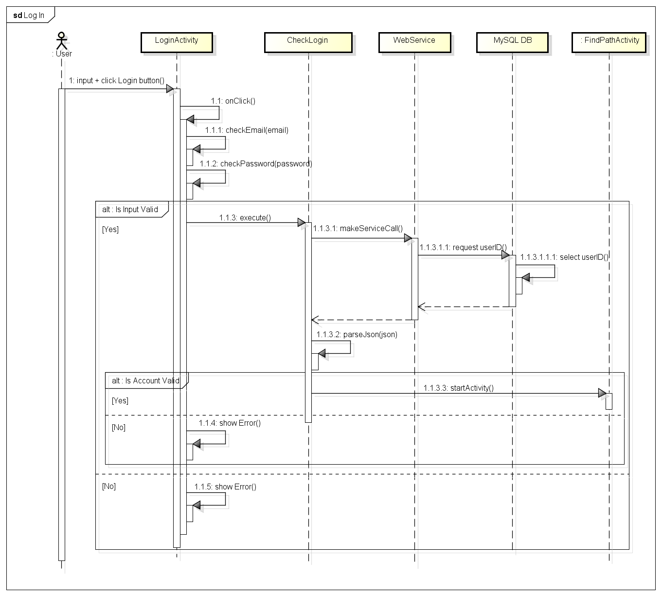 Figure 4-21: Login sequence 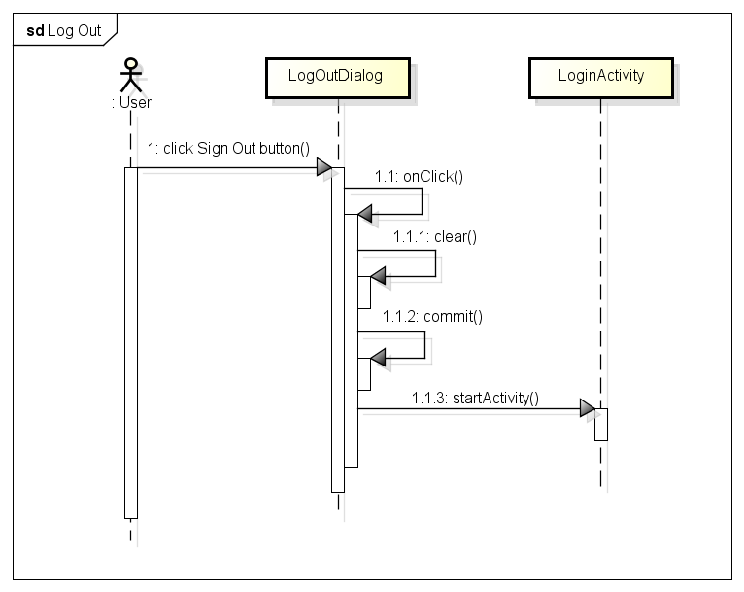 Figure 4-22: Log out sequence

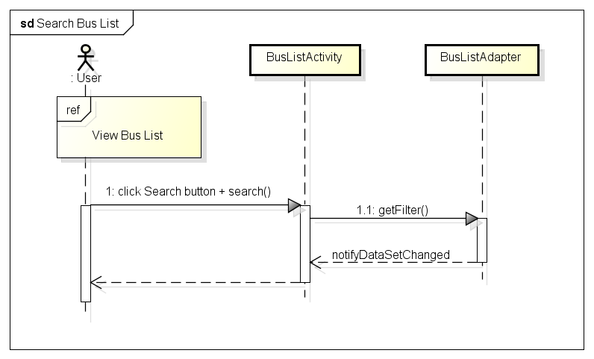 Figure 4-23: Search bus list sequence 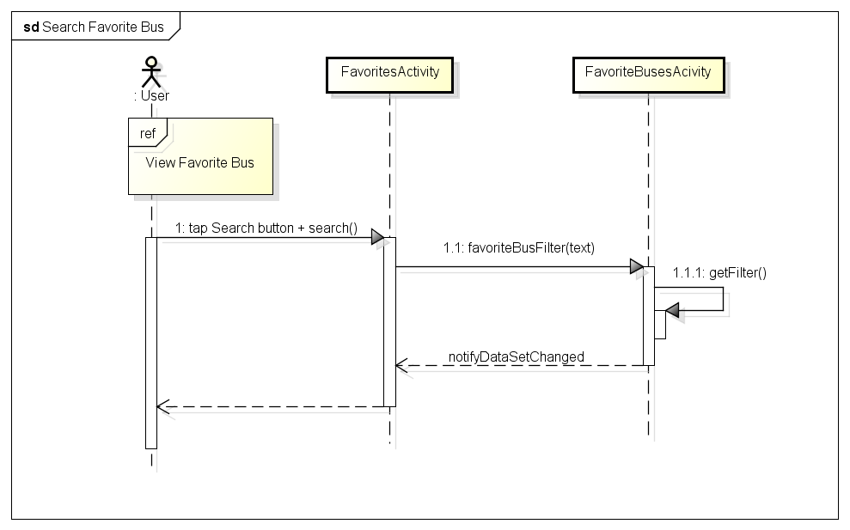 Figure 4-24: Search favorite bus sequence

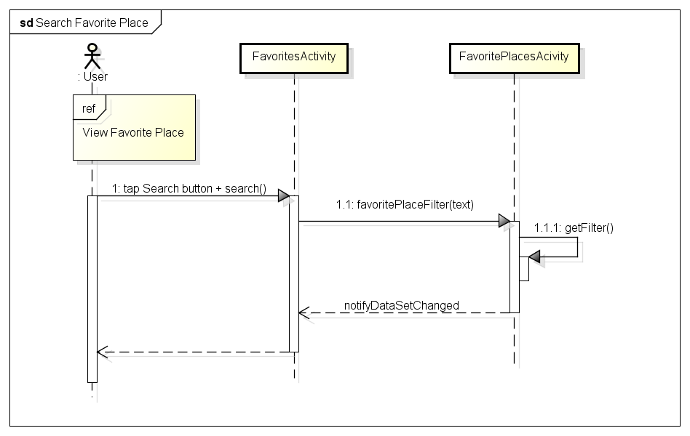 Figure 4-25: Search favorite place sequence

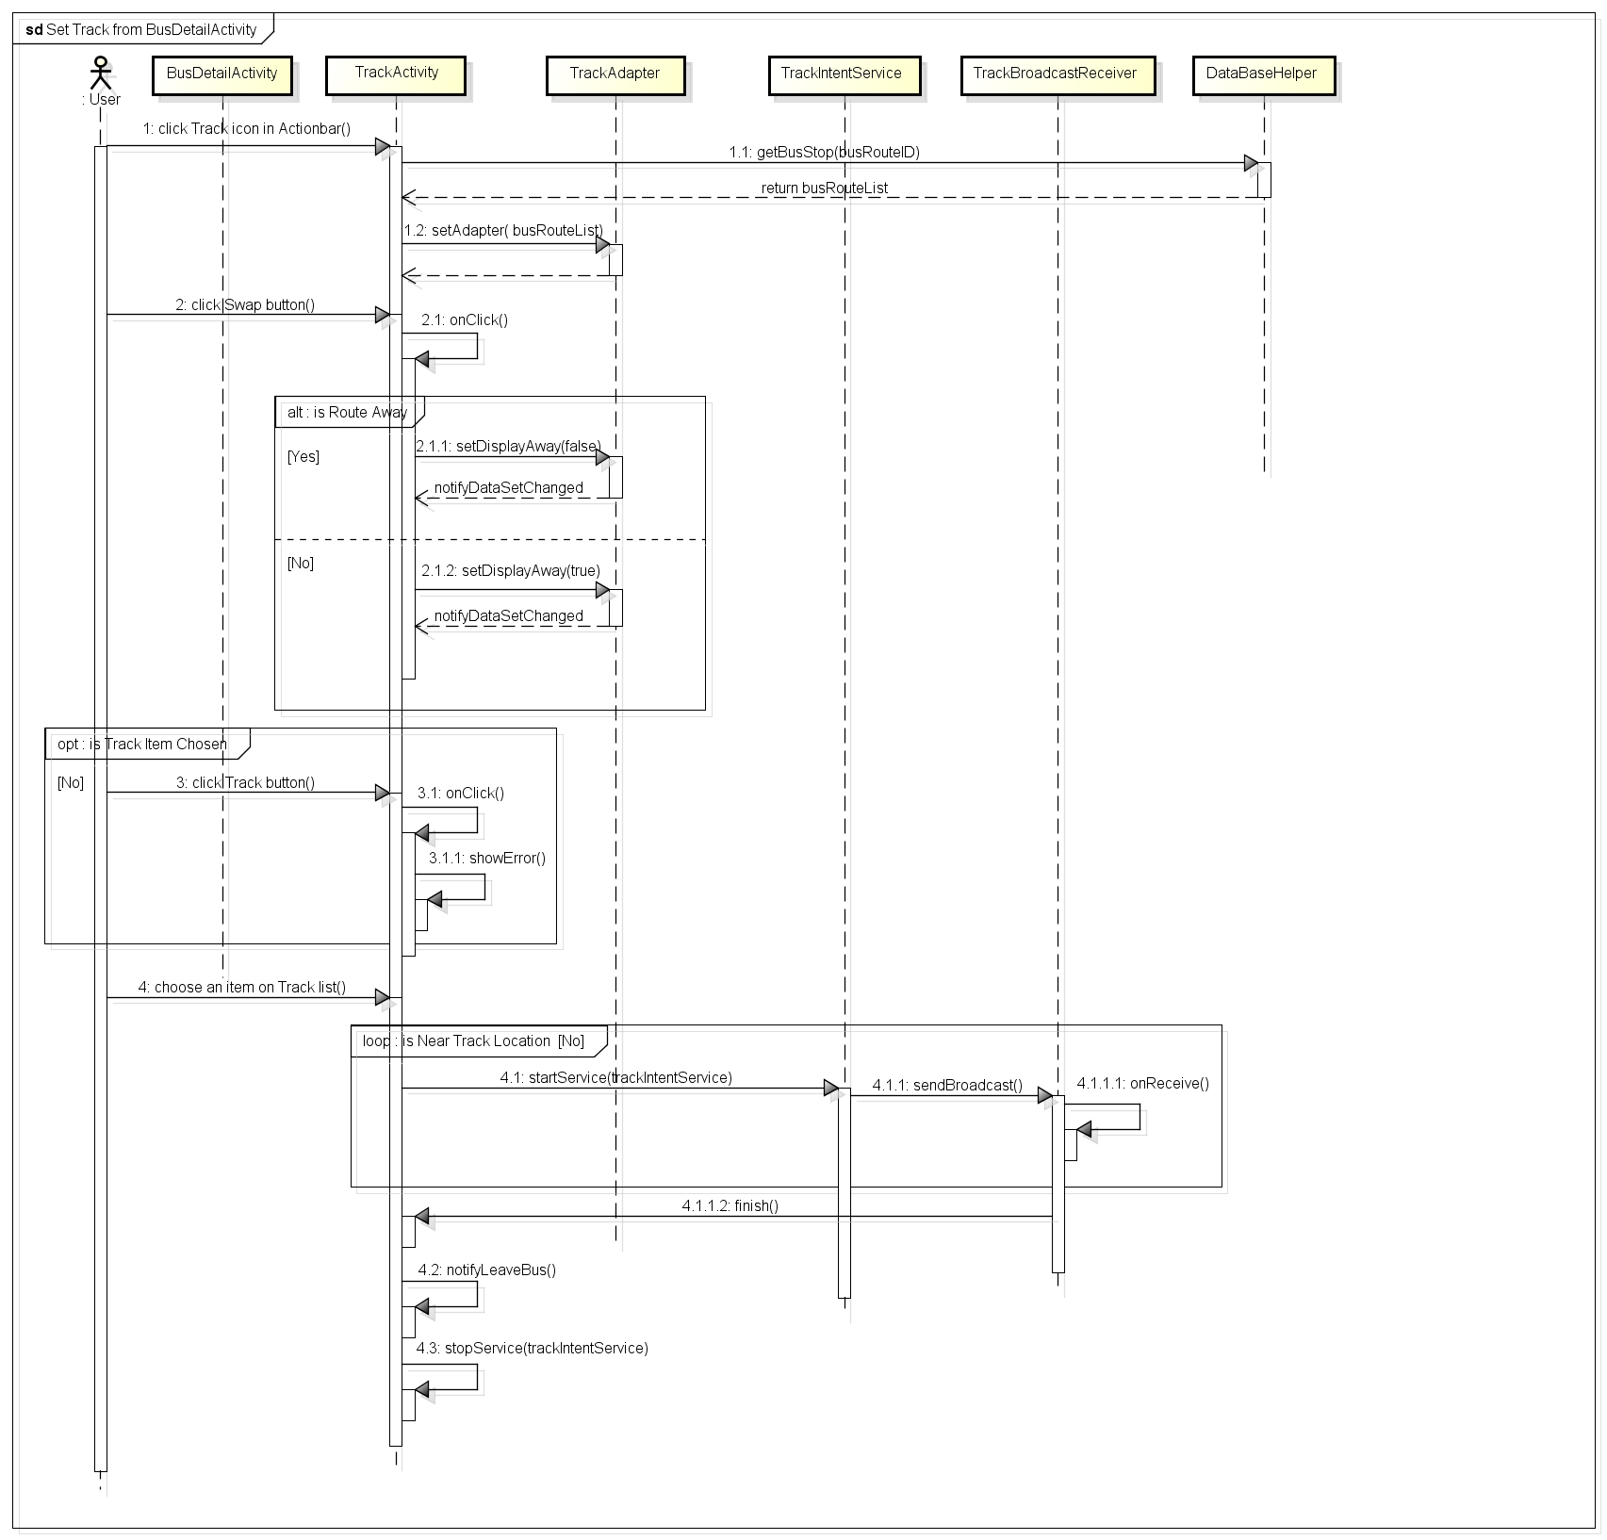Figure 4-26: Set track from Bus Detail sequence

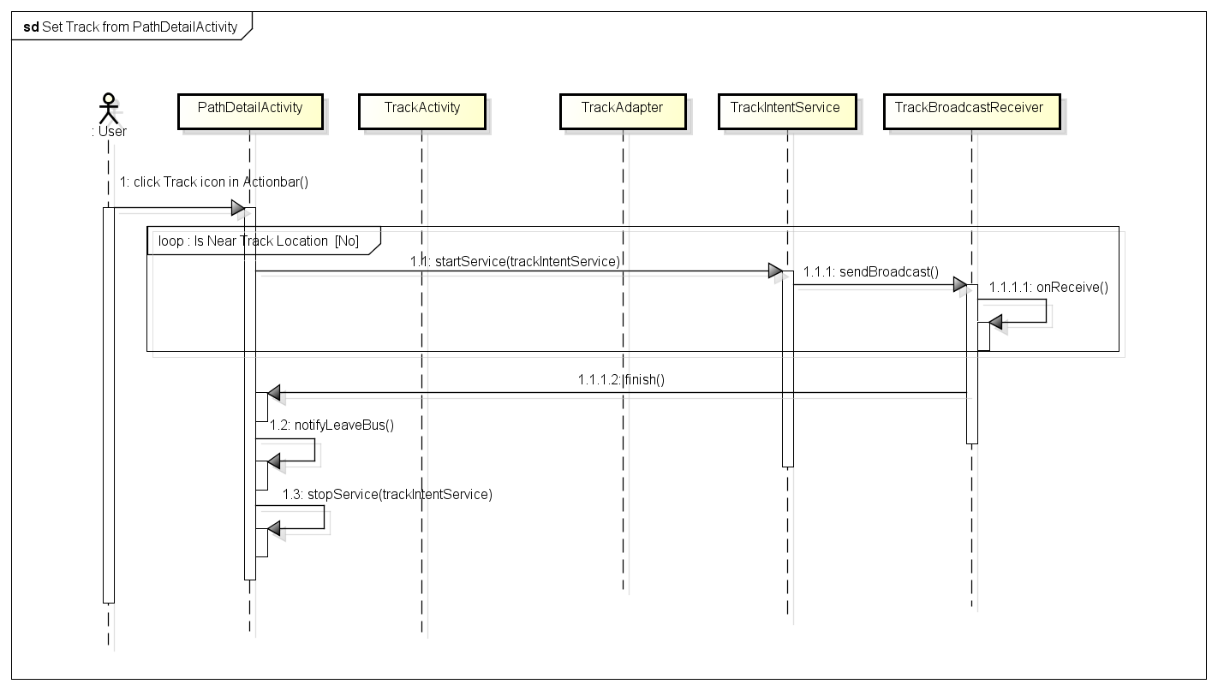 Figure 4-27: Set track from path detail sequence

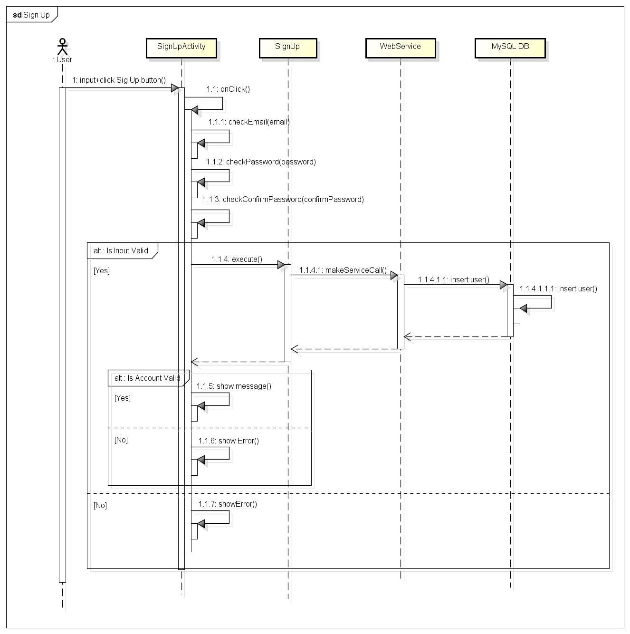 Figure 4-28: Sign up sequence 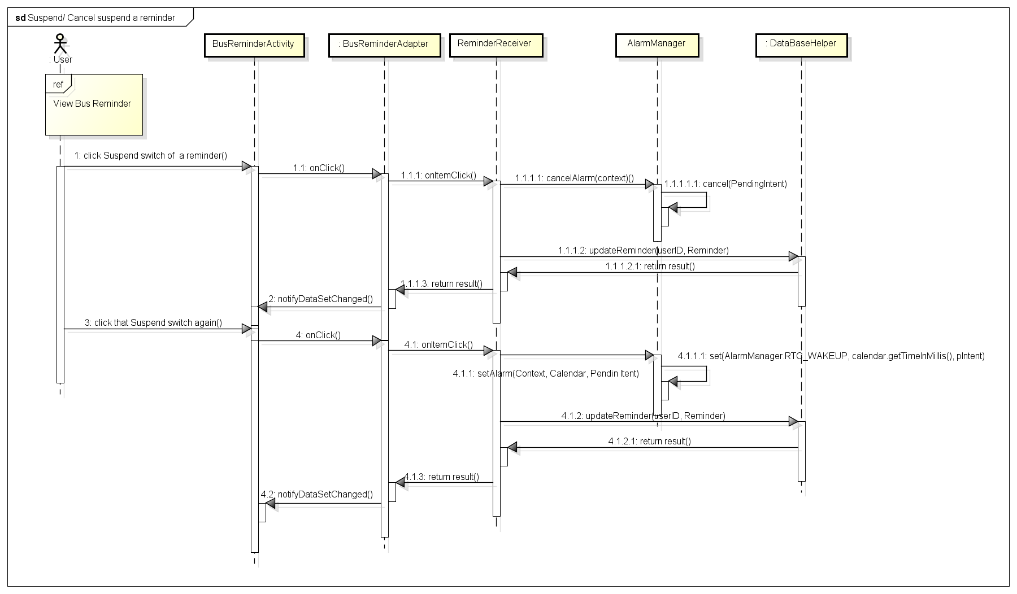 Figure 4-29: Suspend/Cancel a reminder sequence

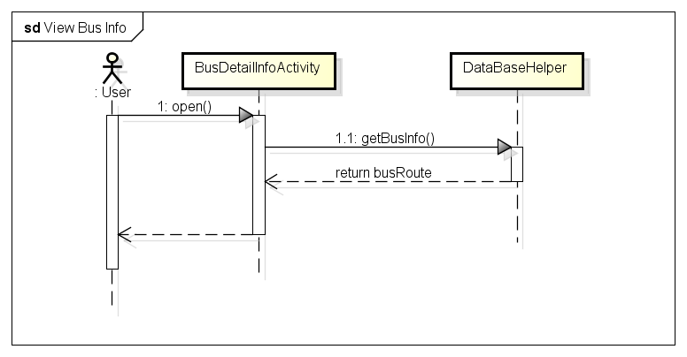 Figure 4-30: View bus info sequence 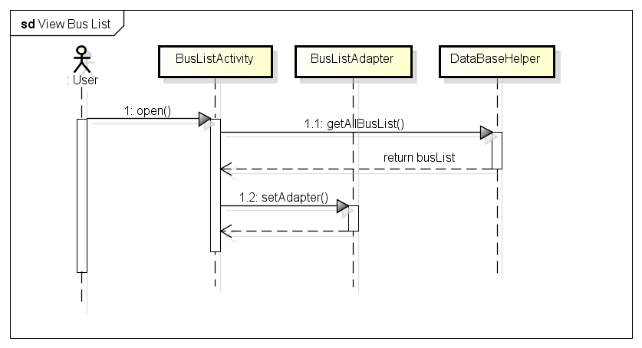 Figure 4-31: View bus list sequence

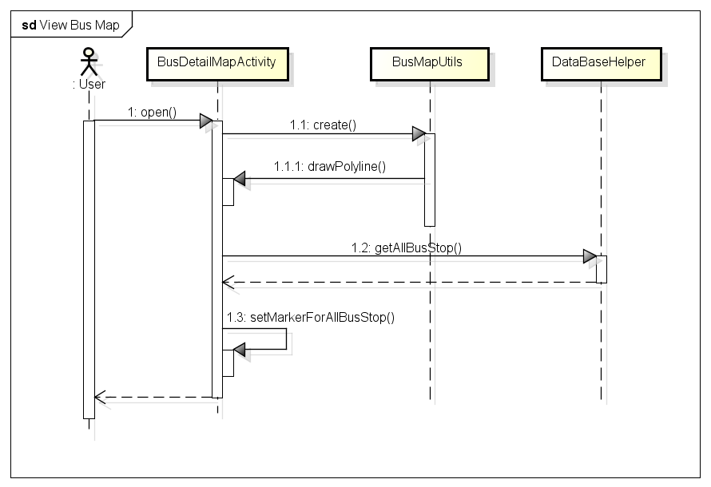 Figure 4-32: View bus map sequence 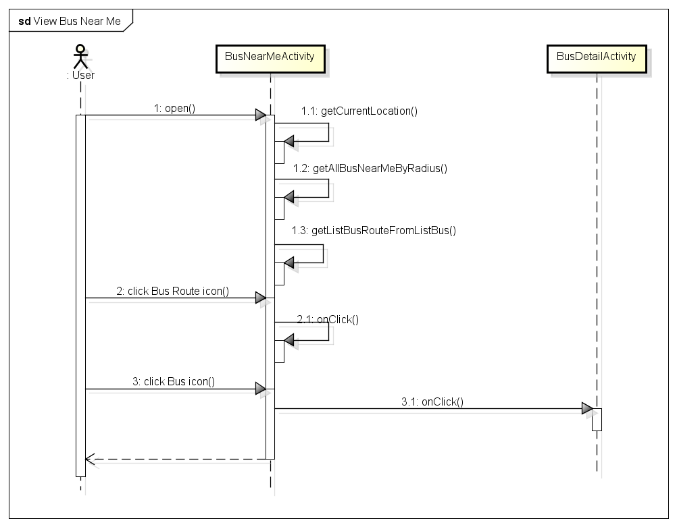 Figure 4-33: View Bus near me sequence 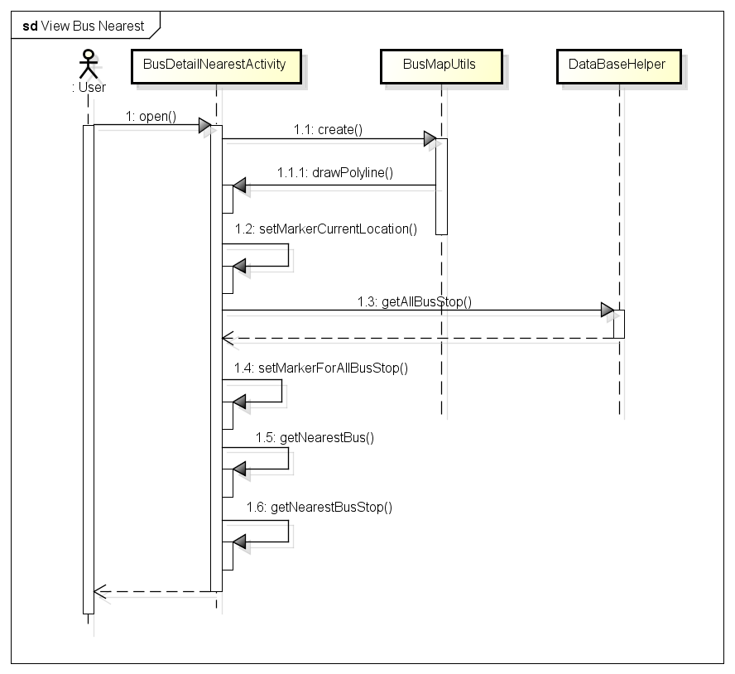 Figure 4-34: View bus nearest sequence 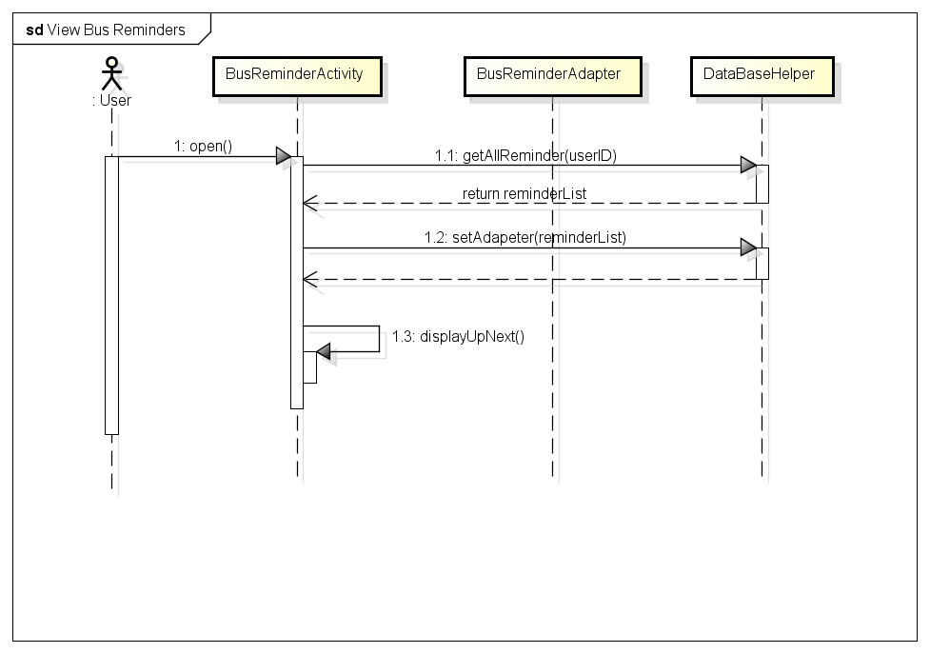 Figure 4-35: View bus reminders sequence 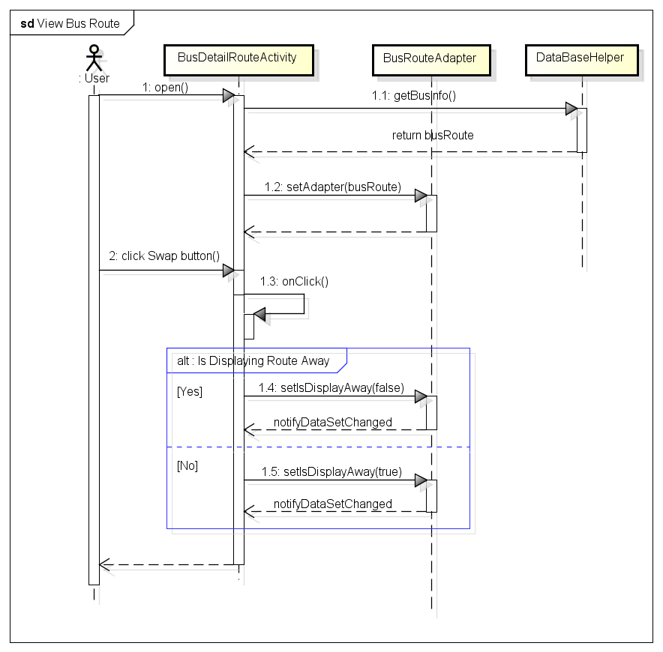 Figure 4-36: View bus route sequence 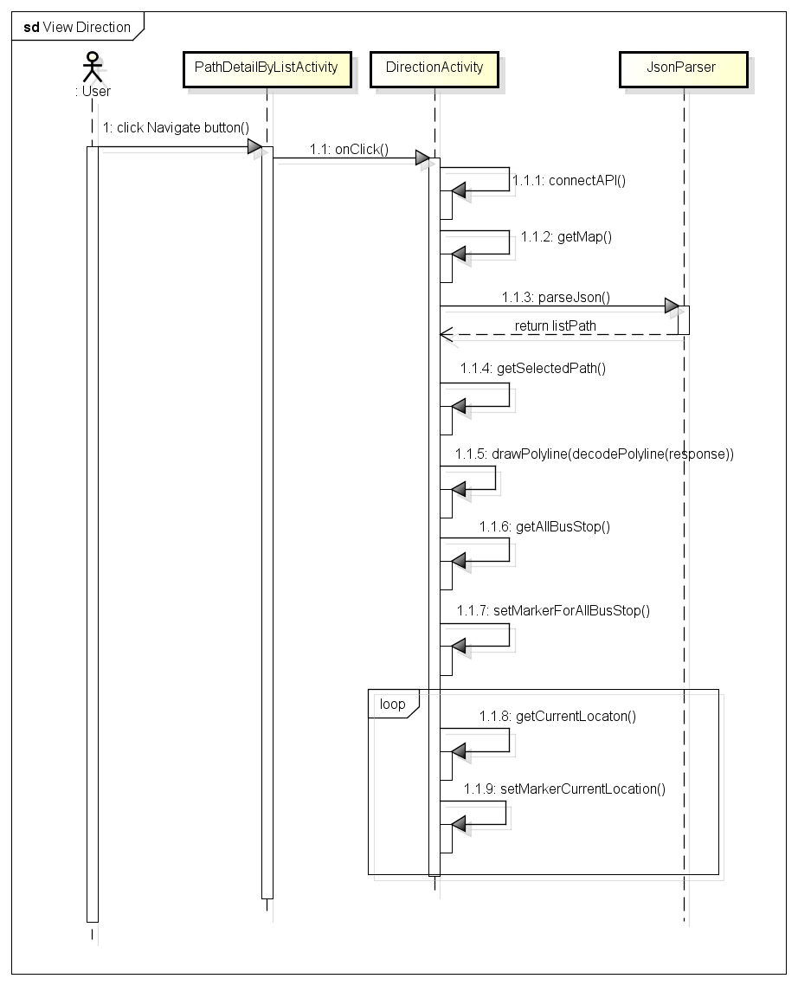 Figure 4-37: View Direction sequence 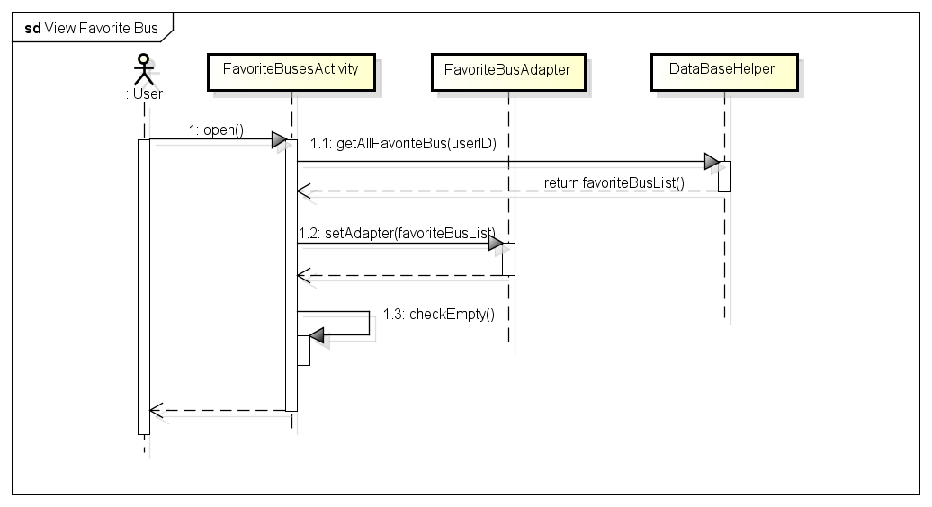 Figure 4-38: View Favorite bus sequence

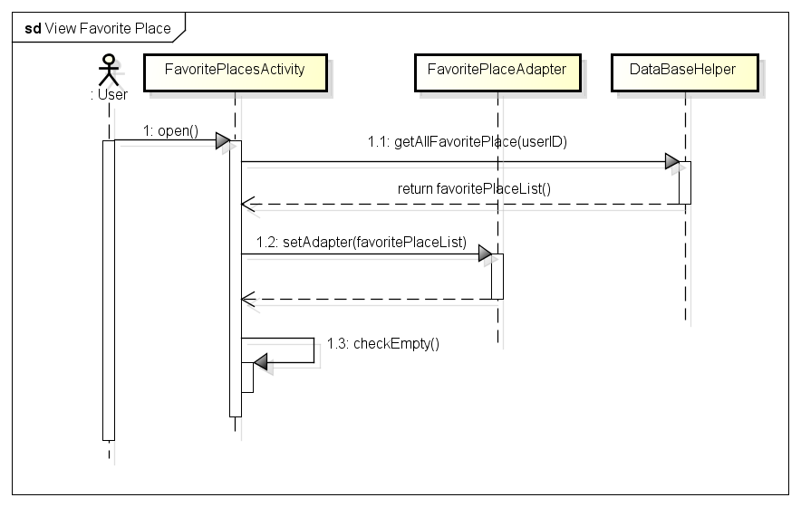 Figure 4-39: View favorite place sequence 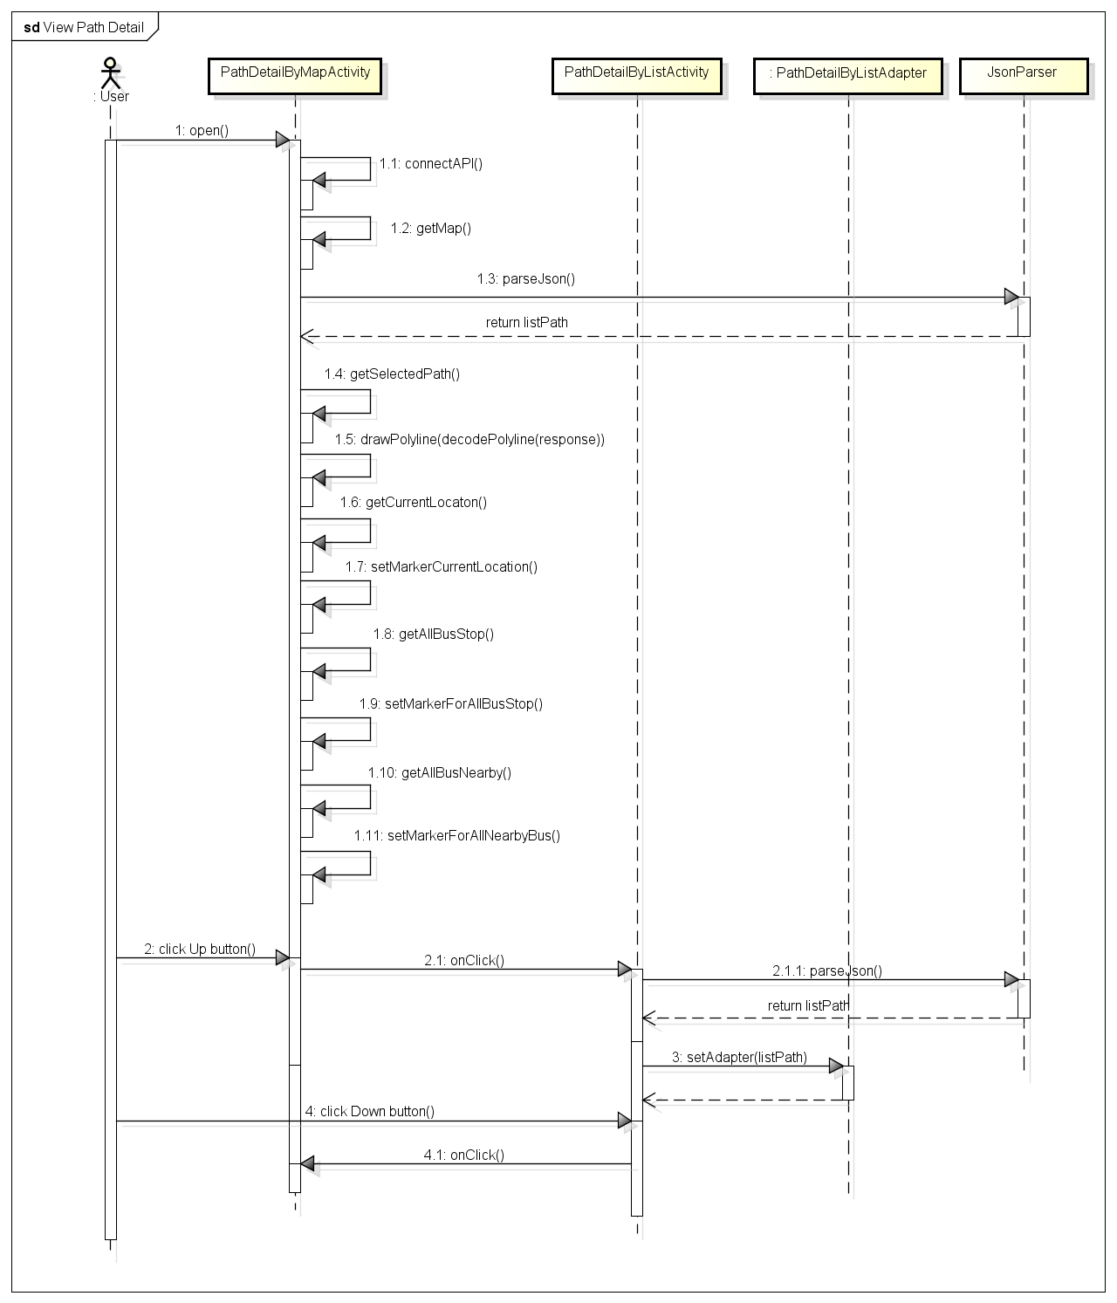 Figure 4-40: View path detail sequence 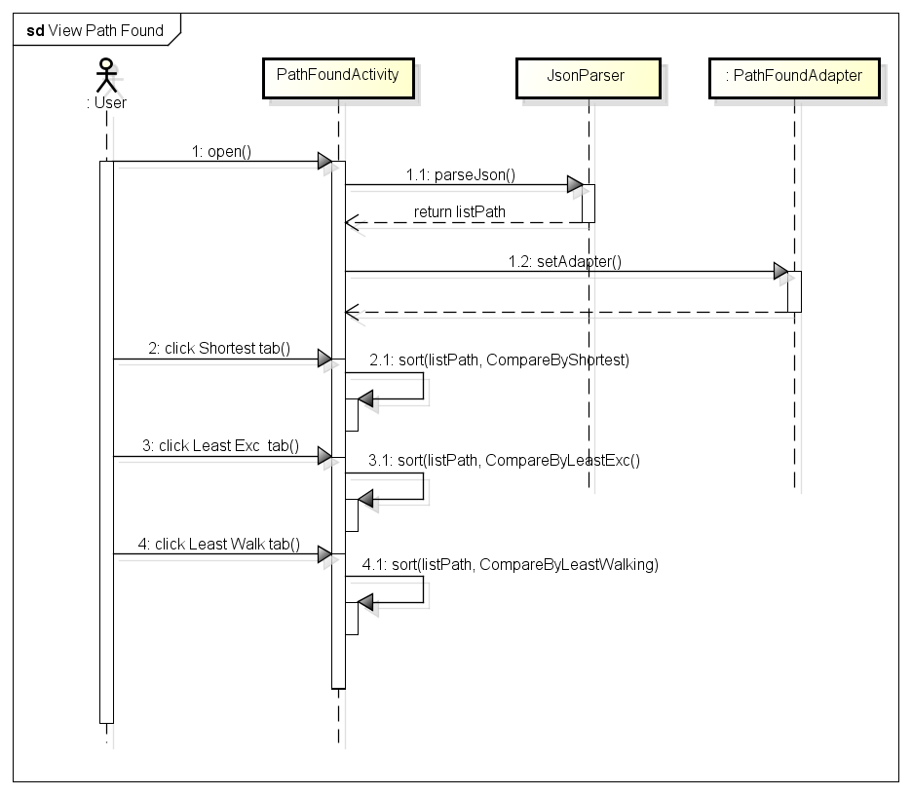 Figure 4-41: View path found sequence

### Deployment view

Deployment view of BUSS:

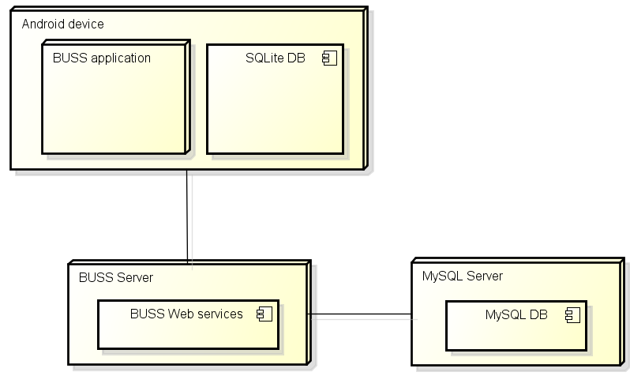

Figure 4-42: Deployment view

|  |  |  |
| --- | --- | --- |
| **No.** | **Name** | **Description** |
| 1 | Android device | Android device with Android 5.0+ |
| 3 | BUSS application | The BUSS android application – BL |
| 3 | SQLite DB | Local SQLite database on Android device |
| 5 | BUSS Web Server | Server for BUSS |
| 6 | BUSS Web Service | Web service for BUSS |
| 7 | MySQL sever | MySQL server use to store system’s data. MySQL5.6.16 or higher |
| 8 | MySQL DB | MySQL database which act as Server DB |

Table 4-6: wsclient package class table

## Class Design

### Packages

|  |  |  |  |
| --- | --- | --- | --- |
| **No** | **Package** | **Language** | **Description** |
| 1. 01 | activity | Java | Store all activities |
|  | adapter | Java | Store all adapters for activities |
|  | common | Java | Store all common class/object |
|  | dao | Java | Store all class which provide access to data |
|  | wsclient | Java | Store all class which work with web service |

Table 4-7: class design package diagram

For more detail, please refer to BUSS_Class_Design_v1.1_EN.docx, section 2. Packages.

### Detailed Functional Design

#### Bus function group

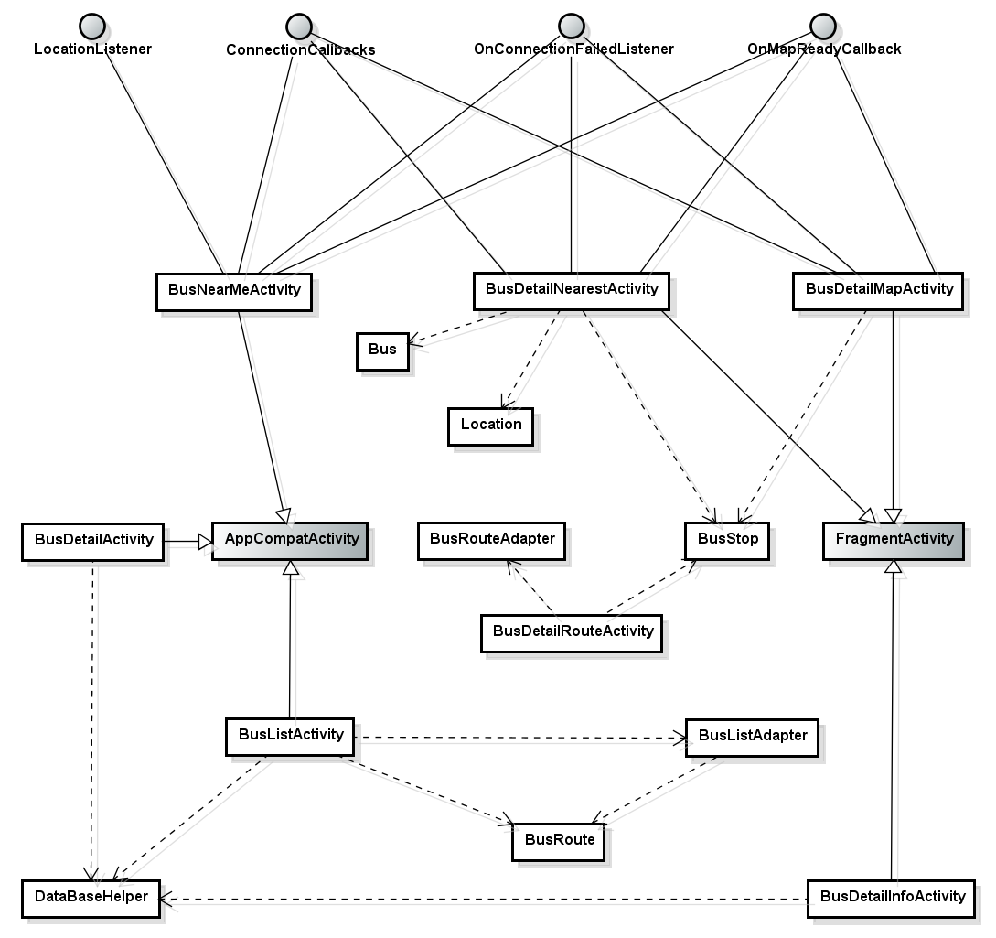

Figure 4-43: Bus function group class diagram

#### Path function group

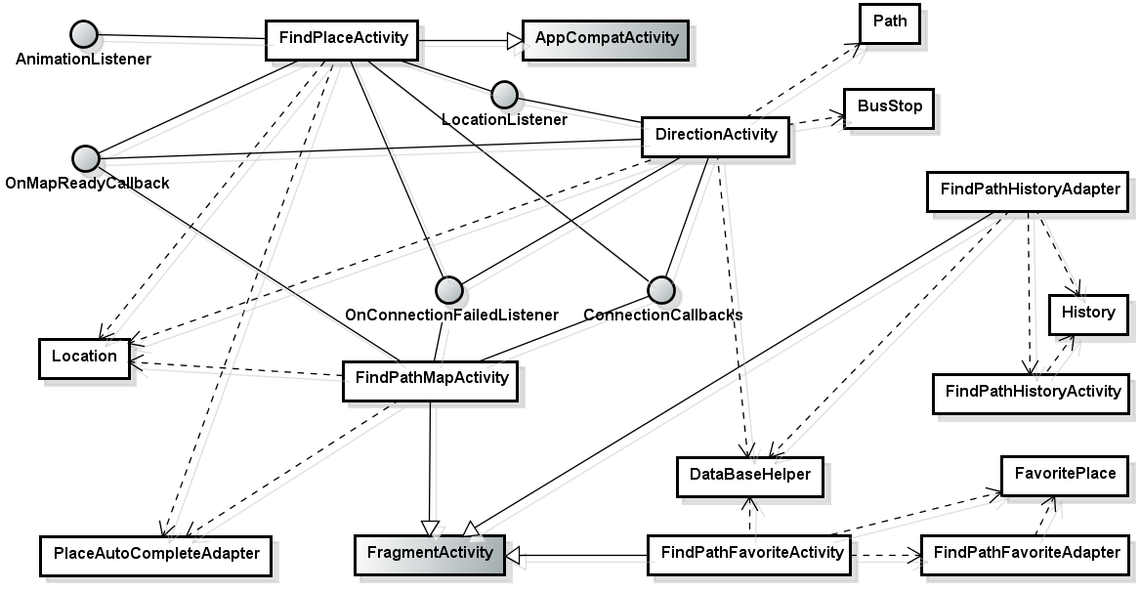

Figure 4-44: Path function group 1 class diagram

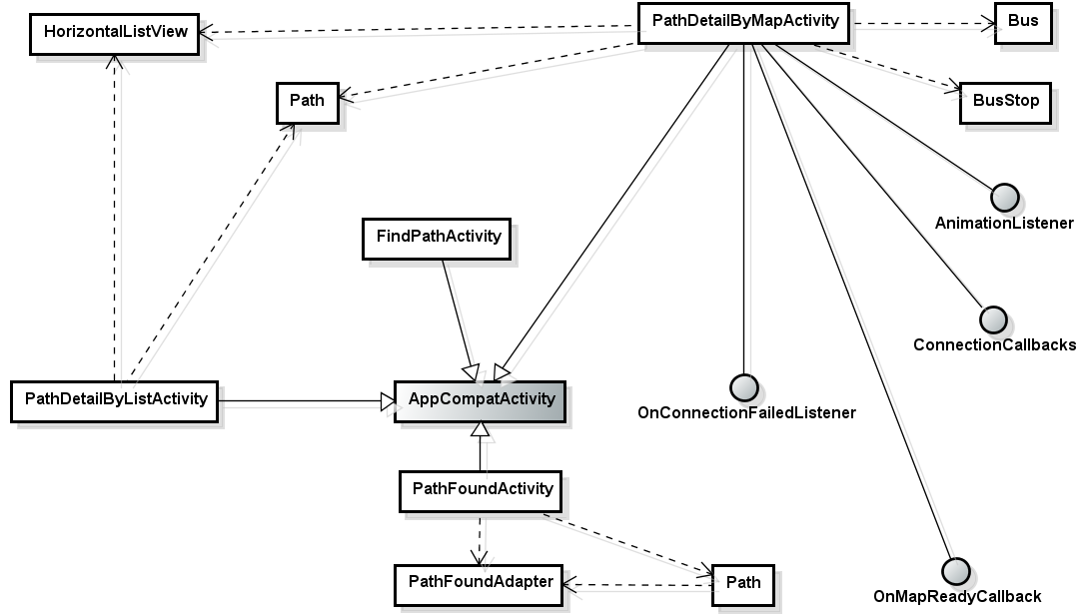

Figure 4-45: Path function group 2 class diagram

#### Favorite function group

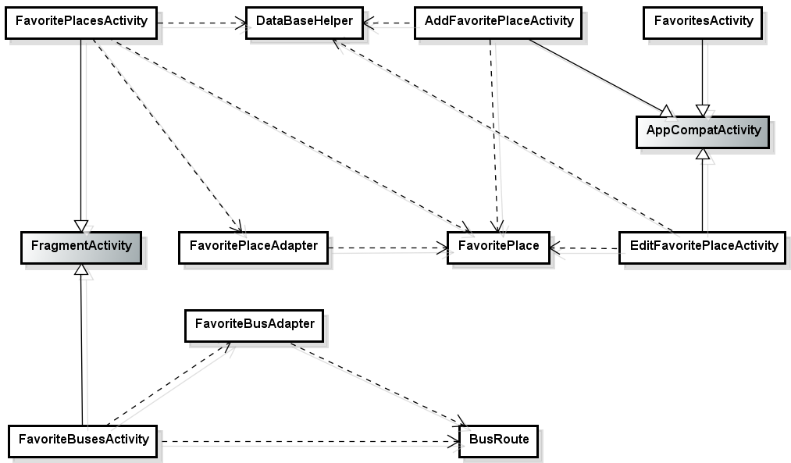

Figure 4-46: Favorite function group class diagram

#### Reminder function group

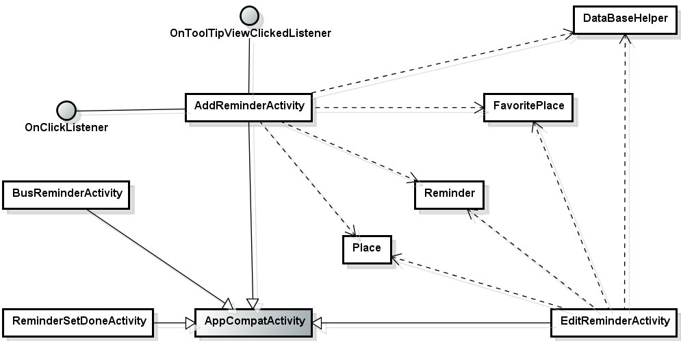

Figure 4-47: Reminder function group class diagram

#### Other

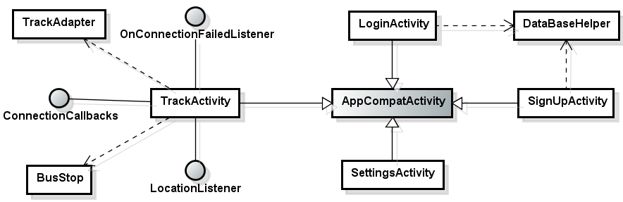

Figure 4-48: Other function class diagram

## Screen Design

### Screen Flow

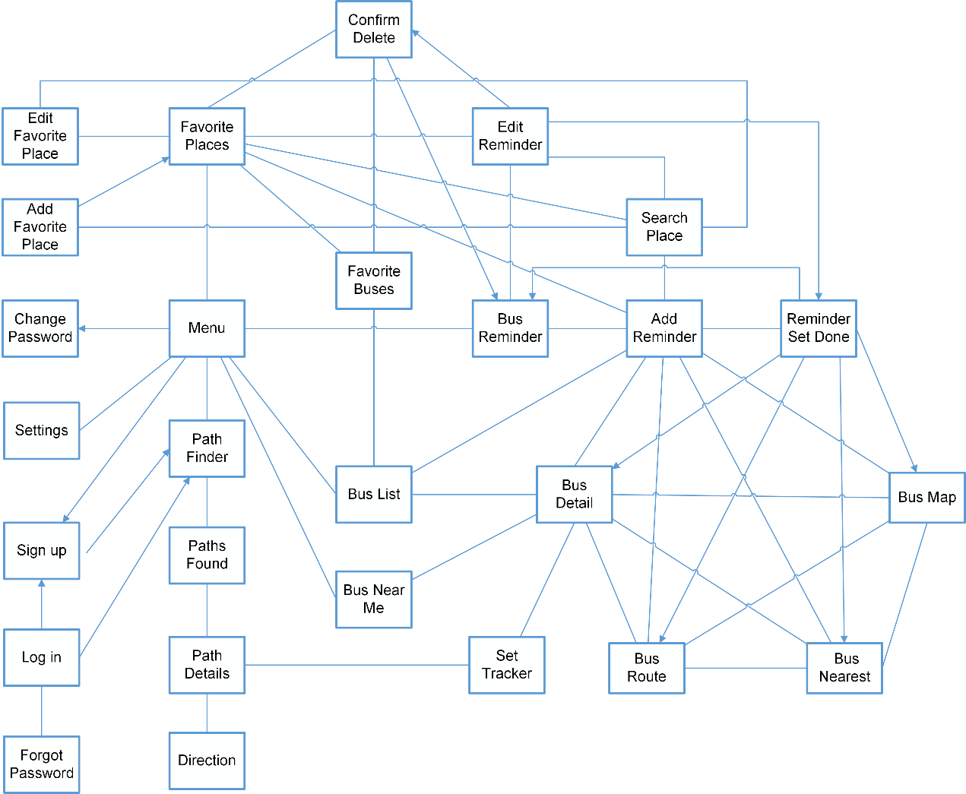

Figure 4-49: Screen Flow

|  |  |  |
| --- | --- | --- |
| **No** | **Screen Name** | **Description** |
| 1 | Log in | Log in |
| 2 | Sign up | Sign up account |
| 3 | Forgot Password | (Dialog) Send password to email |
| 4 | Settings | Settings |
| 5 | Menu | Menu |
| 6 | Bus List | Bus route list |
| 7 | Bus Detail/ Info | Bus route details/info |
| 8 | Bus Route | Display all the bus-stops of the chosen bus route |
| 9 | Bus Nearest | Display nearest buses of the chosen bus route |
| 10 | Bus Map | Display the chosen bus route on map |
| 11 | Set Tracker | Set tracker to notify BU to leave when the bus comes near the predefined stop |
| 12 | Bus Near Me | Display all nearest bus |
| 13 | Path Finder | Find path and all buses which belong to that path |
| 14 | Paths Found | Results of finding path |
| 15 | Path Detail | Details of the chosen path |
| 16 | Directions | Step-by-step giving users detailed directions |
| 17 | Bus Reminder | Lists of bus reminders which will reminder BU when the predefined bus is up to comes to the chosen bus-stop |
| 18 | Add Reminder | Add reminder |
| 19 | Edit Reminder | Edit reminder |
| 20 | Reminder Set Done | Reminder Set Done |
| 21 | Favorite Places | Lists of favorite places |
| 22 | Search place | Search place |
| 23 | Add Favorite Place | Add favorite place |
| 24 | Edit Favorite Place | Edit Favorite Place |
| 25 | Favorite Buses | List of favorite buses |
| 26 | Change Password | Change password dialog |
| 27 | Confirm Delete | Confirm Delete dialog |

Table 4-8: Screen Description

### Screen description

#### Login

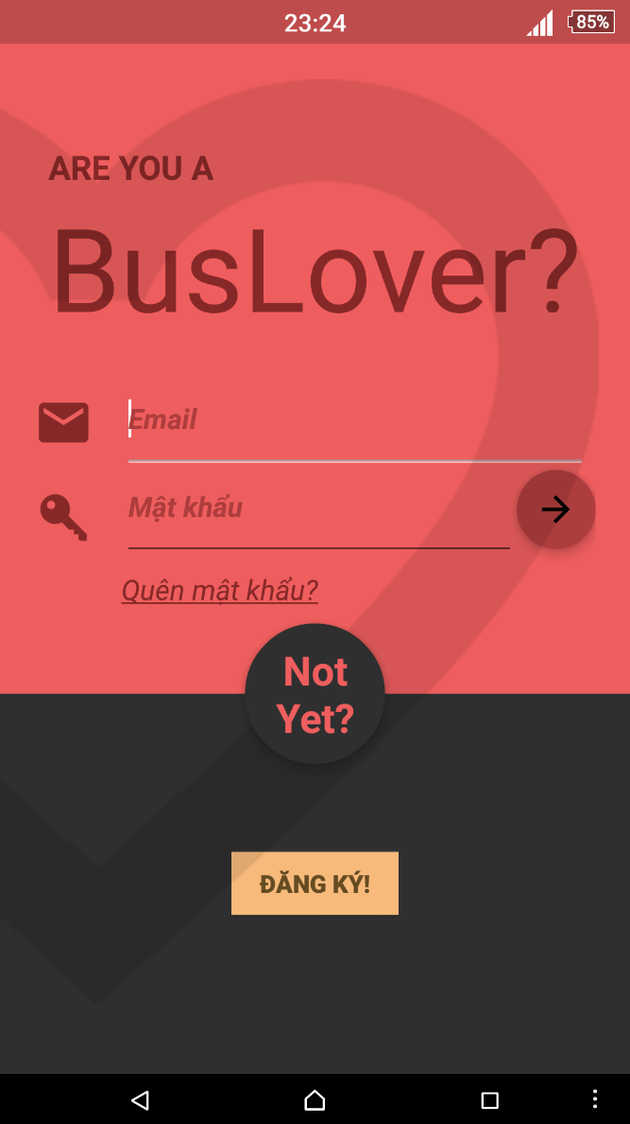

Figure 4-50: Login screen description

|  |  |  |  |  |  |  |  |
| --- | --- | --- | --- | --- | --- | --- | --- |
| **No** | **Field name** | **Field name in Vietnamese** | **Type** | **Require** | **Mandatory** | **Length** | **Description** |
| 1 | Email | Email | Edit Text | Text | Y | 100 | User inputs email |
| 2 | Password | Mật khẩu | Edit Text | Text | Y | 50 | User inputs password |
| 3 | Log in | Đăng nhập | Button | Click | Y |  | User taps on Sign in button |
| 4 | Sign up now | Đăng ký | Button | Click | Y |  | User taps on Sign up now button |
| 5 | Forgot password | Quên mật khẩu | Text | Click | Y |  | User taps on Forgot password text |

Table 4-9: Login Screen Description

#### Sign up

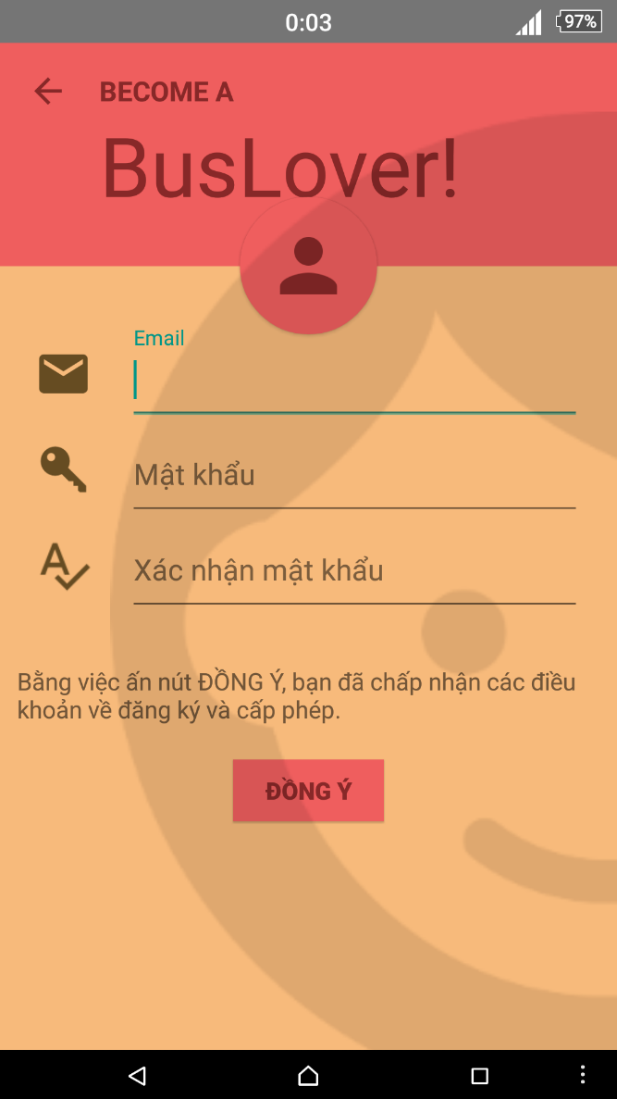

Figure 4-51: Sign up screen description

|  |  |  |  |  |  |  |  |
| --- | --- | --- | --- | --- | --- | --- | --- |
| **No** | **Field name** | **Field name in Vietnamese** | **Type** | **Require** | **Mandatory** | **Length** | **Description** |
| 1 | Email | Email | Edit Text | Text | Y | 255 | User inputs email |
| 2 | Password | Mật khẩu | Edit Text | Password | Y | 50 | User inputs password that only contains number and character |
| 3 | Confirm password | Xác nhận mật khẩu | Edit Text | Text | Y | 50 | User inputs password again |
| 4 | Accept | Đồng ý | Button | Click | Y |  | User taps on Accept button |

Table 4-10: Sign up’s screen description

#### Forgot password

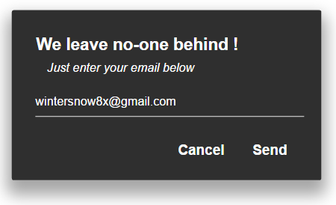

Figure 4-52: Forgot password description

|  |  |  |  |  |  |  |  |
| --- | --- | --- | --- | --- | --- | --- | --- |
| **No** | **Field name** | **Field name in Vietnamese** | **Type** | **Require** | **Mandatory** | **Length** | **Description** |
| 1 | Email | email | Edit Text | Text | Y | 100 | User inputs email |
| 2 | Send | Gửi | Button | Click | Y |  | User taps Send button to send password to email |
| 3 | Cancel | Hủy | Button | Click | Y |  | User taps Cancel button |

Table 4-11: Forgot password’s screen description

#### Change password

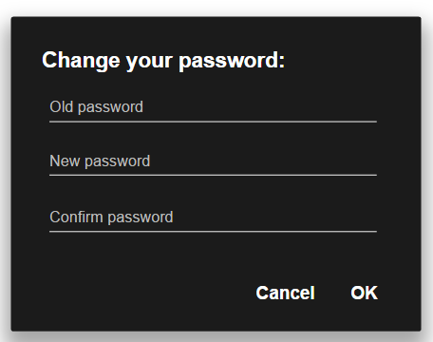

Figure 4-53: Change password description

|  |  |  |  |  |  |  |  |
| --- | --- | --- | --- | --- | --- | --- | --- |
| **No** | **Field name** | **Field name in Vietnamese** | **Type** | **Require** | **Mandatory** | **Length** | **Description** |
| 1 | Old Password | Mật khẩu cũ | Edit Text | Text | Y | 50 | User inputs Old password |
| 2 | New Password | Mật khẩu mới | Edit Text | Text | Y | 50 | User inputs New password |
| 3 | Confirm Password | Xác nhận mật khẩu | Edit Text | Text | Y | 50 | User inputs Confirm password |
| 4 | OK | Đồng ý | Button | Click | Y |  | User taps OK button to change password |
| 5 | Cancel | Hủy | Button | Click | Y |  | User taps Cancel button to cancel |

Table 4-12: Change password’s screen description

#### Settings

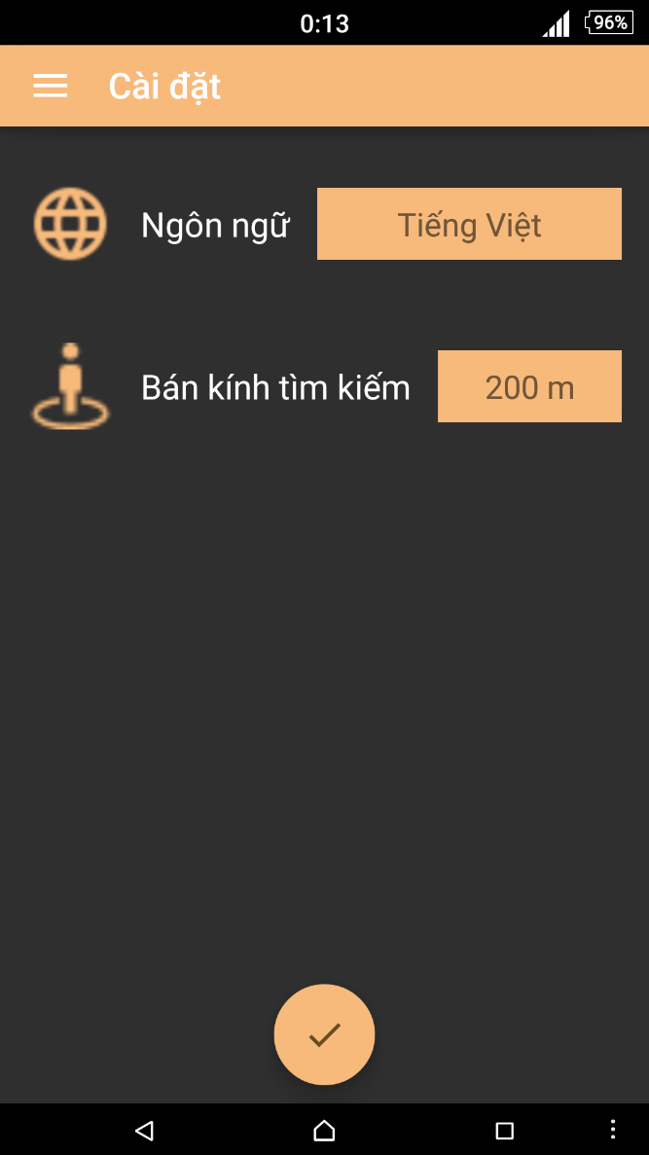

Figure 4-54: Setting Screen

|  |  |  |  |  |  |  |  |
| --- | --- | --- | --- | --- | --- | --- | --- |
| **No** | **Field name** | **Field name in Vietnamese** | **Type** | **Require** | **Mandatory** | **Length** | **Description** |
| 1 | Language | Ngôn ngữ | Drop down list | Click | Y |  | User taps Language dropdown list to choose a language |
| 2 | Search nearby range | Phạm vi tìm kiếm buýt xung quanh | Drop down list | Click | Y |  | User taps Search nearby range dropdown list to choose range |

Table 4-13: Setting’s screen description

#### Menu

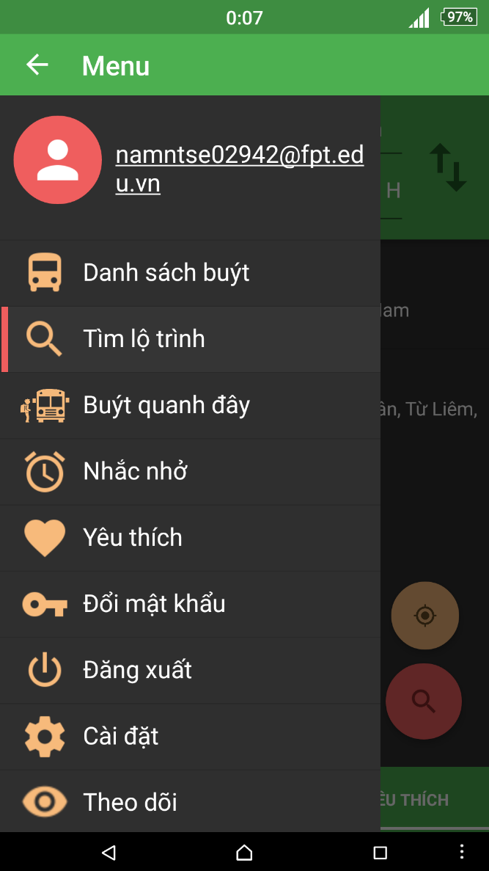

Figure 4-55: Menu

|  |  |  |  |  |  |  |  |
| --- | --- | --- | --- | --- | --- | --- | --- |
| **No** | **Field name** | **Field name in Vietnamese** | **Type** | **Require** | **Mandatory** | **Length** | **Description** |
| 1 | Email | email | Text |  |  |  | User’s email |
| 2 | Bus List | Danh sách buýt | Menu Item | Click | Y |  | User taps Bus List item to enter Bus List screen |
| 3 | Find Path | Tìm lộ trình | Menu Item | Click | Y |  | User taps Bus List item to enter Bus List screen |
| 4 | Bus Near Me | Buýt quanh đây | Menu Item | Click | Y |  | User taps Bus List item to enter Bus List screen |
| 5 | Bus Reminder | Nhắc nhở | Menu Item | Click | Y |  | User taps Bus List item to enter Bus List screen |
| 6 | Favorites | Yêu thích | Menu Item | Click | Y |  | User taps Bus List item to enter Bus List screen |
| 7 | Change Password | Đổi mật khẩu | Menu Item | Click | Y |  | User taps Bus List item to enter Bus List screen |
| 8 | Sign Out | Đăng xuất | Menu Item | Click | Y |  | User taps Bus List item to enter Bus List screen |
| 9 | Settings | Cài đặt | Menu Item | Click | Y |  | User taps Bus List item to enter Bus List screen |
| 10 | Snooze Mode | Chế độ im lặng | Menu Item | Click | Y |  | User taps Bus List item to enter Bus List screen |

Table 4-14: Menu description

#### Bus List

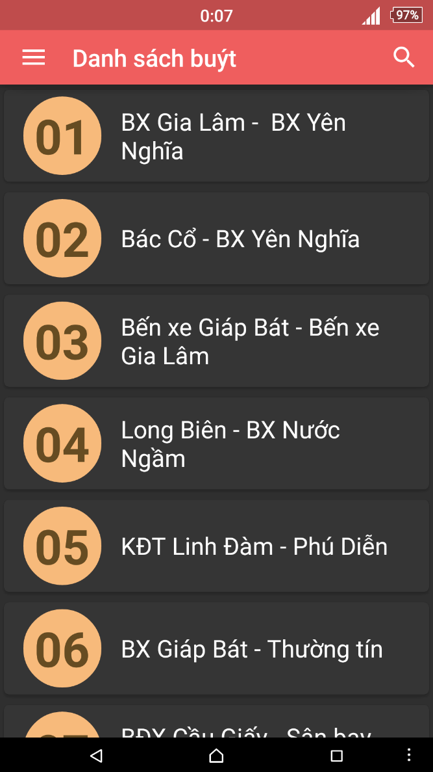

Figure 4.55: Bus List screen

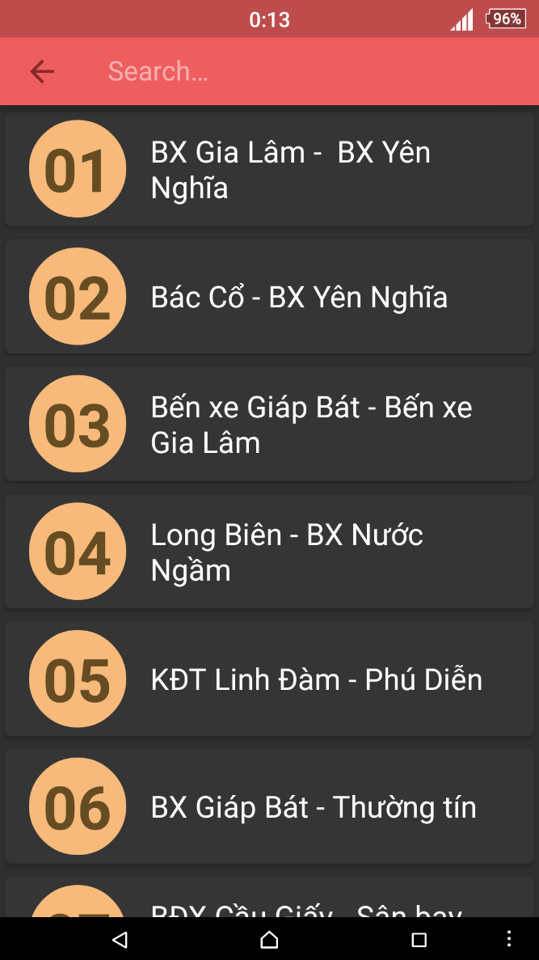

Figure 4.56: Search Bus List screen

|  |  |  |  |  |  |  |  |
| --- | --- | --- | --- | --- | --- | --- | --- |
| **No** | **Field name** | **Field name in Vietnamese** | **Type** | **Require** | **Mandatory** | **Length** | **Description** |
| 1 | Bus route | Tuyến xe buýt | List item | Click | Y |  | User taps on Skip button |
| 2 | Search | Tìm kiếm | Button | Click | Y |  | User taps on Search button |
| 3 | Menu | Danh sách | Button | Click | Y |  | User taps on Menu button |

Table 3-15: Bus List screen description

#### Bus Info

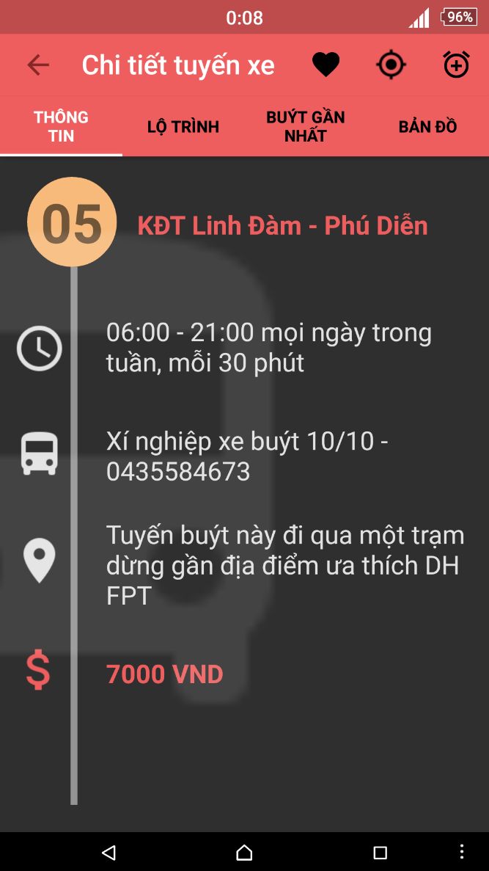

Figure 4-23: View Bus Info

|  |  |  |  |  |  |  |  |
| --- | --- | --- | --- | --- | --- | --- | --- |
| **No** | **Field name** | **Field name in Vietnamese** | **Type** | **Require** | **Mandatory** | **Length** | **Description** |
| 1 | Info | Thông tin | Tab | Click | Y |  | User taps on Info tab |
| 2 | Route | Tuyến đường | Tab | Click | Y |  | User taps on Route tab |
| 3 | Nearest | Gần nhất | Tab | Click | Y |  | User taps on Nearest tab |
| 4 | Map | Bản đồ | Tab | Click | Y |  | User taps on Map button |
| 5 | Favorite | Yêu thích | Button | Click | Y |  | User taps on Favorite button |
| 6 | Tracker | Theo dõi | Button | Click | Y |  | User taps on Track button |
| 7 | Menu | Danh sách | Button | Click | Y |  | User taps on Menu button |
| 8 | Add Reminder | Thêm nhắc nhở | Button | Click | Y |  | User taps on Add Reminder button |

Table 4-16: View Bus Info screen description

#### Bus Route

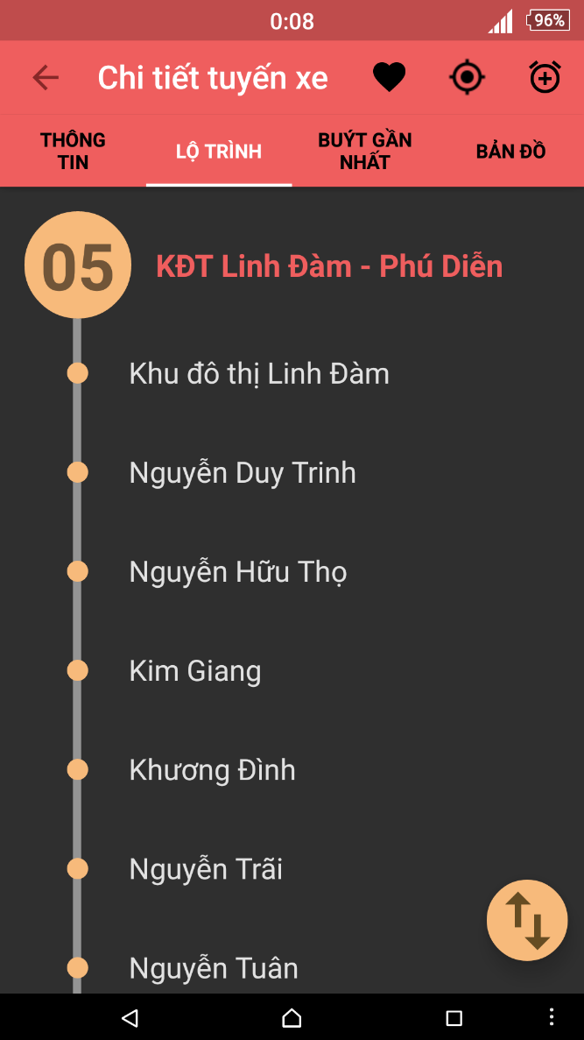

Figure 4-57: View Bus Route

|  |  |  |  |  |  |  |  |
| --- | --- | --- | --- | --- | --- | --- | --- |
| **No** | **Field name** | **Field name in Vietnamese** | **Type** | **Require** | **Mandatory** | **Length** | **Description** |
| 1 | Info | Thông tin | Tab | Click | Y |  | User taps on Info tab |
| 2 | Route | Tuyến đường | Tab | Click | Y |  | User taps on Route tab |
| 3 | Nearest | Gần nhất | Tab | Click | Y |  | User taps on Nearest tab |
| 4 | Map | Bản đồ | Tab | Click | Y |  | User taps on Map button |
| 5 | Favorite | Yêu thích | Button | Click | Y |  | User taps on Favorite button |
| 6 | Tracker | Theo dõi | Button | Click | Y |  | User taps on Track button |
| 7 | Menu | Danh sách | Button | Click | Y |  | User taps on Menu button |

Table 4-17: View Bus Route screen description

#### Bus Nearest

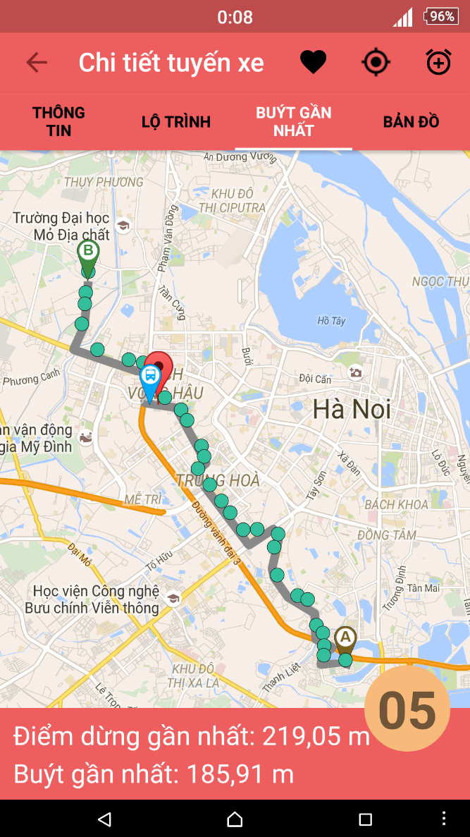

Figure 4-58: View Bus Nearest

|  |  |  |  |  |  |  |  |
| --- | --- | --- | --- | --- | --- | --- | --- |
| **No** | **Field name** | **Field name in Vietnamese** | **Type** | **Require** | **Mandatory** | **Length** | **Description** |
| 1 | Info | Thông tin | Tab | Click | Y |  | User taps on Info tab |
| 2 | Route | Tuyến đường | Tab | Click | Y |  | User taps on Route tab |
| 3 | Nearest | Gần nhất | Tab | Click | Y |  | User taps on Nearest tab |
| 4 | Map | Bản đồ | Tab | Click | Y |  | User taps on Map button |
| 5 | Favorite | Yêu thích | Button | Click | Y |  | User taps on Favorite button |
| 6 | Tracker | Theo dõi | Button | Click | Y |  | User taps on Track button |
| 7 | Menu | Danh sách | Button | Click | Y |  | User taps on Menu button |
| 8 | Add Reminder | Thêm nhắc nhở | Button | Click | Y |  | User taps on Add Reminder button |

Table 4-18: View Bus Nearest screen description

#### Bus Map

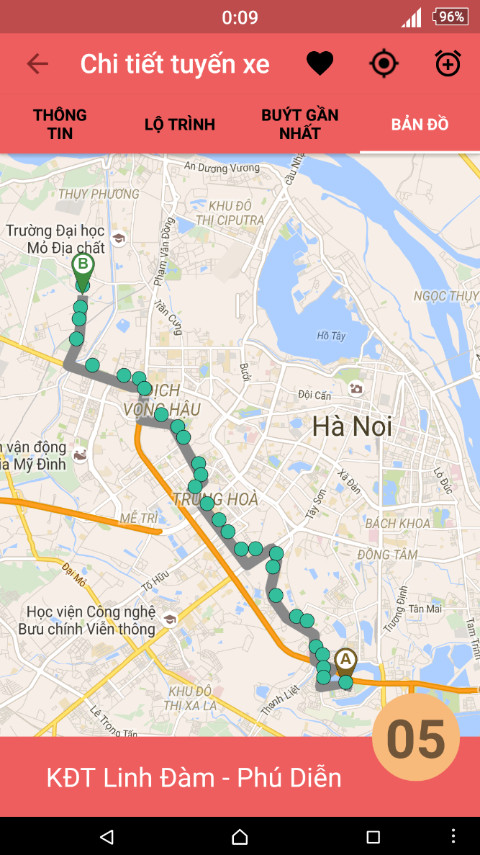

Figure 4-59: View Bus Map

|  |  |  |  |  |  |  |  |
| --- | --- | --- | --- | --- | --- | --- | --- |
| **No** | **Field name** | **Field name in Vietnamese** | **Type** | **Require** | **Mandatory** | **Length** | **Description** |
| 1 | Info | Thông tin | Tab | Click | Y |  | User taps on Info tab |
| 2 | Route | Tuyến đường | Tab | Click | Y |  | User taps on Route tab |
| 3 | Nearest | Gần nhất | Tab | Click | Y |  | User taps on Nearest tab |
| 4 | Map | Bản đồ | Tab | Click | Y |  | User taps on Map button |
| 5 | Favorite | Yêu thích | Button | Click | Y |  | User taps on Favorite button |
| 6 | Tracker | Theo dõi | Button | Click | Y |  | User taps on Track button |
| 7 | Menu | Danh sách | Button | Click | Y |  | User taps on Menu button |
| 8 | Add Reminder | Thêm nhắc nhở | Button | Click | Y |  | User taps on Add Reminder button |

Table 4-19: View Bus Map screen description

#### Bus near Me

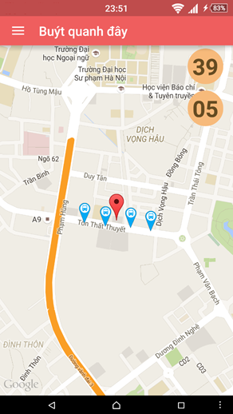

Figure 4-60: View Bus near Me

|  |  |  |  |  |  |  |  |
| --- | --- | --- | --- | --- | --- | --- | --- |
| **No** | **Field name** | **Field name in Vietnamese** | **Type** | **Require** | **Mandatory** | **Length** | **Description** |
| 1 | Menu | Danh sách | Button | Click | Y |  | User taps Menu button |
| 2 | Bus route | Tuyến buýt | Button | Click | Y |  | User taps Bus route button |
| 3 | Bus | Buýt | Icon | Click | Y |  | User taps Bus icon on map |

Table 4-20: View Bus near Me screen description

#### Find Path

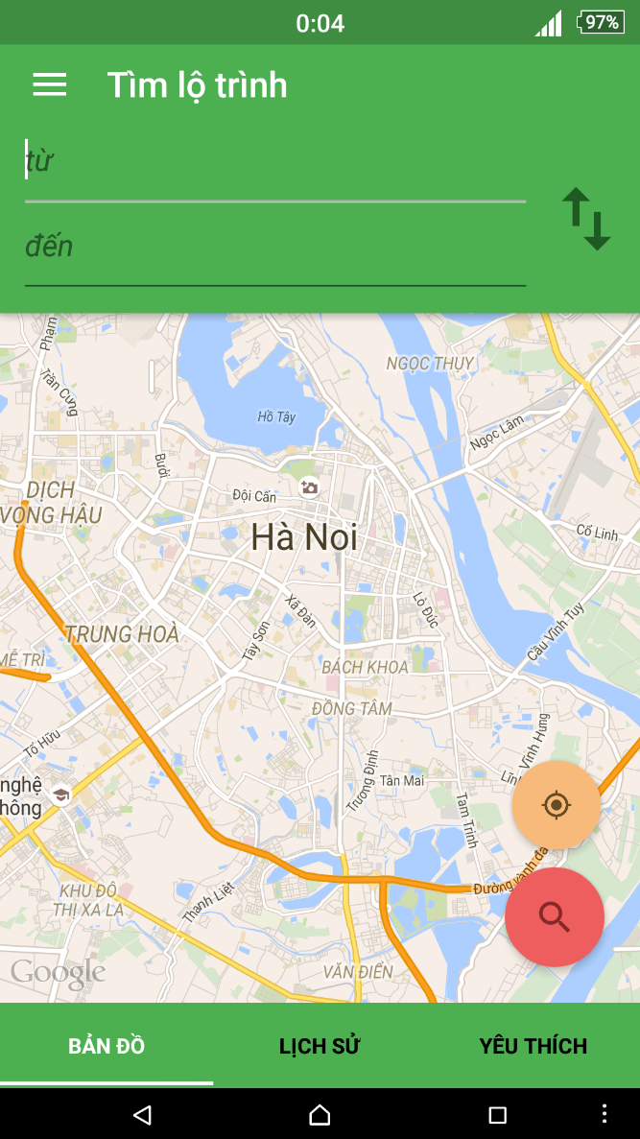

Figure 4-61: Find Path – tab Map

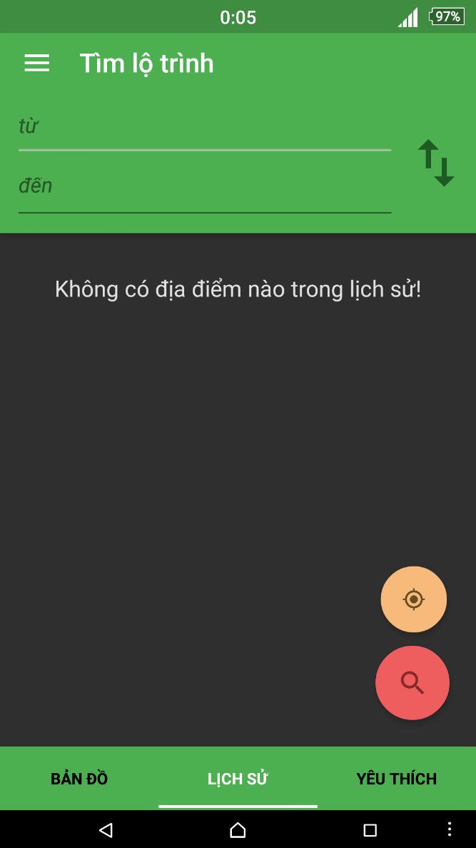

Figure 4-62: Find Path – tab History

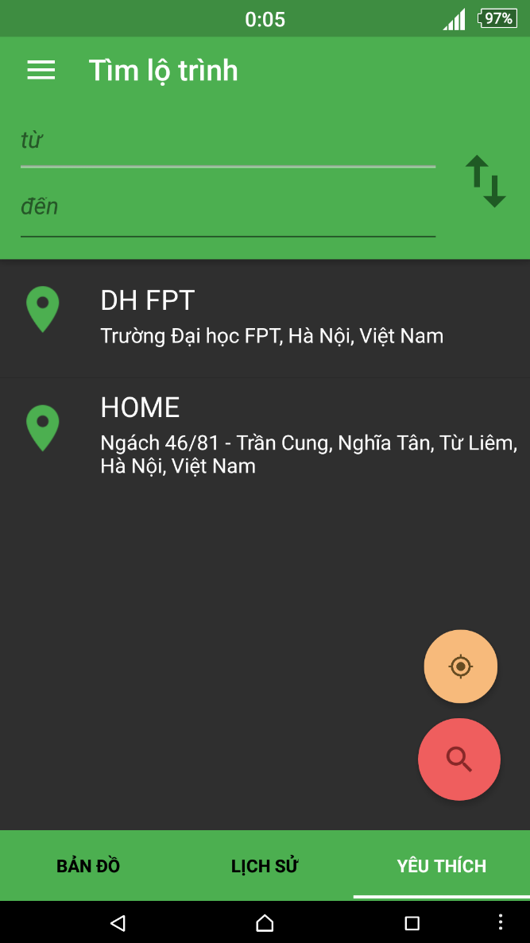

Figure 4-63: Find Path – tab Favorite

|  |  |  |  |  |  |  |  |
| --- | --- | --- | --- | --- | --- | --- | --- |
| **No** | **Field name** | **Field name in Vietnamese** | **Type** | **Require** | **Mandatory** | **Length** | **Description** |
| 1 | From | Từ | Text field | Text | Y | 255 | User inputs their position or the place they start to go with less than 255 characters. |
| 2 | To | Đến | Text field | Text | Y | 255 | User inputs the place they want to go with less than 255 characters. |
| 3 | Reverse | Đảo chiều | Button | Click | Y |  | User taps on Reverse button |
| 4 | Search | Tìm kiếm | Button | Click | Y |  | User taps on Search button |
| 5 | Get current location | Lấy vị trí hiện tại | Button | Click | Y |  | User taps on Get current location button |
| 6 | Map | Bản đồ | Tab | Click | Y |  | User taps on Map tab |
| 7 | History | Lịch sử | Tab | Click | Y |  | User taps on History tab |
| 8 | Favorite | Yêu thích | Tab | Click | Y |  | User taps on Favorite tab |
| 9 | Menu | Danh sách | Button | Click | Y |  | User taps on Menu button |
| 10 | History | Lịch sử | List item | Click | Y |  | User taps on History item |
| 11 | Favorite | Yêu thích | List item | Click | Y |  | User taps on Favorite item |

Table 4-22: Find Path screen description

#### Path Found

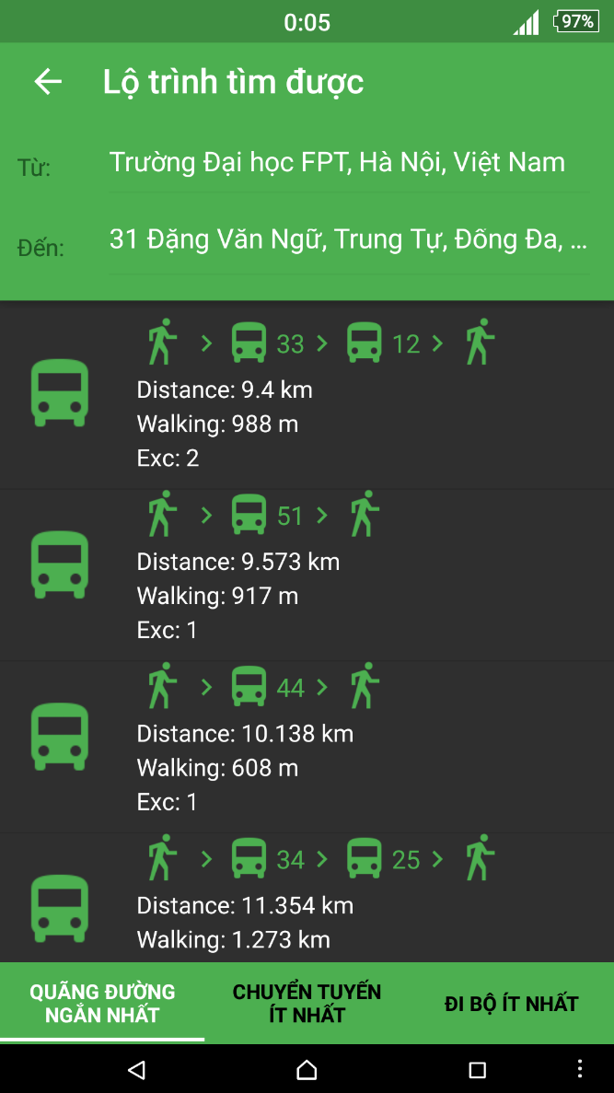

Figure 4-64: Path found screen – Shortest

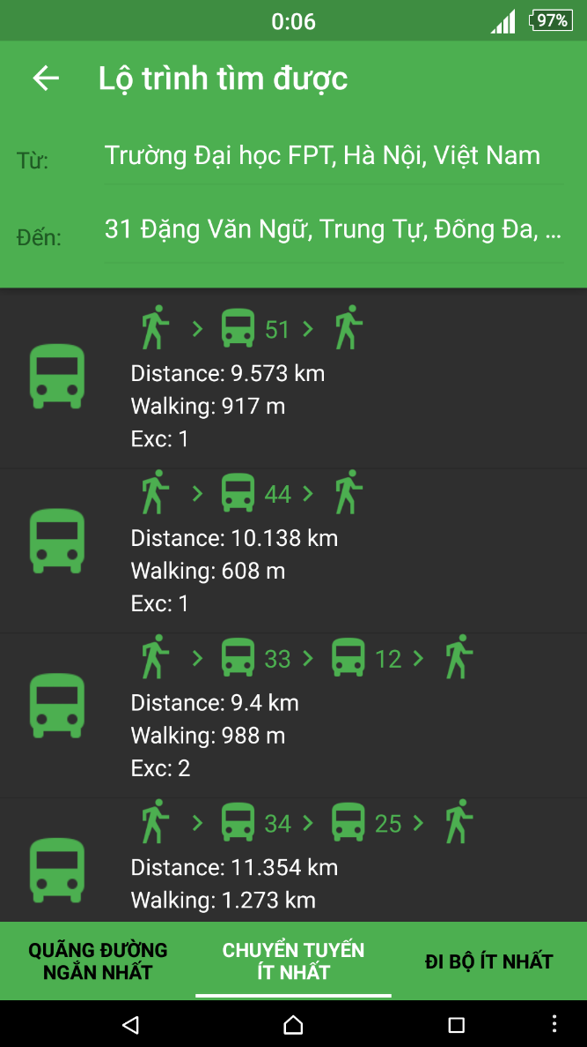

Figure 4-65: Path found screen – Least Exc

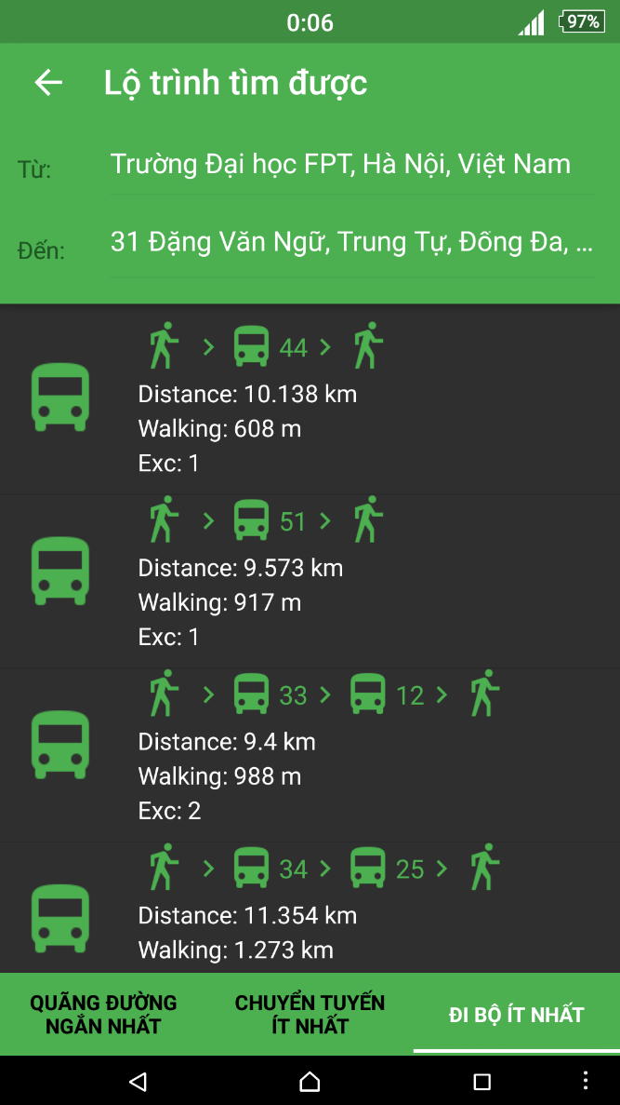

Figure 4-66: Path found screen – Least Walk

|  |  |  |  |  |  |  |  |
| --- | --- | --- | --- | --- | --- | --- | --- |
| **No** | **Field name** | **Field name in Vietnamese** | **Type** | **Require** | **Mandatory** | **Length** | **Description** |
| 1 | Shortest | Quãng đường ngắn nhất | Tab | Click | Y |  | User taps on Shortest tab |
| 2 | Least Exc | Chuyển tuyến ít nhất | Tab | Click | Y |  | User taps on Least Exc tab |
| 3 | Least Walk | Đi bộ ít nhất | Tab | Click | Y |  | User taps on Least Walk tab |
| 4 | Menu | Menu | Button | Click | Y |  | User taps on Menu button |

Table 4-24: View Path Found screen description

#### Path Detail

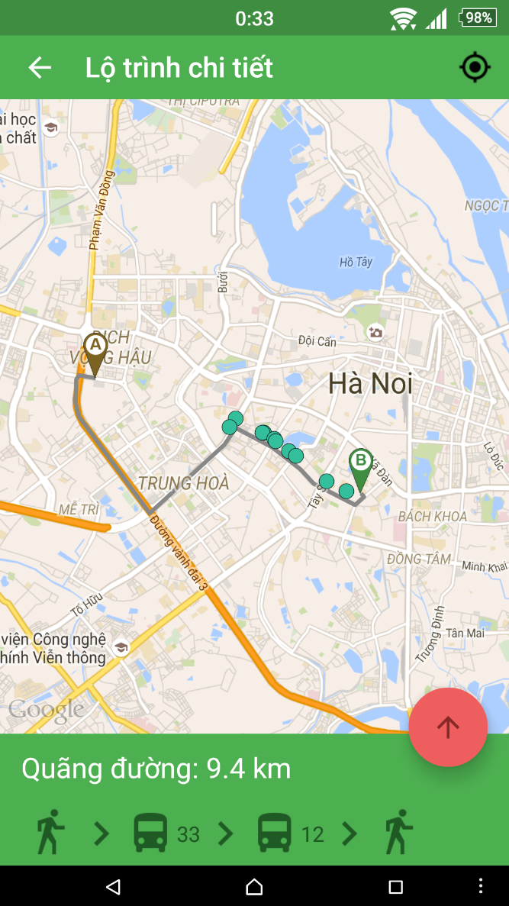

Figure 4-67: Path Detail by Map

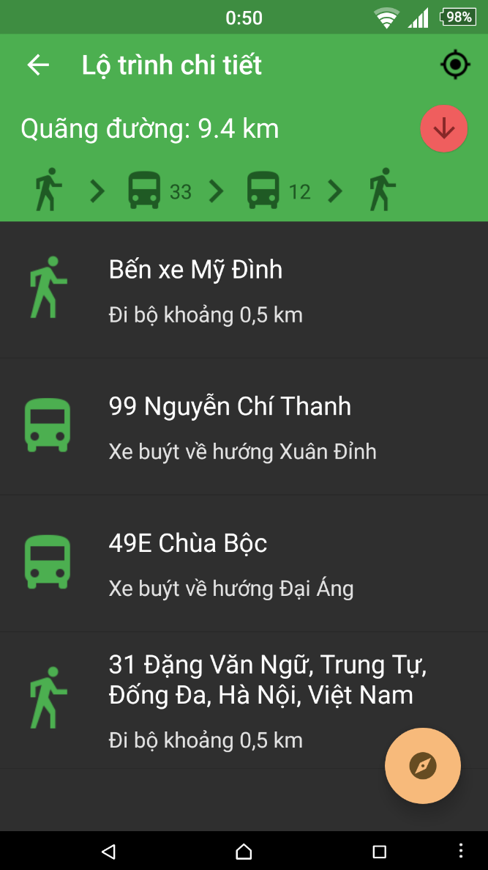

Figure 4-68: Path Detail by List

|  |  |  |  |  |  |  |  |
| --- | --- | --- | --- | --- | --- | --- | --- |
| **No** | **Field name** | **Field name in Vietnamese** | **Type** | **Require** | **Mandatory** | **Length** | **Description** |
| 1 | Track | Theo dõi | Button | Click | Y |  | User taps on Track button |
| 2 | Bus | Buýt | Icon | Click | Y |  | User taps Bus icon displaying on map |
| 3 | Arrow up | Mũi tên đi lên | Button | Click | Y |  | User taps on Arrow up button |
| 4 | Arrow down | Mũi tên đi xuống | Button | Click | Y |  | User taps on Arrow down button |
| 5 | Path detail | Chi tiết đường đi | List item |  |  |  |  |
| 6 | Navigate | Chỉ đường | Button | Click | Y |  | User taps on Navigate button |
| 7 | Back | Quay lại | Button | Click | Y |  | User taps on Back button |

Table 4-26: Path Detail screen description

#### Direction

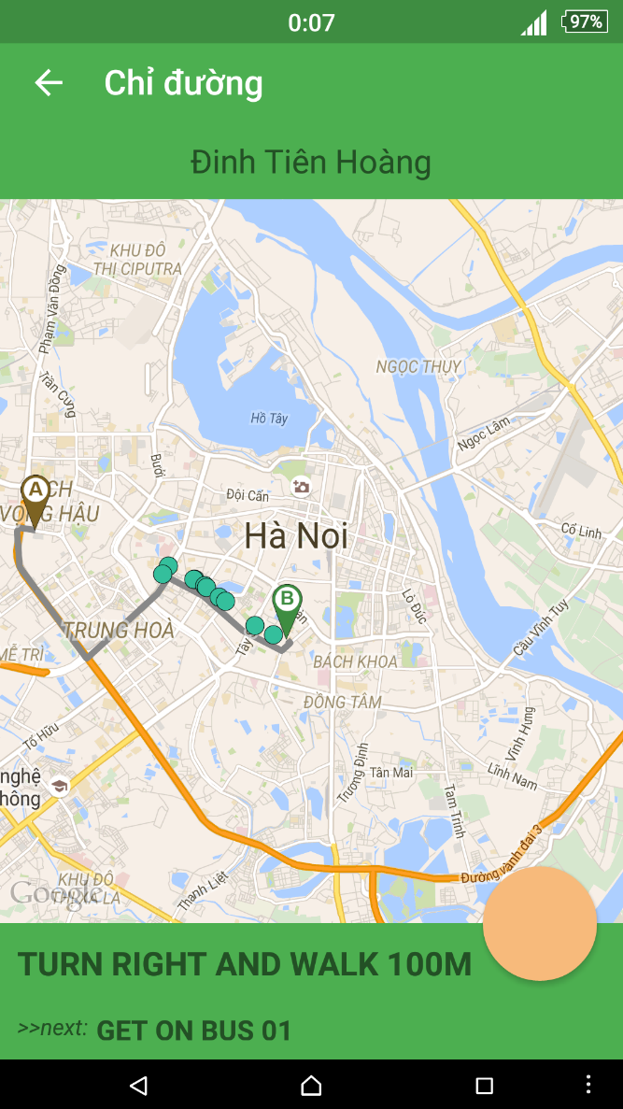

Figure 4-68: View Direction

|  |  |  |  |  |  |  |  |
| --- | --- | --- | --- | --- | --- | --- | --- |
| **No** | **Field name** | **Field name in Vietnamese** | **Type** | **Require** | **Mandatory** | **Length** | **Description** |
| 1 | Back | Quay lại | Button | Click | Y |  | User taps on Back button |

Table 4-27: View Direction screen description

#### Bus Reminder

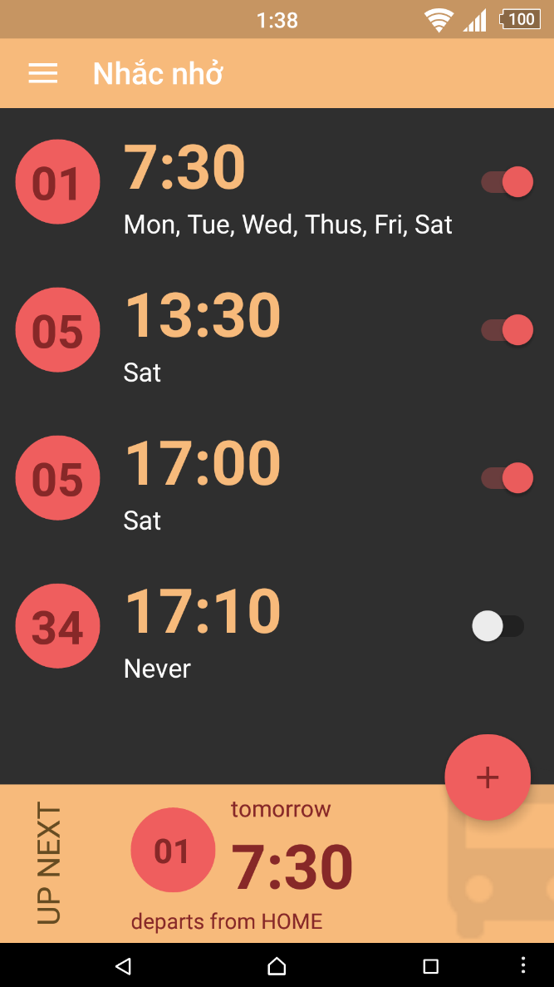

Figure 4-69: View Bus Reminder

|  |  |  |  |  |  |  |  |
| --- | --- | --- | --- | --- | --- | --- | --- |
| **No** | **Field name** | **Field name in Vietnamese** | **Type** | **Require** | **Mandatory** | **Length** | **Description** |
| 1 | Add | Thêm | Button | Click | Y |  | User taps on Add button |
| 2 | Menu | Danh sách | Button | Click | Y |  | User taps on Menu button |
| 3 | Reminder | Nhắc nhở | List item | Click | Y |  | User taps on Reminder item |
| 4 | Suspend | Ngừng | Switch | Click | Y |  | User taps on Suspend switch |

Table 4-28: View Reminder screen description

#### Add Reminder

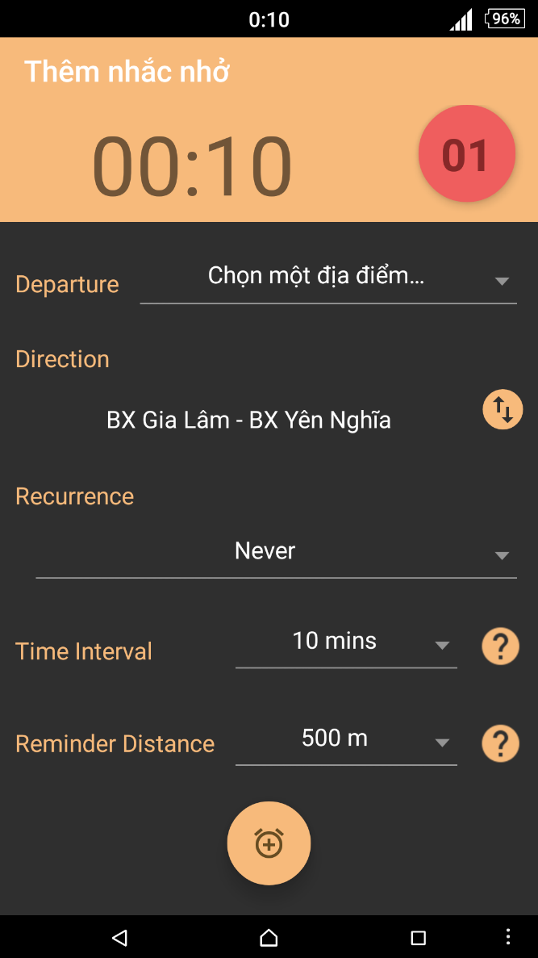

Figure 4-70: Add reminder screen

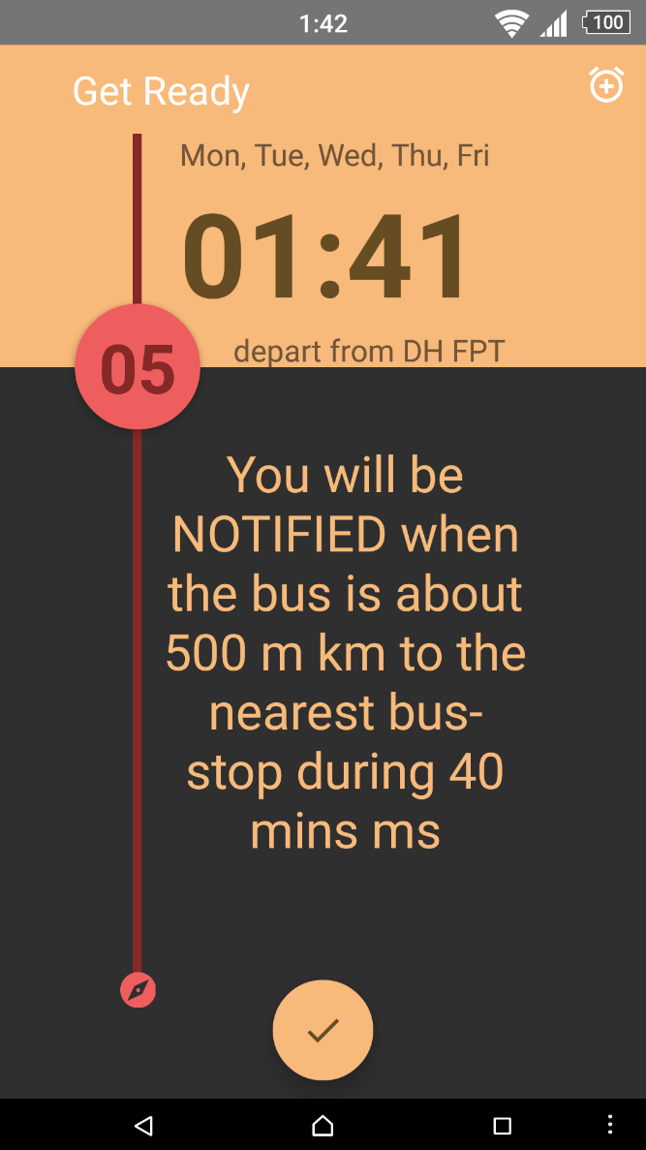

Figure 4-71: Reminder set done screen

|  |  |  |  |  |  |  |  |
| --- | --- | --- | --- | --- | --- | --- | --- |
| **No** | **Field name** | **Field name in Vietnamese** | **Type** | **Require** | **Mandatory** | **Length** | **Description** |
| 1 | Bus route | Tuyến buýt | Button | Click | Y |  | User taps on Bus route button |
| 2 | Time | Giờ | Button | Click | Y |  | User taps on Time button |
| 3 | Departure | Điểm đi | Drop down list | Click | Y |  | User taps Departure drop down list |
| 4 | Direction | Hướng | Drop down list | Click | Y |  | User taps Direction drop down list |
| 5 | Recurrence | Lặp lại | Check box list | Click | Y |  | User taps Recurrece to choose days |
| 6 | Time Interval | Khoảng thời gian báo | Drop down list | Click | Y |  | User taps Time Interval drop down list |
| 7 | Help | Chú thích | Button | Click | Y |  | User taps Help button |
| 8 | Reminder distance | Khoảng cách nhận thông báo | Drop down list | Click | Y |  | User taps Reminder distance drop down list |
| 9 | Add Reminder | Thêm | Button | Click | Y |  | User taps on Add button to add reminder |
| 10 | Back | Quay lại | Button | Click | Y |  | User taps on Back button to go back |
| 11 | Done | Xong | Button | Click | Y |  | User taps on Done button |
| 12 | Add other reminder | Thêm nhắc nhở khác | Button | Click | Y |  | User taps on Add other reminder button |

Table 4-29: Add Reminder screen description

#### Edit Reminder

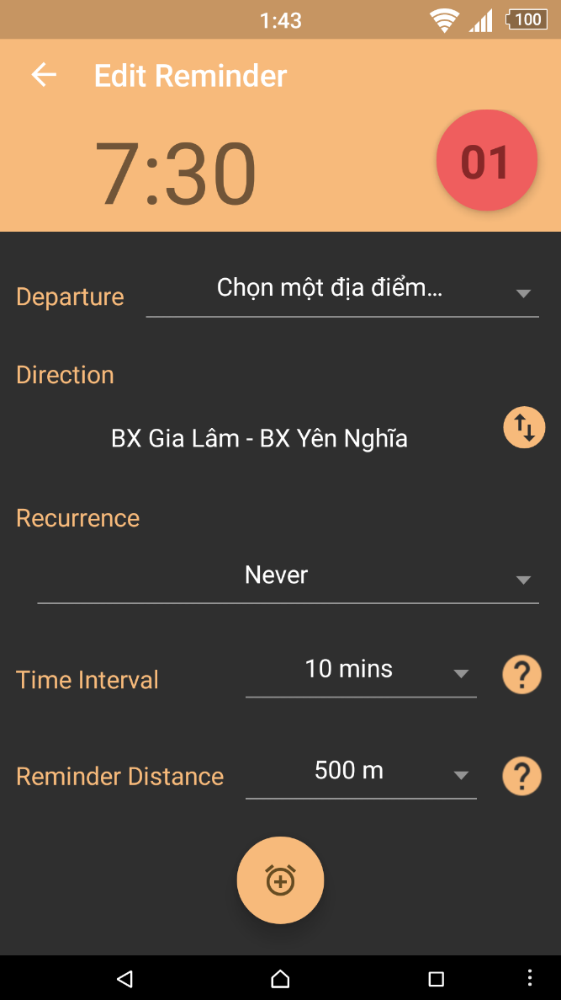

Figure 4-72: Edit reminder screen

|  |  |  |  |  |  |  |  |
| --- | --- | --- | --- | --- | --- | --- | --- |
| **No** | **Field name** | **Field name in Vietnamese** | **Type** | **Require** | **Mandatory** | **Length** | **Description** |
| 1 | Bus route | Tuyến buýt | Button | Click | Y |  | User taps on Bus route button |
| 2 | Time | Giờ | Button | Click | Y |  | User taps on Time button |
| 3 | Departure | Điểm đi | Drop down list | Click | Y |  | User taps Departure drop down list |
| 4 | Direction | Hướng | Drop down list | Click | Y |  | User taps Direction drop down list |
| 5 | Recurrence | Lặp lại | Button | Click | Y |  | User taps Recurrece (dates) buttons |
| 6 | Time Interval | Khoảng thời gian báo | Drop down list | Click | Y |  | User taps Time Interval drop down list |
| 7 | Help | Chú thích | Button | Click | Y |  | User taps Help button |
| 8 | Reminder distance | Khoảng cách nhận thông báo | Drop down list | Click | Y |  | User taps Reminder distance drop down list |
| 9 | Save | Lưu | Button | Click | Y |  | User taps on Save button |
| 10 | Delete | Xóa | Button | Click | Y |  | User taps on Delete button |
| 11 | Back | Quay lại | Button | Click | Y |  | User taps on Back button to go back |
| 12 | Done | Xong | Button | Click | Y |  | User taps on Done button |

Table 4-30: Edit Reminder screen description

#### Confirm delete

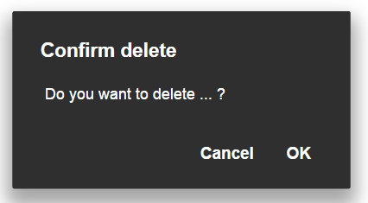

Figure 4-71: Confirm delete screen

|  |  |  |  |  |  |  |  |
| --- | --- | --- | --- | --- | --- | --- | --- |
| **No** | **Field name** | **Field name in Vietnamese** | **Type** | **Require** | **Mandatory** | **Length** | **Description** |
| 1 | Content of dialog | Nội dung | Text View |  |  |  |  |
| 2 | OK | Đồng ý | Button | Click | Y |  | User taps OK button to confim delete |
| 3 | Cancel | Hủy | Button | Click | Y |  | User taps Cancel button to cancel delete |

Table 4-31: Confirm delete description

#### Track

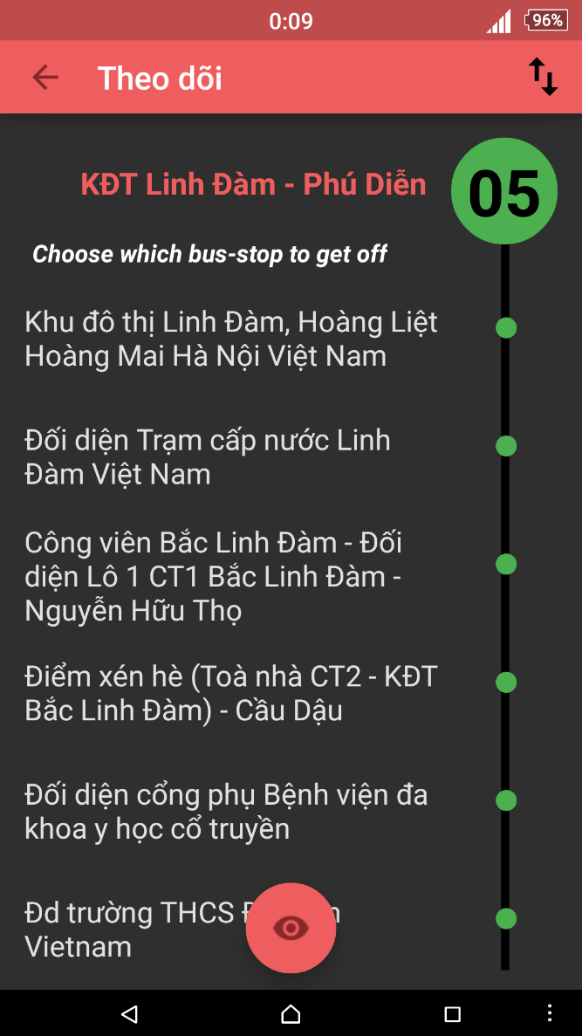

Figure 4-72: Track screen

|  |  |  |  |  |  |  |  |
| --- | --- | --- | --- | --- | --- | --- | --- |
| **No** | **Field name** | **Field name in Vietnamese** | **Type** | **Require** | **Mandatory** | **Length** | **Description** |
| 1 | Track | Theo dõi | Button | Click | Y |  | User taps on Track button |
| 2 | Reverse | Đảo chiều | Button | Click | Y |  | User taps on Revert button to reverse direction |
| 3 | Bus stop | Trạm dừng | List item | Click | Y |  | User taps on Bus stop item to choose where to stop. |
| 2 | Back | Quay lại | Button | Click | Y |  | User taps on Back button to go back |

Table 4-32: Track screen description

#### Cancel Track

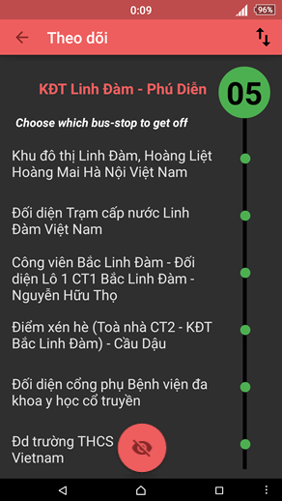

Figure 4-73 Cancel Track screen

|  |  |  |  |  |  |  |  |
| --- | --- | --- | --- | --- | --- | --- | --- |
| **No** | **Field name** | **Field name in Vietnamese** | **Type** | **Require** | **Mandatory** | **Length** | **Description** |
| 1 | Cancel track | Hủy theo dõi | Button | Click | Y |  | User taps on Cancel track button |
| 2 | Reverse | Đảo chiều | Button | Click | Y |  | User taps on Revert button to reverse direction |
| 3 | Bus stop | Trạm dừng | List item | Click | Y |  | User taps on Bus stop item to choose where to stop. |
| 2 | Back | Quay lại | Button | Click | Y |  | User taps on Back button to go back |

Table 4-33: Cancel Track screen description

#### Favorite Place

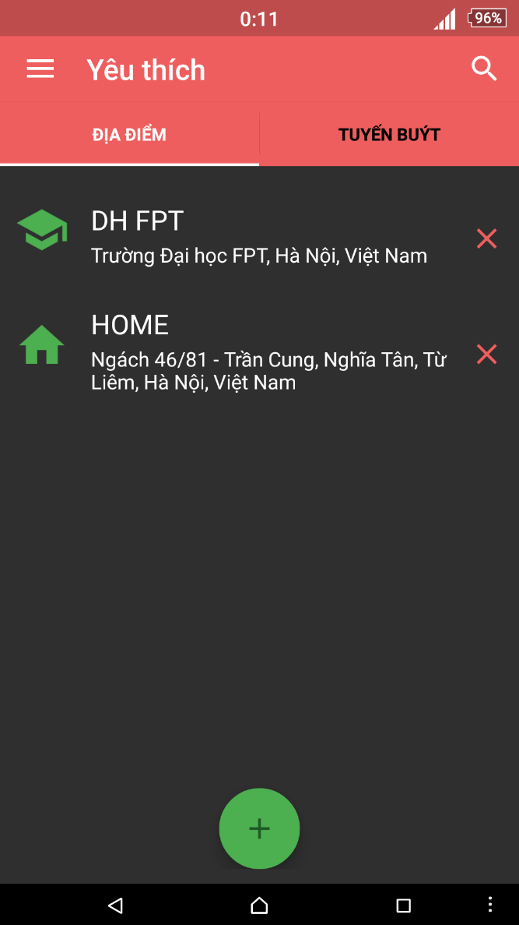

Figure 4-74: View favorite place

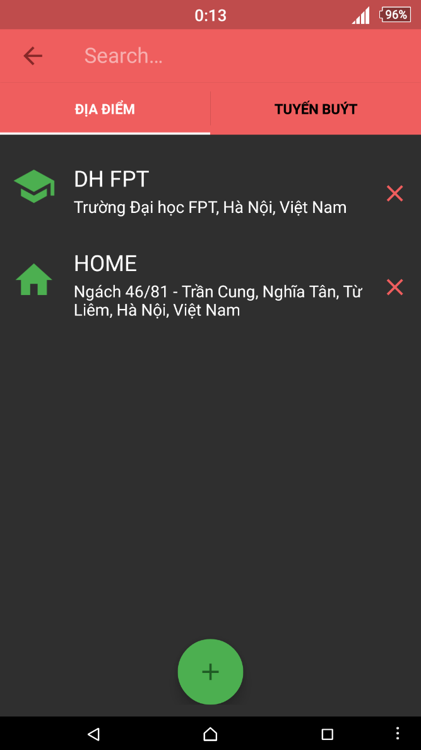

Figure 4-75: View favorite place

|  |  |  |  |  |  |  |  |
| --- | --- | --- | --- | --- | --- | --- | --- |
| **No** | **Field name** | **Field name in Vietnamese** | **Type** | **Require** | **Mandatory** | **Length** | **Description** |
| 1 | Add | Thêm | Button | Click | Y |  | User taps on Add button |
| 2 | Delete | Xóa | Button | Click | Y |  | User taps on Delete button |
| 3 | Favorite place | Địa điểm yêu thích | List item | Click | Y |  | User taps on Favorite place item to edit |
| 4 | Places | Địa điểm | Tab | Click | Y |  | User taps on Places tab item |
| 5 | Buses | Buýt | Tab | Click | Y |  | User taps on Buses tab item |
| 6 | Search | Tìm kiếm | Button | Click | Y |  | User taps on Search button |
| 7 | Menu | Danh sách | Button | Click | Y |  | User taps on Menu button |

Table 4-34: View favorite place screen description

#### Find Place

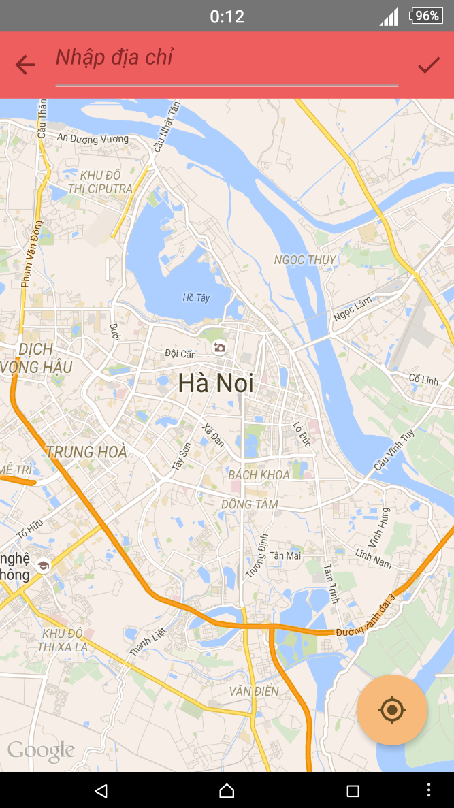

Figure 4-76: Find Place

|  |  |  |  |  |  |  |  |
| --- | --- | --- | --- | --- | --- | --- | --- |
| **No** | **Field name** | **Field name in Vietnamese** | **Type** | **Require** | **Mandatory** | **Length** | **Description** |
| 1 | Input place | Nhập địa điểm | Text | Text | Y | 255 | User inputs the place they want to search with the length less than 255 characters |
| 2 | Back | Quay lại | Button | Click | Y |  | User taps on Back button to go back |
| 3 | Confirm | Xác nhận | Button | Click | Y |  | User taps on Confirm button |
| 4 | Current location | Vị trí hiện tại | Button | Click | Y |  | User taps on Current location button |

Table 4-34: Find Place screen description

#### Add Favorite Place

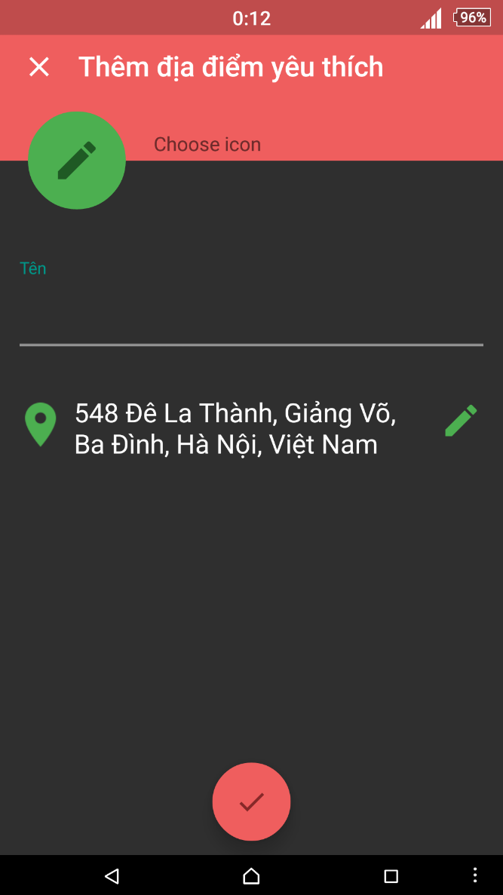

Figure 4-77: Add favorite place screen

|  |  |  |  |  |  |  |  |
| --- | --- | --- | --- | --- | --- | --- | --- |
| **No** | **Field name** | **Field name in Vietnamese** | **Type** | **Require** | **Mandatory** | **Length** | **Description** |
| 1 | Choose icon | Chọn biểu tượng | Button | Click | Y |  | User taps on Choose icon button |
| 2 | Name alias | Tên bí danh | Text field | Text | Y | 50 | User inputs “Name alias” text field. |
| 3 | Location | Địa điểm | Text |  |  |  |  |
| 4 | Edit location | Thay đổi địa điểm | Button | Click | Y |  | User taps “Edit location” button |
| 5 | Done | Hoàn tất | Button | Click | Y |  | User taps “Done” button |

Table 4-36: Add favorite place screen description

#### Edit Favorite Place

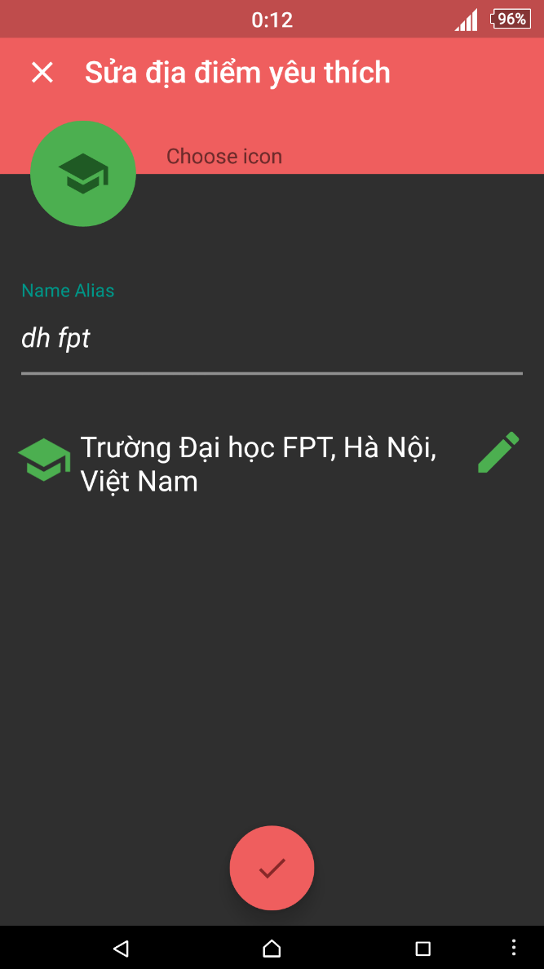

Figure 4-78: Edit favorite place

|  |  |  |  |  |  |  |  |
| --- | --- | --- | --- | --- | --- | --- | --- |
| **No** | **Field name** | **Field name in Vietnamese** | **Type** | **Require** | **Mandatory** | **Length** | **Description** |
| 1 | Input place | Nhập địa điểm | Text | Text | Y | 255 | User inputs the place they want to search with the length less than 255 characters |
| 2 | Back | Quay lại | Button | Click | Y |  | User taps on Back button to go back |
| 3 | Confirm | Xác nhận | Button | Click | Y |  | User taps on Confirm button |
| 4 | Current location | Vị trí hiện tại | Button | Click | Y |  | User taps on Current location button |
| 5 | Choose icon | Chọn biểu tượng | Button | Click | Y |  | User taps on Choose icon button |
| 6 | Name alias | Tên bí danh | Text field | Text | Y | 50 | User inputs “Name alias” text field. |
| 7 | Location | Địa điểm | Text |  |  |  |  |
| 8 | Edit location | Thay đổi địa điểm | Button | Click | Y |  | User taps “Edit location” button |
| 9 | Done | Hoàn tất | Button | Click | Y |  | User taps “Done” button |

Table 4-37: Edit favorite place screen description

#### Favorite Bus

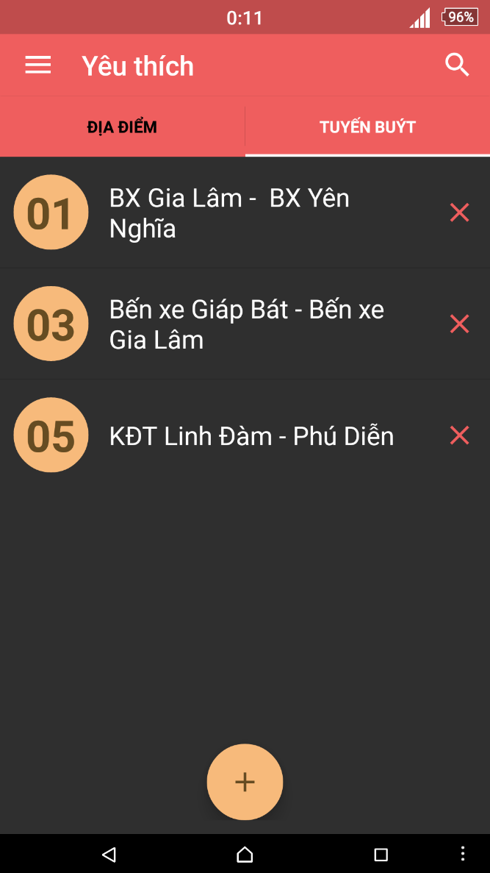

Figure 4-78: View favorite bus

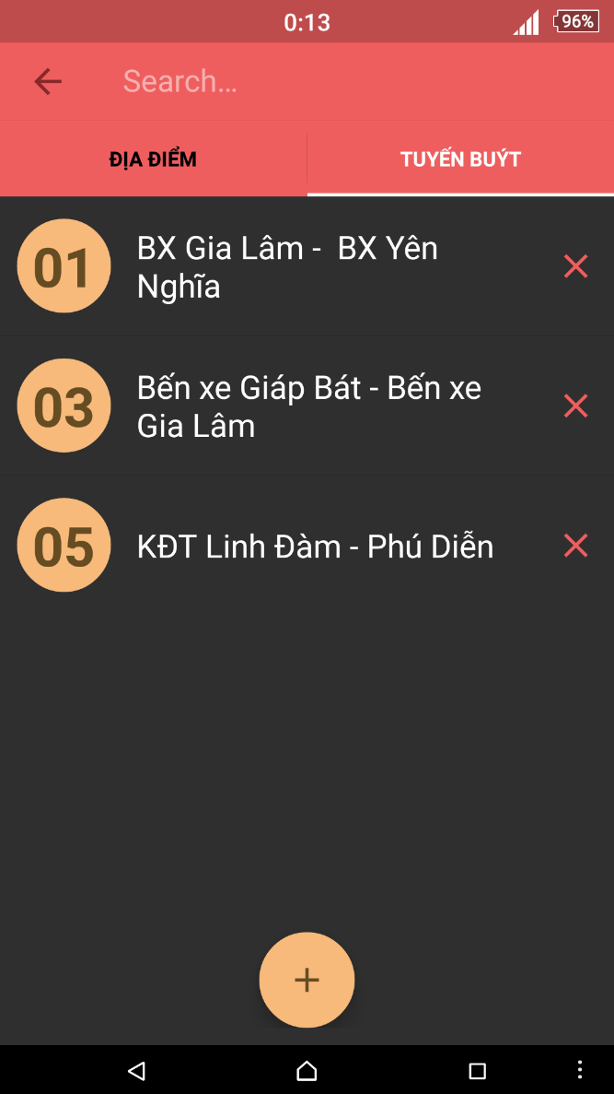

Figure 4-79: Search favorite bus

|  |  |  |  |  |  |  |  |
| --- | --- | --- | --- | --- | --- | --- | --- |
| **No** | **Field name** | **Field name in Vietnamese** | **Type** | **Require** | **Mandatory** | **Length** | **Description** |
| 1 | Add | Thêm | Button | Click | Y |  | User taps on Add button |
| 2 | Delete | Xóa | Button | Click | Y |  | User taps on Delete button |
| 3 | Favorite bus | Địa điểm yêu thích | List item | Click | Y |  | User taps on Favorite bus item to edit |
| 4 | Places | Địa điểm | Tab | Click | Y |  | User taps on Places tab item |
| 5 | Buses | Buýt | Tab | Click | Y |  | User taps on Buses tab item |
| 6 | Search | Tìm kiếm | Button | Click | Y |  | User taps on Search button |
| 7 | Menu | Danh sách | Button | Click | Y |  | User taps on Menu button |

Table 4-38: View favorite bus screen description

## Database design

### Table diagram

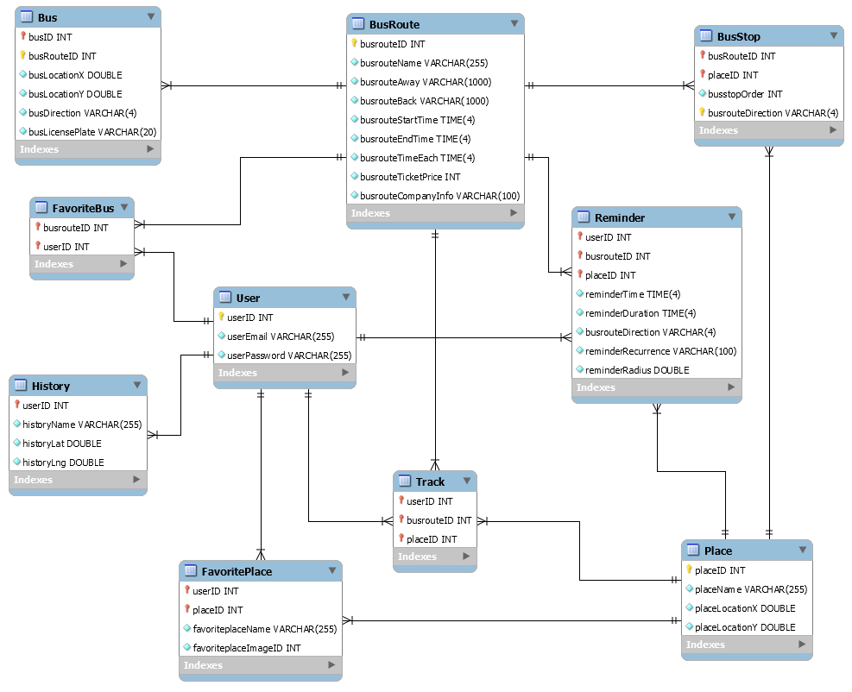

Figure 4-80: Table diagram

n

**List of tables and brief description**

|  |  |  |
| --- | --- | --- |
| **No** | **Table Name** | **Description** |
|  | User | Store all user information |
|  | Place | Store all information of places |
|  | FavoritePlace | Store all information of favorite places |
|  | BusRoute | Store all information of bus routes |
|  | BusStop | Store all information of bus stops |
|  | Bus | Store all information of buses |
|  | FavoriteBus | Store all information of favorite buses |
|  | Track | Store all information of track |
|  | Reminder | Store all information of reminders |
|  | History | Store all information of find path history |

Table 4-39: Table name Database design table

### User table

|  |  |  |  |  |  |  |  |  |
| --- | --- | --- | --- | --- | --- | --- | --- | --- |
| **No** | **Field Name** | **Type** | **Length** | **Null** | **Unique** | **P/F Key** | **Default** | **Description** |
|  | userID | Int |  |  | Y | PK | AI/UN | User’s id |
|  | userEmail | Varchar | 255 |  | Y |  |  | User login email |
|  | userPassword | Varchar | 255 |  |  |  |  | Store password login of user. |

Table 4-40: User table

### Place table

|  |  |  |  |  |  |  |  |  |
| --- | --- | --- | --- | --- | --- | --- | --- | --- |
| **No** | **Field Name** | **Type** | **Length** | **Null** | **Unique** | **P/F Key** | **Default** | **Description** |
|  | placeID | Int |  |  | Y | PK | AI/ UN | Place’s id |
|  | placeName | Varchar | 255 |  |  |  |  | Place’s name |
|  | placeLocationX | Double |  |  |  |  | UN | Place’s latitude |
|  | placeLocationY | Double |  |  |  |  | UN | Place’s longitude |

Table 4-41: Place table

### Favoriteplace table

|  |  |  |  |  |  |  |  |  |
| --- | --- | --- | --- | --- | --- | --- | --- | --- |
| **No** | **Field Name** | **Type** | **Length** | **Null** | **Unique** | **P/F Key** | **Default** | **Description** |
|  | userID | Int |  |  |  | PFK | UN | User’s id |
|  | placeID | Int |  |  |  | PFK | UN | Place’s id |
|  | favoritePlaceName | Varchar | 255 |  |  |  |  | Favorite place name |
|  | favoritePlaceImageID | Int |  |  |  |  | UN | Favorite place image ID |

Table 4-42: Favoriteplace table

### Busroute table

|  |  |  |  |  |  |  |  |  |
| --- | --- | --- | --- | --- | --- | --- | --- | --- |
| **No** | **Field Name** | **Type** | **Length** | **Null** | **Unique** | **P/F Key** | **Default** | **Description** |
|  | busrouteID | Int |  |  | Y | PK | UN | Bus route’s id |
|  | busrouteName | Varchar | 255 |  |  |  |  | Bus route’s name |
|  | busrouteAway | Varchar | 1000 |  |  |  |  | Bus route away |
|  | busrouteBack | Varchar | 1000 |  |  |  |  | Bus route back |
|  | busrouteStartTime | Time | 4 |  |  |  |  | Bus route start time |
|  | busrouteEndTime | Time | 4 |  |  |  |  | Bus route end time |
|  | busrouteTimeEach | Time | 4 |  |  |  |  | Bus route time each |
|  | busrouteTicketPrice | Int |  |  |  |  | UN | Bus route ticket price/ each |
|  | busrouteCompanyInfo | Varchar | 100 |  |  |  |  | Bus route company information |

Table 4-43: Busroute table

### Busstop table

|  |  |  |  |  |  |  |  |  |
| --- | --- | --- | --- | --- | --- | --- | --- | --- |
| **No** | **Field Name** | **Type** | **Length** | **Null** | **Unique** | **P/F Key** | **Default** | **Description** |
|  | placeID | Int |  |  |  | PFK | UN | Place’s id |
|  | busrouteID | Int |  |  |  | PFK | UN | Bus route’s id |
|  | busstopOrder | Int |  |  |  |  | UN | Bus stop order |
|  | busrouteDirection | Varchar | 50 |  |  | PK |  | Bus route direction |

Table 4-44: Busstop table

### Bus table

|  |  |  |  |  |  |  |  |  |
| --- | --- | --- | --- | --- | --- | --- | --- | --- |
| **No** | **Field Name** | **Type** | **Length** | **Null** | **Unique** | **P/F Key** | **Default** | **Description** |
|  | busID | Int |  |  |  | PK | UN | Bus’s id |
|  | busrouteID | Int |  |  |  | PFK | UN | Bus route’s id |
|  | busLocationX | Double |  |  |  |  | UN | Bus latitude |
|  | busLocationY | Double |  |  |  |  | UN | Bus longitude |
|  | busrouteDirection | Varchar | 4 |  |  |  |  | Bus route direction |

Table 4-25: Bus table

### Favoritebus table

|  |  |  |  |  |  |  |  |  |
| --- | --- | --- | --- | --- | --- | --- | --- | --- |
| **No** | **Field Name** | **Type** | **Length** | **Null** | **Unique** | **P/F Key** | **Default** | **Description** |
|  | userID | Int |  |  |  | PFK | UN | User’s id |
|  | busRouteID | Int |  |  |  | PFK | UN | Bus route’s id |

Table 4-46: Favoritebus table

### Track table

|  |  |  |  |  |  |  |  |  |
| --- | --- | --- | --- | --- | --- | --- | --- | --- |
| **No** | **Field Name** | **Type** | **Length** | **Null** | **Unique** | **P/F Key** | **Default** | **Description** |
|  | userID | Int |  |  |  | PFK | UN | User’s id |
|  | placeID | Int |  |  |  | PFK | UN | Place’s id |
|  | busID | Int |  |  |  | PFK | UN | Bus id |

Table 4-47: Track table

### Reminder table

|  |  |  |  |  |  |  |  |  |
| --- | --- | --- | --- | --- | --- | --- | --- | --- |
| **No** | **Field Name** | **Type** | **Length** | **Null** | **Unique** | **P/F Key** | **Default** | **Description** |
|  | userID | Int |  |  |  | PFK | UN | User’s id |
|  | busrouteID | Int |  |  |  | PFK | UN | Bus route’s id |
|  | placeID | Int |  |  |  | PFK | UN | Place’s id |
|  | reminderTime | Time | 4 |  |  | PK |  | Reminder time |
|  | reminderDuration | Time | 4 |  |  |  |  | Reminder duration |
|  | busrouteDirection | Varchar | 4 |  |  |  |  | Bus route direction |
|  | reminderRecurrence | Varchar | 100 |  |  |  |  | Reminder recurrence |
|  | reminderRadius | Double |  |  |  |  |  | Reminder distance |

Table 4-48: Reminder table

# Software Source Code

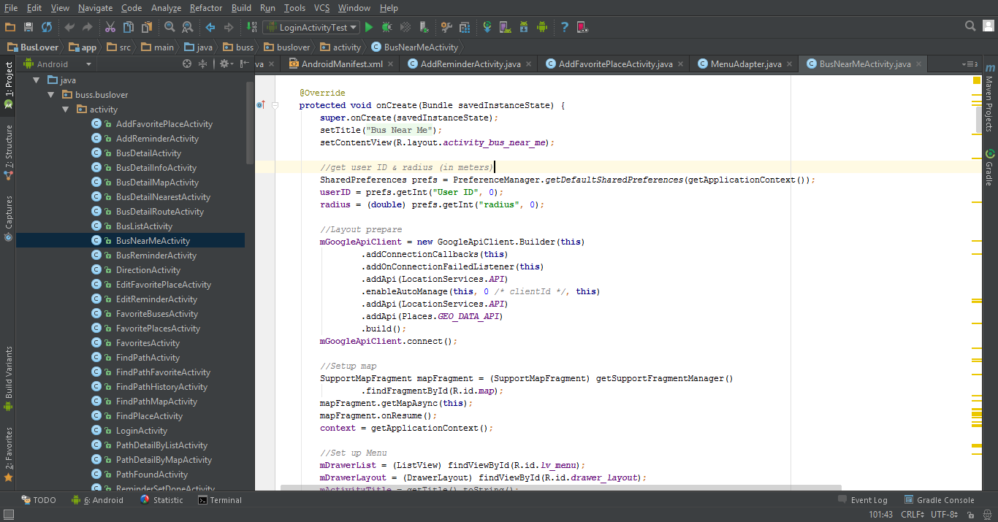

Figure 5-1: Sample of Source Code (BusNearMe)

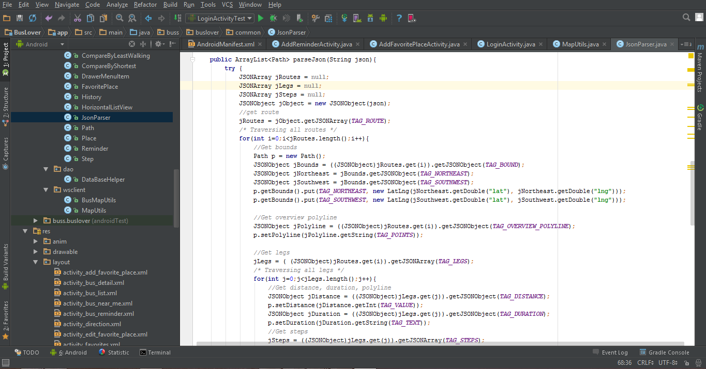

Figure 5-2: Sample of Source Code (Search Controller)

# Software Test Documentation

## INTRODUCTION

### Purposes

The purpose of this document is showing the scope of testing, test items, test strategy, testing approach, resources, test environment, schedule of intended testing activities …

## TEST PLAN

### Scope of Testing

BUSS will be tested by five phases:

**Phase 1: Unit testing**

* Unit testing will be done by developers
* Developers user While Box Testing technique to do
* When executing unit testing, if any bugs are found, developers have to log bug on “Defect Log Management” file and fix it until it is correct.

**Rule for filling test result:**

|  |  |
| --- | --- |
| **Test result pass** | Pass |
| **Test result fail** | Fail |
| **Do not test** | Untested |
| **Cannot test** | N/A (Not available) |

**Phase 2: Component testing**

* After finishing unit testing, component testing will be performed by testers.
* Material are component test cases, low- level design
* Testers user Black Box Testing technique to do
* When executing component testing, if any bugs are found, testers have to log on “Defect Log Management” file and assign to developer fix it and redo this process until it is correct.

**Rule for filling test result:**

|  |  |
| --- | --- |
| **Test result pass** | Pass |
| **Test result fail** | Fail |
| **Do not test** | Untested |
| **Cannot test** | N/A (Not available) |

**Phase 3: Integration testing**

* After finishing component testing, integration testing will be performed by testers.
* Material are integration test cases, high- level design and test tools.
* Do test by flow of functions and items which have relation.
* When executing integration testing, if any bugs are found, testers have to log on “Defect Log Management” file and assign to developer fix it and redo this process until it is correct.

**Rule for filling test result:**

|  |  |
| --- | --- |
| **Test result pass** | Pass |
| **Test result fail** | Fail |
| **Do not test** | Untested |
| **Cannot test** | N/A (Not available) |

**Phase 4: System testing**

* After finishing integration testing and developers collect all functions and items, testers will be performed system testing, it means doing test whole system.
* Material area system test case, SRS
* If any bugs are found, developers have to fix and testers will verify them. System test is ended only when test cases are passed and no bug is found.

**Rule for filling test result:**

|  |  |
| --- | --- |
| **Test result pass** | Pass |
| **Test result fail** | Fail |
| **Do not test** | Untested |
| **Cannot test** | N/A (Not available) |

**Phase 5: Acceptance testing**

* Base on customer/user requirement specification, system is tested again, for ensure there is not lacking or mistake any requirement.
* If there is any problem, developers have to fix/update and tester will verify them.
* Acceptance testing is ended only when whole system met requirement specification.

#### Test Items

| **No** | **Component** | **Feature to be tested** |
| --- | --- | --- |
| 1 | User Interface | Check the display of elements |
| 2 | Function | * Sign up * Log in/ Log out * Forgot password * Change password * Find path * Get current location * Display history of finding paths * Filter path found * Display path detail * Navigate route * Display bus list * Search bus * Display bus details: info, route, nearest, map * Display buses near current location * Set tracker * Cancel tracker * Display favorite buses * Add favorite bus * Delete favorite bus * Search favorite bus * Search place * Display favorite places * Add favorite place * Edit favorite place * Delete favorite places * Search favorite places * Display bus reminders * Add reminder * Edit reminder * Delete reminder * Suspend/Unsuspend reminder * Display next reminder * Settings |

#### Acceptance Test Criteria

* Criteria for Unit test of Development team, for Test team accepts to start testing:
* Number of UTC/KLOC: 40 UTC/KLOC
* Number defects/KLOC: 3-4 defects/KLOC
* Statement coverage: 97%
* Branch coverage: 100%
* Path coverage: 100%
* Criteria for Integration test:
* Number of UTC/KLOC: 30 UTC/KLOC
* Number defects/KLOC: 2-3 defects/KLOC
* Criteria for System test:
* Number of UTC/KLOC: 60 UTC/KLOC
* Number defects/KLOC: 4-6 defects/KLOC
* Criteria for Acceptance test:
* Number defects/KLOC: 1-2 defects/KLOC

#### Testing Risks

* Performance test: Cannot test the case which many users use app at the same time.
* Not enough time to write all test cases, execute test or re-test for fixed bug.
* Tester can be ill during the testing phase.

### Test Strategies

#### Test Model

BUSS project follows V-Model process:

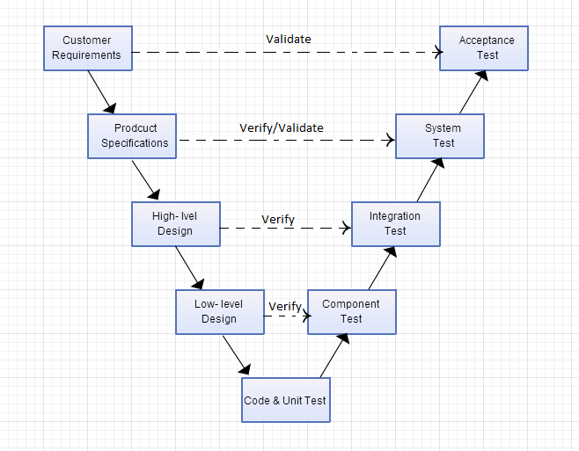

Figure 6-1: V-Model

Testing progress is divided to five phases include: Unit test, Component test, Integration test, System test and Acceptance test

* **Unit test:**
* Unit testing is used to verify a single minimal unit of source code. The purpose of unit testing is to isolate the smallest testable parts of BUSS and verify that they function properly in isolation.
* Unit testing is the first level of testing and is perform prior to component testing.
* Unit testing will be done by developer.
* **Component test:**
* Component testing is used to validate a combined many minimal units of source code.
* Component testing is performed after unit testing and before integration testing.
* Component testing will be done by tester
* **Integration test:**
* Integration testing is a level of the software testing process where individual units or component are combined and tested as a group.
* The purpose is to expose faults in the interaction between integrated units.
* Integration testing is performed after component testing.
* Integration testing will be done by tester.
* There are two methods of doing integration testing: Bottom-up Integration testing and Top Down Integration testing:

| No | Integration Testing Method |
| --- | --- |
| 1 | Bottom-up integration  This testing begins with unit testing, followed by tests of progressively higher-level combinations of units called modules. |
| 2 | Top- Down integration  This testing, the highest-level modules are tested first and progressively lower-level modules are tested after that |

Table 6-1: Integration testing method

* **System test:**
* System Testing is a level of the software testing process where a complete, integrated system is tested
* The purpose is to evaluate the system’s compliance with the specified requirements
* System testing is performed after integration testing
* System testing will be done by tester
* **Acceptance test:**
* Acceptance testing is performed after system testing
* Acceptance testing will be performed by the test leader and team leader.
* The acceptance test will be done for a period of 1 weeks after completion of the system test process.

#### Types of Testing

##### Function Testing

* Functional testing is a type of software testing whereby the system is tested against the functional requirements/specifications.
* Functions are tested by feeding them input and examining the output. Functional testing ensure that the requirements are properly satisfied by the website. This type of testing is not concerned with how processing occurs, but rather, with the results of processing.
* During functional testing, [**Black Box Testing**](http://softwaretestingfundamentals.com/black-box-testing/) technique is used in which the internal logic of the system being tested is not known to the tester.

|  |  |
| --- | --- |
| **Test Objective:** | The type of this test is to ensure proper target-of-test functionality, including user interaction, all function defined in specification document implemented correctly. |
| **Technique:** | Executing each use case, use-case flow, or function, using valid and invalid data, to verify the following:  - The expected results occur when valid data is used.  - The appropriate error or warning messages are displayed when invalid data is used.  - Each business rule is properly applied. |
| **Completion Criteria:** | - All planned tests have been executed.  - All identified defects have been addressed and closed. |
| **Special Considerations:** | Testing may be stopped when:   * Time runs out * A certain number of defects found * Test coverage > 97% * Stop when testing becomes unproductive |

Table 6-2: Function Testing

##### User Interface Testing

* GUI testing is the process of ensuring proper functionality of the GUI for a given web and making sure it conforms to its written specifications.
* GUI testing evaluates design elements such as layout, color, font sizes, labels, text boxes, text formatting, captions, buttons, lists, icons, links, content and more.

|  |  |
| --- | --- |
| **Test Objective:** | Verify the following:  - Navigation through the target-of-test properly reflects business       functions and requirements, including window-to-window, field-to-field, and use of access methods (tab keys, mouse movements, accelerator keys)  - Window objects and characteristics, such as menus, size, position, state, and focus conform to standards. |
| **Technique:** | Create or modify tests for each window to verify proper navigation and object states for each application window and objects. |
| **Completion Criteria:** | Each window successfully verified to remain consistent with benchmark version or within acceptable standard. |
| **Special Considerations:** | Not all properties for custom and third party objects can be accessed. |

Table 6-3: GUI Testing

##### Data and Database Integrity Testing

The databases and the database processes should be tested as a subsystem within the Project. These subsystems should be tested without the target-of-test’s User Interface as the interface to the data.  Additional research into the Database Management System (DBMS) needs to be performed to identify the tools and techniques that may exist to support the testing identified below.

|  |  |
| --- | --- |
| **Test Objective:** | Ensure database access methods and processes function properly and without data corruption. |
| **Technique:** | - Invoke each database access method and process, seeding each with valid and invalid data or requests for data.  - Inspect the database to ensure the data has been populated as intended, all database events occurred properly, or review the returned data to ensure that the correct data was retrieved for the correct reasons. |
| **Completion Criteria:** | All database access methods and processes function as designed and without any data corruption. |
| **Special Considerations:** | - Testing may require a DBMS development environment or drivers to enter or modify data directly in the databases.  - Processes should be invoked manually.  - Small or minimally sized databases (limited number of records) should be used to increase the visibility of any non-acceptable events. |

Table 6-4: Data and Data Integrity Testing

#### Test Stages

Clearly state the stage in which the test will be executed. Identified below are the stages in which common test are executed.

| Type of Tests | Stage of Test | | | |
| --- | --- | --- | --- | --- |
| Unit | Component | Integration | System |
| Function Testing | X | X | X | X |
| User Interface Testing | X |  |  | X |

# 

#### Tools/Environments

##### Hardware

|  |  |  |
| --- | --- | --- |
| Name | Purpose | Detail |
| Laptop (Asus, Vaio, Dell) | Device for creating and executing test | Window 8.1 Pro |
| Mobile (Sony Z3, Zenphone 5, Samsung Note 3) | Device for executing test | Android 5.0 + |

Table 6-5: Hardware

##### Software

|  |  |  |
| --- | --- | --- |
| Name | Purpose | Detail |
| Test Plan | Managing test | Microsoft Word 2013, 2010 |
| Test case | Executing test | Microsoft Excel 2013, 2010 |
| Test report, Test checklist | Tracking test | Microsoft Excel 2013, 2010 |
| Android Studio with Junit | Executing test | Android Studio with Junit |
| Chrome | Executing test with Postman for Webservice | Chrome newest version |

Table 6-6: Software

### Resources

|  |  |  |
| --- | --- | --- |
| Worker/Doer | Role | Specific Responsibilities/Comments |
| MaiTTT | Tester | * Create Test Plan. |
| PhuongBB | Tester | * Create and review Test Case. * Execute test. * Create Test view points * Create and review Test Report |

Table 6-7: Resources

### Test Milestones

|  |  |  |  |
| --- | --- | --- | --- |
| Milestone Task | Effort (pd) | Start Date | End Date |
| Create TP | 6 | 16/06/2015 | 22/06/2015 |
| Review & update TP | 2 | 23/06/2015 | 23/06/2015 |
| Create Component Test case | 12 | 23/06/2015 | 26/06/2015 |
| Review & update Component TC | 2 | 27/06/2015 | 27/06/2015 |
| Create Integration TC | 2 | 07/07/2015 | 07/07/2015 |
| Review & Update Integration TC | 2 | 08/07/2015 | 08/07/2015 |
| Create System TC | 6 | 09/07/2015 | 11/07/2015 |
| Review & Update System TC | 2 | 11/07/2015 | 11/07/2015 |
| Execute CT phase 1 | 1 | 16/07/2015 | 16/07/2015 |
| Execute CT phase 2 | 1 | 24/07/2015 | 24/07/2015 |
| Execute IT phase 1 | 2 | 17/07/2015 | 17/07/2015 |
| Execute IT phase 2 | 2 | 25/07/2015 | 28/07/2015 |
| Execute ST phase 1 | 4 | 21/07/2015 | 22/07/2015 |
| Execute ST phase 2 | 4 | 28/07/2015 | 29/07/2015 |

Table 6-8: Test milestone

## TEST CASES

### Unit Test

We execute Unit Test with JUnit and Android Studio. Below is an example screen:

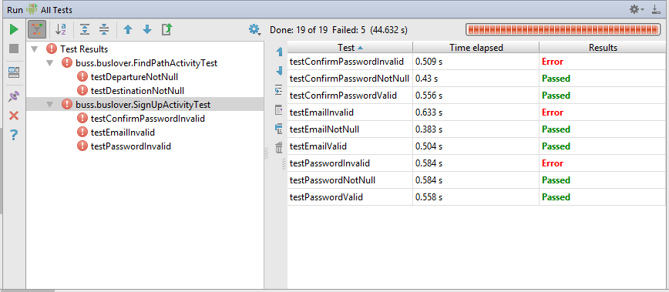

### Component Test Case

Refer to BUSS_Component_Test_Case_v1.0_EN to see detail all test cases.

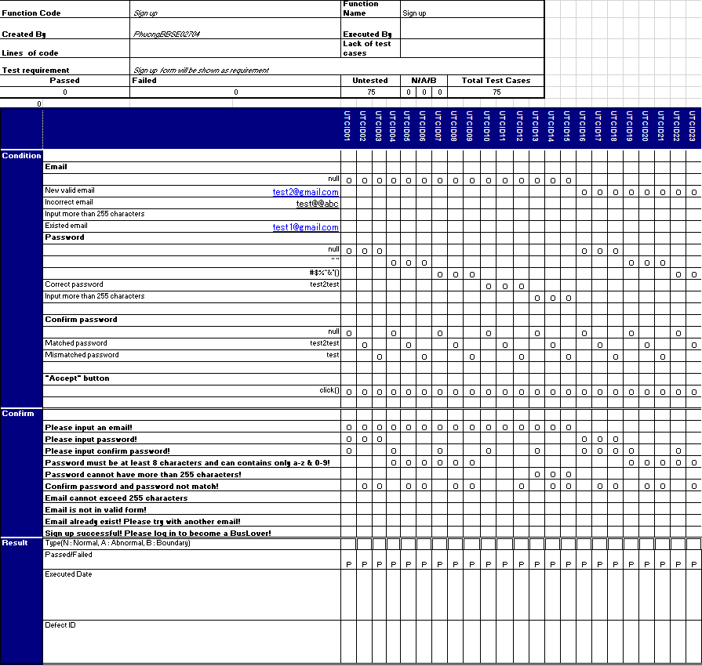

### Integration Test Case

Refer to BUSS_Integration_Test_Case_v1.0_EN to see detail all test cases.

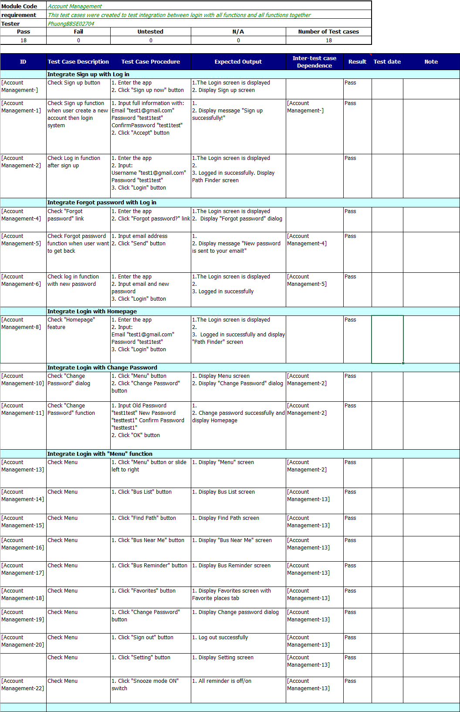

### System Test Case

Refer to BUSS_System_Test_Case_v1.0_EN to see detail all test cases.

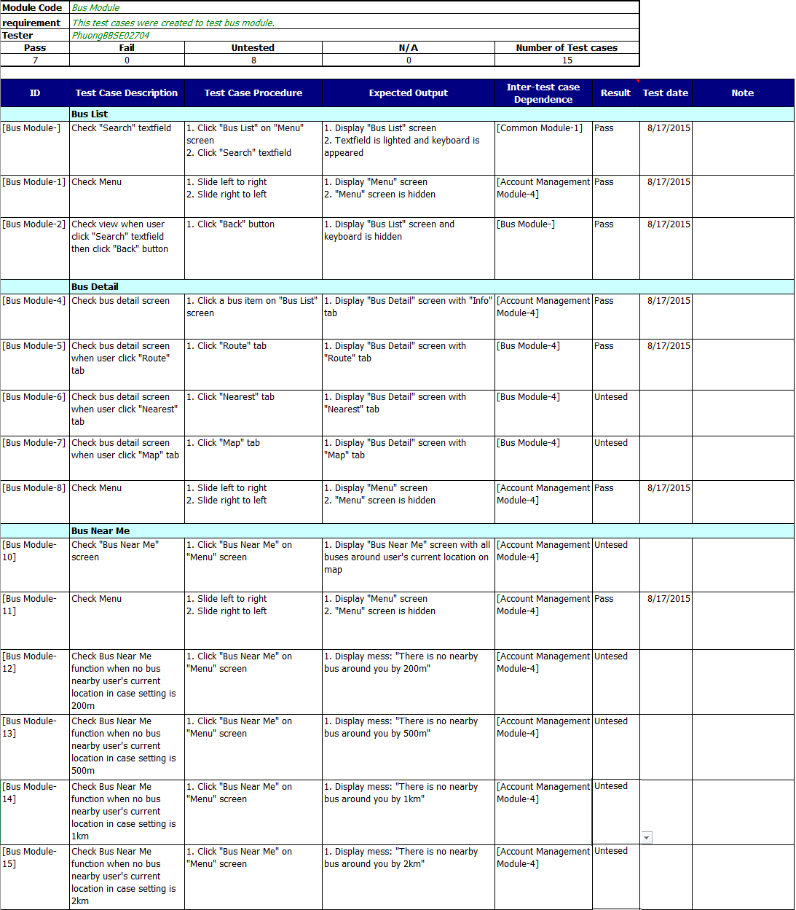

## CHECKLISTS

### Test Checklist

|  |  |  |  |  |  |  |
| --- | --- | --- | --- | --- | --- | --- |
| **Question** | **Yes** | **No** | **N/A** | **Note** | **Priority** | **Severity** |
| Is the system test using the unit tests and incremental integration test cases, requirements and design? | x |  |  |  |  |  |
| Have volume tests been included? |  |  | x |  |  |  |
| Have concurrency tests been included? (Multi user tests) |  |  | x |  |  |  |
| Have error-logging conditions been tested? | x |  |  |  | Mandatory |  |
| Have restart features been tested? |  |  | x |  | Mandatory |  |
| Have invalid input conditions been tested? | x |  |  |  | Mandatory |  |
| Have invalid output conditions been tested? | x |  |  |  | Mandatory |  |
| Has the functionality as per requirements been tested? | x |  |  |  | Mandatory |  |
| Have performance requirements been tested? |  |  | x |  | Mandatory |  |
| Have security requirements been tested? |  |  | x |  |  |  |
| Have the test results regarding security requirements been reviewed? |  |  | x |  |  |  |
| Have fail over conditions been tested? | x |  |  |  | Mandatory |  |
| Have scalability tests been conducted? |  |  | x |  |  |  |
| Is the correct version of the requirements, design, test case being used for system test? | x |  |  |  |  |  |

Table 6-9: System Test Checklist

|  |  |  |  |  |  |
| --- | --- | --- | --- | --- | --- |
| **Question** | **Yes** | **No** | **N/A** | **Note** | **Priority** |
| **DOCUMENT CONTROL** |  |  |  |  |  |
| Verify whether document control procedures have been followed by checking for the following: |  |  |  |  | Mandatory |
| *Does the title page contain the document name, version number, release date and issued date?* | X |  |  |  |  |
| *Does the header and footer correctly specify the name, and version of the document?* | X |  |  |  |  |
| *Does the page – numbering scheme indicate the total number of pages in the document?* | X |  |  |  |  |
| *Is the history traceable?* | X |  |  |  |  |
| *Does it include list of reference documents?* | X |  |  |  |  |
| *Are all documents checked Spelling and Grammar in MS Word or similar tools?* | X |  |  |  |  |
| **TEST PLAN CHECKLIST** |  |  |  |  |  |
| Have products that are to be tested been identified? | X |  |  |  | Mandatory |
| Is the overall defect expectation or defect expectation rate stated in the plan? | X |  |  |  | Mandatory |
| Does the plan provide clearly scope for the following? | X |  |  |  | Mandatory |
| *Unit testing* | X |  |  |  |  |
| *Integration testing* | X |  |  |  |  |
| *System testing* | X |  |  |  |  |
| *Acceptance testing* | X |  |  |  |  |
| Does the plan reflect the requirements as specified in the SRS? | X |  |  |  | Mandatory |
| Have the conditions that would cause each test to be stopped been stated? | X |  |  |  |  |
| Have the test types addressed the following? | X |  |  |  |  |
| *Function testing* | X |  |  |  |  |
| *User interface testing* | X |  |  |  |  |
| *Data and Database Integrity Testing* | X |  |  |  |  |
| *Performance testing* |  | X |  |  |  |
| *Security and Access Control Testing* |  | X |  |  |  |
| *Portability* |  | X |  |  |  |
| Have acceptance criteria for requirements been identified? | X |  |  |  |  |
| Do the types of tests reflect all requests specified in SRS? |  |  |  |  |  |
| Is it a maintenance project? If yes, Has the regression test been identified? |  |  | X |  |  |
| *Trigger for Regression test* |  |  | X |  |  |
| *Period for Regression test* |  |  | X |  |  |
| *Scope of Regression test* |  |  | X |  |  |
| Does the description of each type of test include the following? |  |  |  |  |  |
| *Test objectives* | X |  |  |  | Mandatory |
| *Techniques* | X |  |  |  | Mandatory |
| *Completion criteria* | X |  |  |  |  |
| *Special consideration* | X |  |  |  |  |
| Have the testing environment, testing tools and testing software and hardware been described? | X |  |  |  | Mandatory |
| Are the Pass/Fail criteria of tested products defined in Special consideration correspondent with requirements in SRS? | X |  |  |  |  |
| Are Doer and Responsibilities identified correctly? | X |  |  |  |  |
| Have the test deliverables been defined? | X |  |  |  | Mandatory |
| Does the testing schedule correspond to the development schedule? | X |  |  |  | Mandatory |
| Have staffing and training needs been specified? | X |  |  |  |  |
| Have the risks of testing been identified? | X |  |  |  | Mandatory |

Table 6-9: Checklist Test Plan

### GUI checklist

Refer to BUSS_GUI_Checklist_v1.0_EN to see all detail.

## TEST LOGS

### Defect Logs

Refer to BUSS_Defect_Log_Management_v1.0_EN to see detail all Bug List.

|  |  |  |  |  |
| --- | --- | --- | --- | --- |
| **Defects** | **Logged** | **%Closed** | **%Invalid** | **%Open** |
| **Critical** | 0 | 0% | 0% | 0% |
| **High** | 0 | 0% | 0% | 0% |
| **Medium** | 9 | 100% | 0% | 0% |
| **Low** | 15 | 100% | 0% | 0% |
| **Total** | 24 | 100% | 0% | 0% |

Tabel 6-11: Defect Logs

### 

### Test Reports

This is Test report of BUSS project during Test process.

Refer to:

BUSS_Test_Report_v1.0_EN

To see detail test report for each phase.

|  |  |  |  |  |  |  |  |
| --- | --- | --- | --- | --- | --- | --- | --- |
| **Phase** | **# Test cases Planned** | **#Defects Planned** | **#Test cases Actual(cases)** | **#Defects Actual** | **% Tests Executed** | **% Tests Passed** | **% Tests Fail** |
| **Unit Test** | 40TC/KLOC | 3 -4 | 30 | 0 | 100% | 100% | 0% |
| **Component Test** | 40TC/KLOC | 3 -4 | 184 | 9 | 100% | 100% | 0% |
| **Integration Test** | 30TC/KLOC | 2 -3 | 67 | 5 | 100% | 100% | 0% |
| **System Test** | 60TC/KLOC | 4 -6 | 130 | 4 | 100% | 100% | 0% |
| **Total** | 400 | 16 - 32 | 411 | 18 | 100% | 100% | 0% |

Table 6-12: Test Report

|  |  |  |  |  |  |  |  |  |
| --- | --- | --- | --- | --- | --- | --- | --- | --- |
| **Phase** | **Round 1** | | | | **Round 2** | | | |
| Pass | Fail | Untested | Bug | Pass | Fail | Untested | Bug |
| **Unit Test** | 20 | 0 | 10 | 0 | 10 | 0 | 0 | 0 |
| **Component Test** | 100 | 9 | 75 | 9 | 84 | 0 | 0 | 0 |
| **Integration Test** | 58 | 0 | 4 | 5 | 9 | 0 | 0 | 0 |
| **System Test** | 115 | 0 | 11 | 4 | 15 | 0 | 0 | 0 |
| **Total** | 293 | 9 | 100 | 18 | 108 | 0 | 0 | 0 |

Table 6-13: Test Report

### Quality Report

|  |  |  |  |  |
| --- | --- | --- | --- | --- |
|  |  |  | **Defect (No of Def/KLOC)** | |
| **#** | **Product** | **Quality Control Activity** | **Plan** | **Actual** |
| **1** | Test case | Unit Test | 3-4 | 0 |
| Component Test | 3-4 | 9 |
| IT | 2-3 | 5 |
| System test | 4-6 | 4 |
| Leakage (UAT) | 1-2 | 0 |
| **2** | Requirements | Review | 10 | 6 |
| **3** | Design | Review | 15 | 21 |
| **4** | Code | Review | 30 | 15 |
| **5** | Project Plan | Review | 10 | 3 |
| **6** | Project Schedule | Review | 10 | 6 |
| **7** | Test Plan | Review | 10 | 4 |
| **8** | Other document | Review | 15 | 10 |
| **Total** |  |  |  | 83 |

# Software User Manual

## Installation guide

### Introduction

This document contains guide-lines step by step to use BUSS – BusLover , and set it up.

### Environment

Following are the software required to run BUSS:

A smartphone with Android 5.0 or higher and at least 25MB free of memory.

### Application Installation

#### From CHPlay

This app is currently not available on CHPlay, but will be launched soon. The launch will be announced through our facebook. Please contact us for more details.

#### Directly from .apk file

As long as BusLover is an Android application, you can install it directly from our .apk file. We provide the demo version .apk file for trial using only. Please feel free to take it, but just remember that it is still a developing products, so it can have bugs. If you know well and accept it, welcome to be a BusLover.

## User Guide

### Overview

This user's manual has been developed to help users better understand the requirements that may apply to use this website by providing them simple step by step tutorials. This manual is intended to help make website's functions more accessible and their associated requirements more understandable to users.

### Details guidelines

#### Login

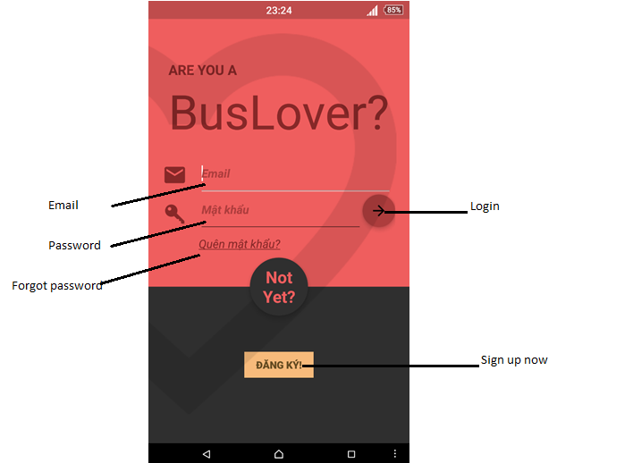

At login screen, we will see:

* Email – Edit text: Input email.
* Password – Edit text: Input password.
* Forgot password – Text: Click to go to Forgot password screen.
* Sign up now – Button: Using for Sign up.
* Login – Button: Using for login to app.

#### Sign up

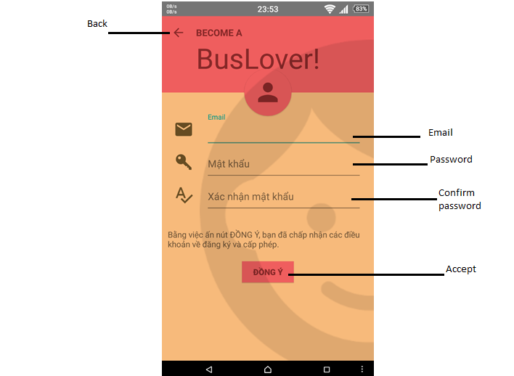

At Sign up screen, we will see:

* Back – Button: Back to previous screen.
* Email – Edit text: Input email.
* Password - Edit text: Input password.
* Confirm password – Edit text: Re-input password.
* Accept – Button: Accept to find the password

#### Forgot password



You can access Forgot password dialog from Forgot password text on Login screen.

You are required to fill your email in this dialog in order to check and send password to the provided email.

#### Setting

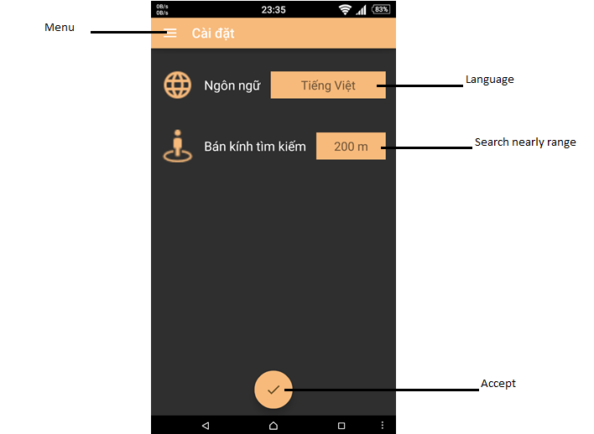

To go to Settings, you can tap Settings on Menu.

This screen allows you to change language and search nearby range.

#### Menu



You can see the menu by click on Menu item on the top left or swipe right from left edge.

The menu provide navigation between screens, which some can be directly accessed are Bus List, Find Path, Bus Near Me, Reminder, Favorites, Change Password, Settings, Log out and Tracking.

#### Bus List

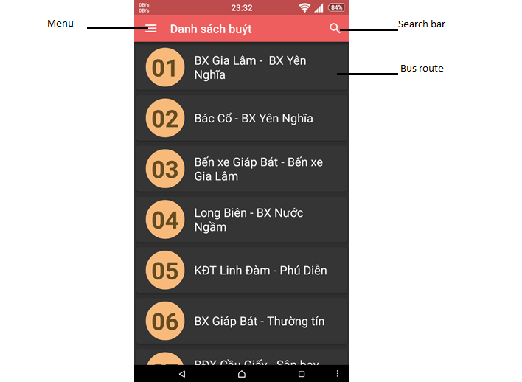

At Bus List screen, we will see:

* + Menu - Button: Click to show menu
  + Search bar – Button: Click to search bus route.
  + Bus route – List item: Click to go to Bus detail screen.

#### Bus detail/info

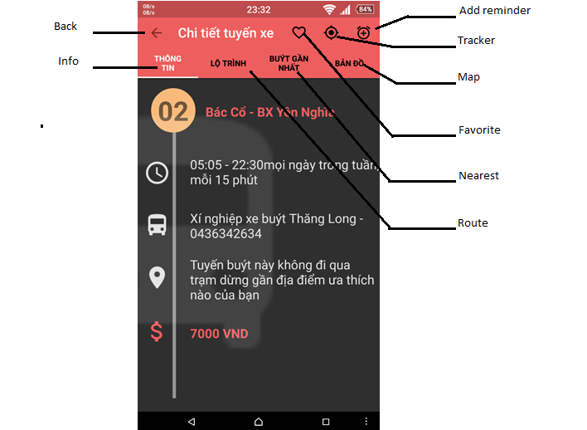

At Bus Detail/Info screen, we will see:

* + Back – Button: Click to back to previous screen.
  + Info – Tab: Click to view bus’s information.
  + Add reminder – Button: Click to go to Addreminder screen.
  + Tracker – Button: Click to follow bus.
  + Map – Tab: Click to view map.
  + Favorite – Button: Click to set bus to favorite.
  + Nearest – Tab: Click to view nearest bus.
  + Route – Tab: Click to view route of bus.

#### Track

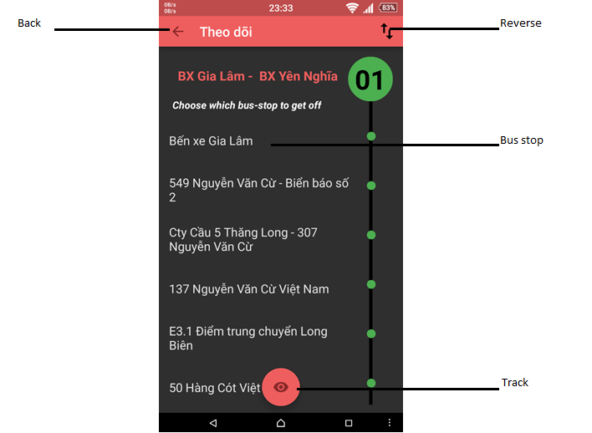

At Set Tracker screen, we will see:

* Back – Button: Click to go to previous screen.
* Reverse – Button: Click to Reverse.
* Bus stop – List item: Click to choose bus stop.
* Track – Button: Click to finish.

#### Bus near Me

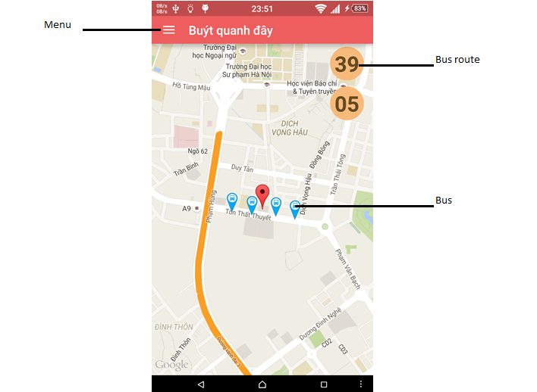

At Bus near me screen, we will see:

* + Menu – Button: Click to show menu.
  + Bus route – Button: Click to choose bus route.
  + Bus – Icon

#### Find Path

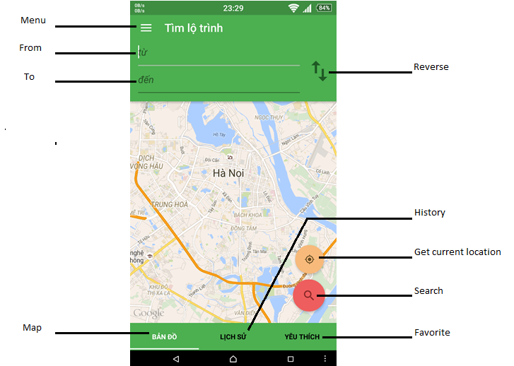

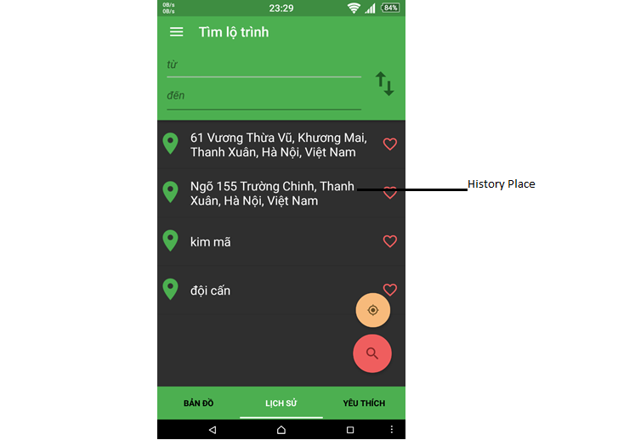

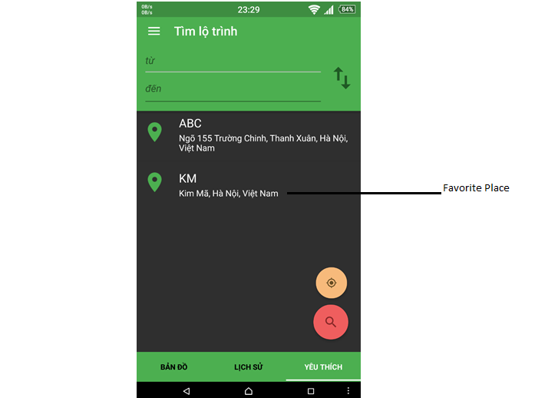

At Path Finder screen, we will see:

* Menu – Button: Click to show menu.
* From – Edit text: Input place.
* To – Edit text: Input place.
* Map – Tab: Click to view map.
* Reverse – Button: Click to reverse.
* History – Tab: Click to view history path.
* Get current location – Button: Click to get current location.
* Search – Button: Click to search path.
* Favorite – Tab: Click to view favorite path.
* History place – List item.
* Favorite place – List item.

#### Path Found

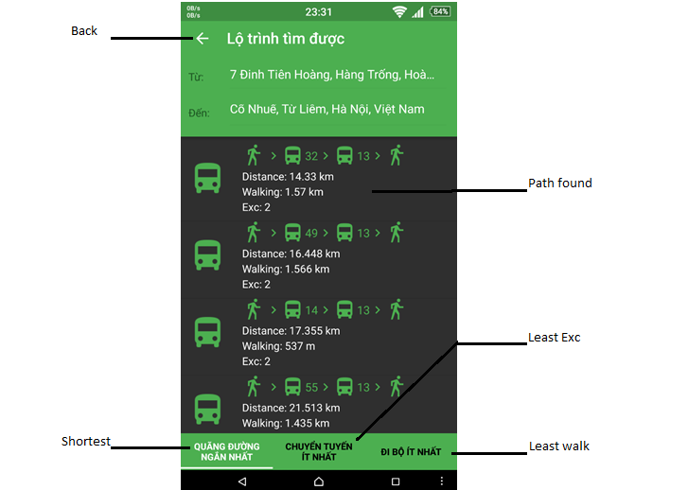

At Paths Found screen, we will see:

* + Back – Button: Click to go to previous screen.
  + Path found – List item: Click to view path found detail.
  + Least Exc – Tab: Click to view path with least exc.
  + Shortest – Tab: Click to view path shortest.
  + Least walk – Tab: Click to view path with least walk.

#### Change password



At Change Password screen, we will see:

* + Old password – Edit text: Input old password.
  + New password – Edit text: Input new password.
  + Confirm password – Edit text: Confirm new password.
  + Ok – Button: Click to accept.
  + Cancel – Button: Click to cancel.

#### Confirm Delete



## PROJECT RESULT REPORT

### Product Judging

#### Advantage of BUSS

The idea of the Bus User Support System is to develop a brand new app for bus user that inherits the advantages and improve issues and learns from other app. So the BusLover app have a bright potential in develop in the future.

As the goals that we have set before started the project, the Bus User Support System project has been developed in a right direction. And what it provides to users is in the list below:

The user using Bus User Support System will save time, make people more convenient in using buss, for more detail: help them find path, find bus, track, reminder bus…

#### Current Limitations

* GUI and function meet demand of almost of young user but might be not suitable for all user at all age.
* In the moment, we are supporting only English and Vietnamese, so people who do not understand both two language might find it hard to use, but we will continue to develop to support more and more language in the future.
* We are using free host, so the server can be down/ unable to use… anytime, which related to a serious risk.

#### Expectation in Future

* Deploy server and web service on a rent host with more utilities.
* Product can support more and more people, not only the young but people at all age, not only English and Vietnamese speaker but people all over the world who came to our beautiful country.
* Providing more function to user and expect to commercialized product in the future.

### Product Summary

|  |  |  |  |  |
| --- | --- | --- | --- | --- |
| **Project Title** | | Bus User Support System | | |
| **Project Supervisor** | | Nguyễn Văn Sang | | |
| **Committers (4)** | | | | |
| **1** | **Project Manager** | Nguyễn Thành Nam | [NamNTSE02942@fpt.edu.vn](mailto:NamNTSE02942@fpt.edu.vn) | |
| **2** | **Developer** | Trịnh Thị Tuyết Mai | [MaiTTTSE02630@fpt.edu.vn](mailto:MaiTTTSE02630@fpt.edu.vn) | |
| **3** | **Developer** | Trần Tú Anh | [AnhTTSE02596@fpt.edu.vn](mailto:AnhTTSE02596@fpt.edu.vn) | |
| **4** | **Tester** | Bùi Bích Phương | [PhuongBBSE02704@fpt.edu.vn](mailto:PhuongBBSE02704@fpt.edu.vn) | |
| **Main objective** | | Develop a system which will support user to use bus more convenience and easily | | |
| **Purpose** | | Provide a BUSS to users | | |
| **Source Repository** | | <https://github.com/sangnvus/2015SUMJS02> | | |
|  | | **Plan** | | **Actual** |
| **Start Date** | | 11/05/2015 | | 11/05/2015 |
| **End Date** | | 28/08/2015 | | 27/08/2015 |
| **Releases version** | | 1.0 | | 1.0 |
| **Duration** | | 75 | | 74 |
| **Effort (person-day)** | | 2400 | | 2464 |
| **Test cases** | | 400 | | 412 |
| **Defects** | | 30-40 | | 56 |
| **Document pages** | | 1000 pages | | 800 pages |
| **Lines of code** | | ~7000 | | ~ 9000 |

### Lessons Learnt

* Understand ways of working with Japanese style.
* Putting knowledge into practice.
* Improve skill
* Technical: Java, PHP Codeigniter, MySQL, XML, Android…
* Soft skill: brainstorm, teamwork, research and self-study, plan management, time management.
* Risk and issues management
* Technical:

+ When thinking ideas for project, all member of team decided to develop webservice by PHP language (user Codeigniter framework) and MySQL. But member haven’t experience about PHP and Codeigniter. So before start project about 1 week, two members were assigned training PHP language and MySQL for webservice.

+ In process coding, we had a function which not completed on time. And our solution is thanks to the help from people who have some experience about Android and Java language and researching internet.

+ In process of do document, we have difficulty in manage document. Some document was lost because of we don’t have many experience about GitHub. So we were meeting and training about GitHub in one day.

* Human resource:

+ Some members are lazy for their task. So at 8.30pm everyday we have meeting to report about task of each member.

+ During the project, 1 member has quit, so all the plan, scope, schedule… must be updated, that lead to a significant impact to project status. But with the great moral, we had overcome it and make the project to this day.

## Reference

**Software Project Management**

1. Template_Project_Plan, (2010), FPT University, Hanoi, Vietnam.
2. Ian Sommerville, Software Engineering, 8th edition, (2007), USA at FPT University.
3. Kathy Schwalbe, Managing Information Technology Projects, 6th edition, Cengage Learning, (2009), Canada.
4. Rational Unified Process - *Best Practices for Software Development Teams*, Rational Software Corporation (1998), Canada.
5. <http://en.wikipedia.org/wiki/IBM_Rational_Unified_Process>
6. <http://en.wikibooks.org/wiki/RUP_-_IBM_Rational_Unified_Process/Phases>
7. <http://msdn.microsoft.com/en-us/library/ff926074.aspx>

**Software Requirement Specification**

1. Template Software_Requirements_Specification, (2010), FPT Software, Hanoi, Vietnam.

**Software Design Description**

1. Template Software_Design_Template, (2010), FPT Software, Hanoi, Vietnam.
2. Internal_Design_Template, FPT Software, Hanoi, Vietnam.
3. Kai Qian, Software Architecture and Design Illuminated, Jones & Bartlett Learning, (2010), USA.

**Software Test Documentation**

1. Templates for Test case & Defect log, FPT Software, Hanoi, Vietnam.